**Working with Oracle GoldenGate 12c**

From Implementation to Troubleshooting

# Contents

**Dedication *vii***

**Contents *ix***

**List of Figures *xiii***

**List of Tables *xiv***

**About the Author *xvii***

**Introduction 1**

**Chapter 1 GoldenGate Architecture 3**

1.1 Different Replication Methods 4

1.1.1 Master-to-Slave Replication 5

1.1.2 Master-to-Master Replication 5

1.1.3 GoldenGate Options for Use with Oracle Database 6

1.2 The Architecture of GoldenGate 6

1.2.1 The Manager Process 7

1.2.2 The Extract Process 7

1.2.3 The Replicat Process 8

1.2.4 The Collector Process 9

1.2.5 Checkpoints 9

1.2.6 Extract Files 10

1.2.7 Groups 13

1.2.8 The Commit Sequence Number (CSN)s 13

1.2.9 Support for Globalized Character Sets 14

1.3 So What’s Next? 14

*ix*

Working with Oracle GoldenGate 12c

|  |  |
| --- | --- |
| **Chapter 2 Installing GoldenGate** | **15** |
| 2.1 Pre-Installation Steps | 16 |
| 2.2 Downloading and Installing | 17 |
| 2.2.1 Downloading GoldenGate Software | 17 |
| 2.2.2 Installing GoldenGate Software | 19 |
| 2.2.3 Testing GoldenGate Software | 22 |
| 2.3 Setting up Oracle Database for GoldenGate | 23 |
| 2.3.1 Oracle Transparent Network Substrate (TNS) | 23 |
| 2.3.2 Replication Logging | 26 |
| 2.4 So What’s Next? | 36 |
| **Chapter 3 Confi guring GoldenGate** | **37** |
| 3.1 The Architecture of Capture (Extract) and Apply (Replicat) | 38 |
| 3.1.1 Capture Method Architecture | 38 |
| 3.1.2 Apply Method Architecture | 40 |
| 3.1.3 Mixing Methods of Capture and Apply | 41 |
| 3.2 Confi guring Classic Capture | 41 |
| 3.2.1 Adding Data Pump to the Extract Confi guration | 43 |
| 3.2.2 Limitations of Classic Capture | 45 |
| 3.3 Confi guring Integrated Capture | 46 |
| 3.4 Confi guring Apply | 47 |
| 3.4.1 Limitations of Non-Integrated Apply | 49 |
| 3.5 Confi guration Limitations for both Capture and Apply | 50 |
| 3.6 Process Group Confi guration | 53 |
| 3.7 Starting Up Oracle GoldenGate Replication | 55 |
| 3.7.1 Deinstall and Rebuild Replication | 57 |
| 3.7.2 A Simple Installation of Extract and Replicat | 59 |
| 3.8 So What’s Next? | 66 |
| **Chapter 4 Basic GoldenGate Administration** | **67** |
| 4.1 Confi guring Credentials for GoldenGate | 68 |
| 4.1.1 Identities in the Credential Store | 68 |
| 4.1.2 Password Encryption | 73 |
| 4.2 Using the GGSCI Command Line Interface | 76 |
| 4.2.1 GGSCI Commands | 77 |
| 4.2.2 More on the Manager Process | 82 |
| 4.2.3 More on the Extract and Replicat Processes | 84 |
| 4.2.4 Automation in GGSCI | 85 |
| 4.2.5 Working with Parameters and Parameter Files | 89 |

Contents *xi*

4.3 GoldenGate Backups 90

4.4 So What’s Next? 91

**Chapter 5 Loading Data into GoldenGate 93**

5.1 Cold Copying a Database with Data Pump 94

5.1.1 Recovering with Data Pump up to a System

Change Number (SCN) 96

5.2 Hot Copying a Single Table with SQL*Loader 99

5.3 Other Load Options 104

5.4 So What’s Next? 105

**Chapter 6 Applying Replication 107**

6.1 Using GoldenGate for Live Reporting 108

6.2 Using GoldenGate for a Standby/Failover Database 112

6.2.1 Implementing Standby for Two Oracle Databases

Using GoldenGate 113

6.3 Using GoldenGate for Data Distribution to Many Targets 120

6.3.1 Implementing Data Distribution to Two Targets 120

6.4 Using GoldenGate to Consolidate a Warehouse from

Many Sources 130

6.4.1 I mplementing Data Warehouse Consolidation with

GoldenGate 130

6.5 High Availability with Master-to-Master Replication 139

6.5.1 Implementing Master-to-Master Replication with

GoldenGate 140

6.6 So What’s Next? 141

**Chapter 7 Wrapping It Up 143**

7.1 Deinstalling GoldenGate 144

7.1.1 Stop the GoldenGate Processes 144

7.1.2 Removing DDL 144

7.1.3 Removing Objects 145

7.1.4 Uninstalling Oracle GoldenGate 145

7.1.5 R emoving GGATE User and Tablespace in

Oracle Database 146

7.2 Reinstalling GoldenGate 146

7.2.1 Restart Oracle Databases 147

7.2.2 Recreate Tablespace 147

7.2.3 Reinstall GoldenGate Software 147

7.2.4 Database-Level Logging and Confi guration 155

Working with Oracle GoldenGate 12c

|  |  |
| --- | --- |
| 7.2.5 Schema-Level Application Logging | 155 |
| 7.2.6 Supporting DDL Replication | 156 |
| 7.2.7 Extraction and Application Users | 156 |
| 7.2.8 Confi gure and Start the Source | 156 |
| 7.2.9 Test Replication | 159 |
| 7.2.10 Add New Schemas | 160 |
| 7.2.11 Script Only Basic Replication | 162 |
| 7.2.12 GoldenGate Silent Installations | 165 |
| 7.3 References | 168 |
| 7.4 The End | 169 |
| **Glossary** | **171** |
| **Index** | **179** |

# List of Figures

|  |  |  |
| --- | --- | --- |
| **Figure 1.1** | Master-to-Slave Replication Duplicates Change from |  |
|  | One Database to Another | 5 |
| **Figure 1.2** | Master-to-Master Replication Duplicates Change from All |  |
|  | Databases to All Other Databases | 6 |
| **Figure 1.3** | The Internal Architecture of Oracle GoldenGate Software | 7 |
| **Figure 1.4** | GoldenGate Internal Architecture and Trails | 11 |
| **Figure 1.5** | Data Pump Runs on Source into a Local Trail | 12 |
| **Figure 1.6** | GoldenGate Extract Trail Must Be a Remote Trail if Data |  |
|  | Pump Is Not Used | 13 |
| **Figure 2.1** | Finding the GoldenGate Software Download | 17 |
| **Figure 2.2** | Moving GoldenGate Software to a Server | 18 |
| **Figure 2.3** | Linux .bash_profi le for Oracle Database with |  |
|  | GoldenGate Added | 20 |
| **Figure 2.4** | Inside GGSCI, Type HELP to Show All Options Under the |  |
|  | GGSCI Command Summary | 24 |
| **Figure 3.1** | Basic GoldenGate process fl ow from source to target | 38 |
| **Figure 3.2** | How Classic Capture works on the source | 39 |
| **Figure 3.3** | How Integrated Capture works on the source | 40 |
| **Figure 3.4** | How Non-Integrated Apply works on the target | 40 |
| **Figure 3.5** | How Integrated Apply works on the target | 41 |
| **Figure 4.1** | GGSCI available commands | 71 |
| **Figure 5.1** | Finding the DATA_PUMP_DIR Location | 95 |

Working with Oracle GoldenGate 12c

|  |  |
| --- | --- |
| **Figure 6.1** Removing Live Reporting to a GoldenGate Target  **Figure 6.2** Reporting on the Source Can Overtax the Resources of | 108 |
| the Source Database | 109 |
| **Figure 6.3** Adding the Target Database to the Reporting Tool  **Figure 6.4** The Target Database can Execute Reports and Remove | 110 |
| Some Processing from the Source | 111 |
| **Figure 6.5** Active Standby from Source to Target | 112 |
| **Figure 6.6** Temporary Standby from Target to Source | 112 |
| **Figure 6.7** Distributing Data from a Single Source to Two or More Targets  **Figure 6.8** Distributing Data from a Single Source to Two or More Targets | 121 |
| —Testing on the Source  **Figure 6.9** Distributing Data from a Single Source to Two or More Targets | 126 |
| —Testing the First Target  **Figure 6.10** Distributing Data from a Single Source to Two or More Targets | 127 |
| —Testing the Second Target  **Figure 6.11** Consolidating from Multiple Sources into a Single Data | 128 |
| Warehouse | 131 |
| **Figure 6.12** Starting all Three Replicat Processes on the Source  **Figure 6.13** Starting the Extract and Data Pump Processes on all | 137 |
| Three Sources  **Figure 6.14** Master-to-master Replication Can Substitute for Non- | 138 |
| Colocated Source and Target Servers | 140 |
| **Figure 7.1** Emulate a Server on a Client Machine | 149 |
| **Figure 7.2** Connect to a Server Using VNC and TightVNC  **Figure 7.3** Starting an xterm in TightVNC to Emulate Linux X to a | 149 |
| Client Machine  **Figure 7.4** The oracle Linux user .bash_profi le for Oracle Database | 150 |
| and GoldenGate | 150 |
| **Figure 7.5** Running the Runinstaller Script | 151 |
| **Figure 7.6** GoldenGate Installation Screen 1 | 152 |
| **Figure 7.7** GoldenGate Installation Screen 2 | 153 |
| **Figure 7.8** GoldenGate Installation Screen 3 | 153 |
| **Figure 7.9** GoldenGate Installation Screen 4 | 154 |
| **Figure 7.10** GoldenGate Installation Screen 5 | 154 |

# List of Tables

|  |  |  |
| --- | --- | --- |
| **Table 4.1** | GGSCI Available Commands | 78 |
| **Table 4.2** | Miscellaneous Commands Available in the GGSCI |  |
|  | Command Line Interface | 79 |

# Introduction



The overall goal of this book is to demonstrate the basics of using GoldenGate with Oracle® Database. GoldenGate is an excellent replication tool that can be used to replicate between one or more Oracle databases, as well as other non-Oracle databases transparently. The road map for this book includes chapters covering GoldenGate architecture, installation, confi guration, basic administration, loading data into a replicated GoldenGate Oracle database, and fi nally applying GoldenGate in various practical scenarios. The end of the book includes a chapter covering both installing and deinstalling GoldenGate as easy to follow sequences of events (Linux® only).

1

# Chapter 1 GoldenGate Architecture



The goal of this chapter is to describe the general architecture and purpose of GoldenGate, divided up as a description of various replication methods, followed by detailed internal architecture, including various processes, checkpoints, extract trails, groupings, internal change sequencing, and globalization.

3

## 1.1 Different Replication Methods

Replication in computer science is the process of duplicating both information and active change on that information. This process can occur in one direction, in both directions, between two computers, or even between many computers. Oracle Corporation likes to label each one of these architectural structures (called *topologies*) with distinctive names, where each of these topologies has a very specifi c application function:

* **Unidirectional.** Replication occurs from a source to a target machine in one (uni) direction (master to slave). This creates a constantly maintained copy of a source database, replicating typically to a reporting database or standby (failover) database, where no changes can be made on the target.
* **Broadcast.** Classic replication is where a database is distributed from a single source to two or more targets (master to slave). This topology is somewhat of a dated approach. Its purpose is to spread source database information to multiple locations in order to improve access times to information by localizing data. With the advent of extensive broadband network installations, this topology has become less important to individual companies; however, it has become useful for cloud services such as Amazon Web Services, but at the server and not the database level.
* **Consolidation.** The opposite of broadcast where multiple sources are consolidated into one target (master to slave), such as in a data warehouse or data mart (a data mart is a subset of a data warehouse). Data warehouses tend to gather and reprocess information from disparate sources, and mold it into a data set that can be used to predict patterns and trends.
* **Cascading.** Allows for dividing up databases into multiple layers of source and target environments (master to slave), with the purpose of allowing for performant scalability.
* **Bi-Directional.** Used for standby or automated real-time failover environments in order to help cater to high-availability applications. If a source database fails, then the target database automatically takes over servicing the end user population, and preferably instantaneously. This topology can allow for changes on the target without disrupting the information on the source. This structure is

a master-to-master form of replication, where all information and change is replicated from both source *to* target, to both source *and* target.

* **Peer-to-Peer.** This topology is used to provide for high availability in the form of connecting multiple databases into an inter-connected, inter-related, concurrently available processing environment. All information and change is replicated from all sources to all targets (and visa versa), constantly and simultaneously. This is a master-to-master replicating system that creates a form of a clustered or grid connected environment.

### 1.1.1 Master-to-Slave Replication

Master-to-slave replication, as shown in Figure 1.1, means that information and changes to that information are passed from a source database to a target database; however, information is never passed back from target to source, and nothing can be changed on the slave database. All changes originate on the source database, but some database engines would allow new additions into the target as long as they don’t confl ict with anything from the source. Also, database changes are divided up into two different categories: (1) Data Manipulation Language (DML) that changes data in tables, and (2) Data Defi nition Language (DDL) that changes tables and other metadata objects (data about the data). With respect to replication, not all database engines and confi gurations will support DDL changes, where DDL changes might have to be replicated manually.

### 1.1.2 Master-to-Master Replication

Master-to-master replication, as shown in Figure 1.2, is extremely complex, in that its objective is to replicate information between two or more

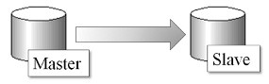

**Figure 1.1** Master-to-Slave Replication Duplicates Change from One Database to Another

databases, to all the other databases in the group, regardless of in which database a change is made. Master-to-master replication copies information from all servers to all other servers, where each is both source and target.

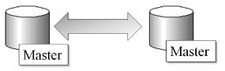

**Figure 1.2** Master-to-Master Replication Duplicates Change from All Databases to All Other Databases

### 1.1.3 GoldenGate Options for Use with Oracle® Database

These options are already covered previously in this chapter but are worth mentioning again from the perspective of the application of the architecture, as opposed to the architecture itself:

* **Unidirectional.** A reporting database
* **Broadcast.** Single direction replication that distributes the same information geographically
* **Consolidation.** Aggregate data from multiple sources into data ware houses, data marts, and BigData databases
* **Cascading.** Scales up a system into multiple layers
* **Bi-Directional.** Implements standby (failover) databases
* **Peer-to-Peer.** Clustered or grid database for high availability

## 1.2 The Architecture of GoldenGate

Like many other parts of Oracle software, GoldenGate consists of a structure that encompasses a number of appropriately named locations, in addition to named processes that connect those locations. The basic structure is two databases, consisting of a source and target database, plus extract fi les that contain the sequence of DML and DDL changes from the source database, to be applied to the target database through replication fi les located on the target server. Figure 1.3 shows a general picture of the architecture of Oracle GoldenGate software.

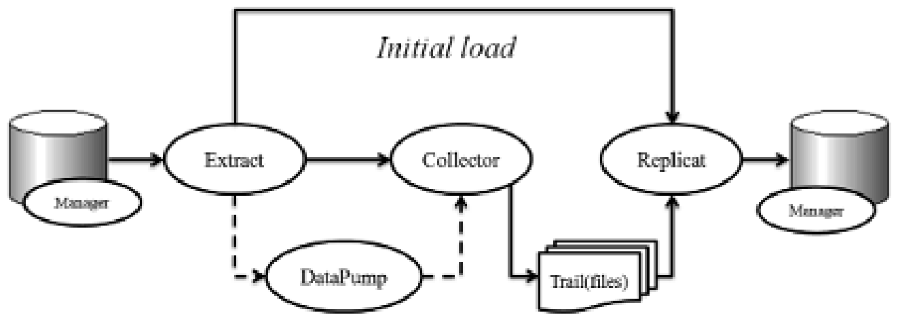

**Figure 1.3** The Internal Architecture of Oracle GoldenGate Software

### 1.2.1 The Manager Process

The Manager process controls GoldenGate and must be up and running on all databases to allow for the Extract and Replicat processes to be started up. The Manager process starts and stops GoldenGate processing, any dynamic processes, assigns port number allocations, purging of trail fi les, as well as managing reporting.

### 1.2.2 The Extract Process

The Extract process captures changes from a source database and usually runs on the source database but can run on a target database as well. The Extract process can be used to run initial loads from a single set of source tables between source and target databases. After the initial load, the Extract process is used to synchronize (replicate) DML and DDL changes between source and target databases on an ongoing basis, by using logs of change to replicate (copy) changes from sources to targets, duplicating the sequence of changes on target environments. There are some important points to note:

* Commit and rollback of change is part of the normal transactional logging sequence of a database and will simply be duplicated to target databases as it occurs on the source. This replication of persisted change is achieved simply by writing committed changes to trails, where a rollback would undo changes before a commit occurred. So commits are persisted to the trail and rollbacks are not, because rollbacks are not needed.

*Rollbacks are part of transactional logs in a standard transactional database, because the fastest approach is to write all changes to a database, and then reverse those changes in the event of a rollback, regardless of when a commit is executed. The assumption is that commits are far more frequent than rollbacks, and thus duplication of activity is sacrificed to cater to overall performance.*

* Source and target databases can be explicitly confi gured where not all objects (such as tables) on a source database are to be replicated to target databases. The Extract process will simply not replicate changes to objects that are not confi gured to replicate (excluded from replication confi guration).
* Replication can be performed in parallel using multiple matching sets of parallel executed Extract processes, Replicat processes, and extraction (persistence) trails.
* Online Extract and Replicat processes run until stopped by a user, continuously extracting and replicating DDL and DML changes occurring on the source, to the target.

*The EXTRACT and REPLICAT parameters help to confi gure Extract and Replicat processing.*

### 1.2.3 The Replicat Process

The Replicat process essentially executes the replication (or repetition) of DML and DDL processing as executed on the source and copied into the trails, where those same trails are subsequently used to provide DML and DDL change feed information into the target database. Replicat is used to execute what are called *initial loads* (loading a database from scratch), as well as to apply changes that synchronize between source and target databases; this is called *change synchronization* (syncing changes between source and target to cause the target to be synchronized with the source).

Some points to remember:

* Replicat can be confi gured in coordinated or integrated modes, where integrated mode applies to Oracle databases, and coordinated mode can be used to coordinate between Oracle and some other type of target database environment.
* Replicat can have a delay confi gured to allow for a delay of errone-ous application using a parameter called the DEFERAPPLYINTERVAL parameter.
* Further information on GoldenGate parameters can be found in the online Oracle GoldenGate documentation on Oracle’s website, at docs.oracle.com.
* An initial load of a target replication database can be executed using a special run of the Replicat process, where there are known starting and ending points in time for the replication. The SPECIALRUN parameter can be confi gured in this case in order to allow for reading between two points of the Extract process trails.

*See the video “Finding, Downloading, and Navigating Oracle GoldenGate Documentation” at* [*www.ezoracle tutor.com*](http://www.ezoracletutor.com/)*.*

### 1.2.4 The Collector Process

The Collector process runs on the target database, writing changes from the source database into the trail fi les, to be consumed by the Replicat process on the target database.

### 1.2.5 Checkpoints

A checkpoint in a database environment is a set of pointers that describe the state of a database at a specifi c juncture (point in time), and that checkpoint is stored so that the checkpoint can be reverted to if necessary. A recovery back to a previous checkpoint places a database into the state of change it was in at the juncture of the checkpoint. So the failure of any of the parts between a constantly synchronizing (extracting) source, and a constantly (replicating) target database, can be recovered back to a previous checkpoint juncture (a previous point in time).

In reality, GoldenGate only has to re-read the transaction logs on the source database in order to recover to a checkpoint. Checkpoints are a part of the target database in GoldenGate and are stored by the Replicat process on the target database as a table called the *checkpoint table.* So GoldenGate checkpoints themselves are stored as part of backup processing on the target database, which is more secure in maintaining recoverability. Checkpoint information stored includes read and write details, what is captured by the Extract process, and what is applied by the Replicat process. It is, however, important to note that checkpoints are not transactional based with respect to a DML change on the source database, and thus a checkpoint can be created within a database change transaction, and controlled by a time interval using a GoldenGate confi guration parameter called CHECKPOINTSECS. So when database backups are performed for source and target GoldenGate databases, one should also include the GoldenGate trail fi les, given that the trails are not stored inside source or target databases.

### 1.2.6 Extract Files

In general, GoldenGate can perform different types of extraction depending on the phase of implementation, where (1) an initial load takes an initial consistent snapshot of the source for an initialization loading into the target; (2) continuously updating is later performed by applying DML and DDL changes from source to target, in the sequence in which those changes have already been applied to the source database; and (3) initial loads and continuous replication can be sent outside of an Oracle database to a target database other than Oracle.

As shown in Figure 1.3, the trail fi les are a fi le system stored sequence of transactions produced after the Extract process (the Collector process). Those trails are in turn read as a record of committed source database transactions, as a way to form an architecture in the replication process that: (1) allows for recoverability outside of the source and target environments; and (2) allows the Extract and Replicat processes to execute without being dependent upon each other—failure on one server will not cause failure on others, which is important for a replication tool that can also function as a failover. The trail can be located on the source (Extract or Local Trail) or target (Remote Trail) database server, and even on another server in between (Remote Trail), or any combination thereof. The Extract Trail can even be stored as an Extract File (one or more recycling fi les), where checkpoints do not exist (Extract and Remote Trails do record checkpoints). Extract processes must each be linked to a trail into which committed transactions can be generated, which must be unique if local (on the source server). When using data pump processes to write trails, there should be one trail for each data pump, and those trails can even have the same name, as long as those trails are located on separate remote servers.

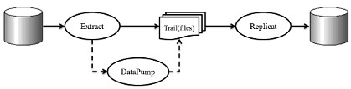

**Figure 1.4** GoldenGate Internal Architecture and Trails

As shown in Figure 1.4, the trail can be located on either server (or both) and even be accessed by data pump processing, which extracts DDL and DML from a local trail where changes are moved to another trail that would be read by the Replicat process.

#### Data Pump

*Data pump* is Oracle Database technology used primarily for making consistent, *re-playable* DDL and DML export dumps from an Oracle database. Data pump can also be used to perform a small amount of expressionbased data and object fi ltering (copy only specifi c objects or data items), data mapping (change the names of objects and data structures), as well as data conversion (transform data between different formats) during the export data pumping process. So data pump can be used to pump data from one server to another, much like data warehousing Extract Transport and Load (ETL) processing.

*Expression-based processing is functional based where one value is passed in and another single value is passed out, as in x = (y+1), where substituting y=3 results in x=4; the point is that a single value is returned so that the expression (x+1) can be embedded inside a Structured Query Language (SQL) coded query.*

Data pump can also be confi gured in pass-through mode, where no ETL data manipulations occur. Data pump processing is effectively an additional Extract process and runs on the source database and writes to the trail on the source database server, as shown in Figure 1.5.

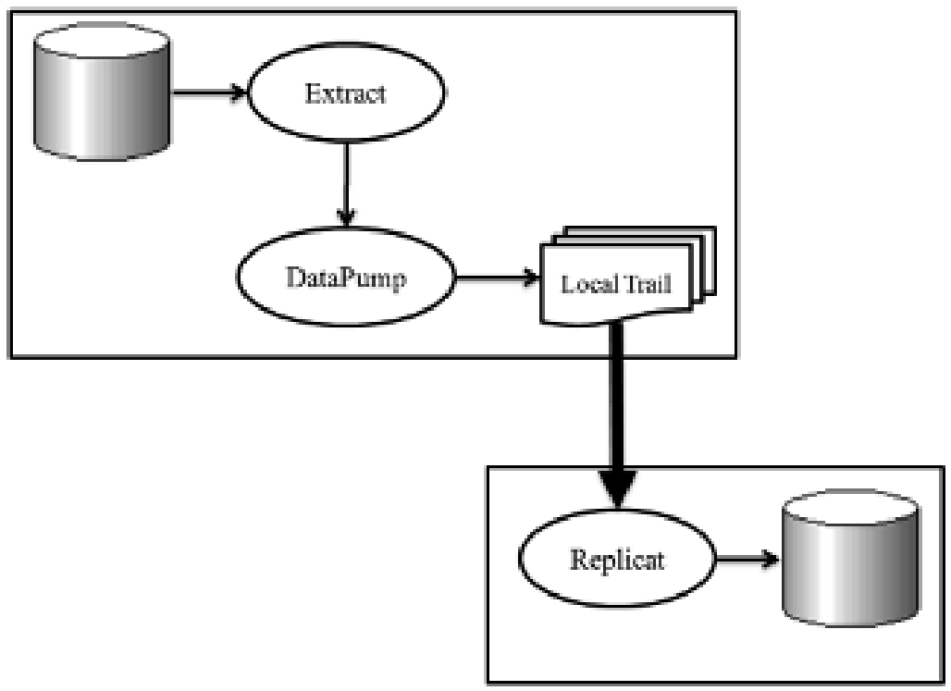

**Figure 1.5** Data Pump Runs on Source into a Local Trail

When not using data pump, then the Extract process that runs on a source server database must send extracted committed transactions to the trail (fi le or fi les), which must be running on a remote trail. The remote trail is running on the target, which is another server that protects from failure, as shown in Figure 1.6.

Data pump allows for the effective further isolation between source and target databases in order to allow for easier recovery from failure without disconnecting the source and target systems. Data pump builds another layer, in that it allows for both consolidation (many sources to one target such as in a data warehouse) and distribution (one source to many targets that distribute data as in large cloud service providers). The further isolation between source and target inherently provides the following:

* Insurance against network failure.
* Insurance for failure at one or more targets.
* ETL processing capabilities within replication processing helping to limit processing time further down the processing chain of events.

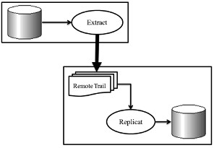

**Figure 1.6** GoldenGate Extract Trail Must Be a Remote Trail if Data Pump Is Not Used

* Consolidation into a single data warehouse target should not be halted by the failure of one of many sources, where the data pump processing occurs on the sources. Warehouse processing is not dependent upon committed transaction trails that are generated on one specifi c source database server.
* Multiple targets can be serviced by multiple data pump Extract pro-cesses running on a single source database server, and thus network failure to a single target server does not affect all target servers at once.

### 1.2.7 Groups

Processing groups are used to describe and create multiple sets of related Extract or Replicat processes, where each group runs in parallel to other groups. So a group can contain a process such as an Extract or a Replicat process, along with confi guration parameter fi les, trails, and checkpoints (Replicat). The ADD EXTRACT and ADD REPLICAT commands are used to create groups in the GoldenGate Software Command Line Interface (GGSCI); GGSCI is the GoldenGate character-based shell interface.

### 1.2.8 The Commit Sequence Number (CSN)

A GoldenGate CSN is used to identify GoldenGate replicated transactions, which are used to ensure data integrity (consistency) on target databases by identifying the juncture of a committed transaction. The CSN can be used to link between where to place the Extract process in the transaction log on the source database, and the Replicat process in the trails on the target database. So a CSN identifi es the point in time at which a transaction is committed on the target replicated database by the Replicat process. The CSN can be useful in placing the Extract process at a specifi c juncture in the sequence of transactions, or also to place the Replicat process on the trail.

*Oracle and DB2 have variable-length CSNs. Oracle depends on Oracle System Change Numbers (SCNs), whereas other databases generally have fixed length CSNs.*

### 1.2.9 Support for Globalized Character Sets

GoldenGate allows for replication between source and target databases using what is called *native language encoding,* based on the character sets of those source and target databases. In other words, character-based content is replicated by GoldenGate between differing character sets; the detailed mechanics of this process is out of the scope of this book. A very useful online posting on this topic can be found here:

jinyuwang.weebly.com/core-platform/oracle-goldengateglobalization

**1.3 So What’s Next?**

As a fi rst chapter in a book introducing Oracle GoldenGate, it is important to get an overall non-detailed picture of how GoldenGate works as a piece of replication software. Thus, this chapter briefl y describes the general architecture of GoldenGate, including all the pieces, what they do, and how they all fi t together to make a whole. The next chapter covers installing and basic confi guration of GoldenGate within source and target Oracle databases.

# Chapter 2 Installing GoldenGate



The goal of this chapter is to demonstrate installation of GoldenGate software, as well as some basic required logging confi guration that must be added to source and target Oracle® databases. Also included are preinstallation steps, downloading software, and Oracle connectivity.

15

## 2.1 Pre-Installation Steps

GoldenGate is just another piece of software in some respects, and as with any piece of software, it has certain requirements before installing. For example, one would not want to try to install the Windows® operating system onto an Apple Mac computer; thus the requirement of needing a Windows-compatible computer is a prerequisite or pre-installation step.

At the time of writing this book, the basic system-level requirements for GoldenGate were found at this URL:

[http://www.oracle.com/technetwork/middleware/ias/downloads/ fusion-certification-100350.html](http://www.oracle.com/technetwork/middleware/ias/downloads/fusion-certification-100350.html)

*The Oracle GoldenGate manuals can be found at* [*http:// docs.oracle.com/golengate/c1221/gg-winux/index.html*](http://docs.oracle.com/golengate/c1221/gg-winux/index.html)

The servers used to write this book are two 64-bit Dell servers containing Oracle Linux (Red Hat 5), with 8Gb of Random Access Memory (RAM) and a terabyte (Tb) of disk space each. Installing software generally requires super-user or administration-type privileges for installing, which implies root for Linux® or UNIX®, and Administrator for Windows. The graphical Oracle Universal Installer (OUI) is an Oracle built in Java® application and can be used to install GoldenGate; there is also a character-based interface that will not be used in this book.

GoldenGate obviously requires two databases, given that GoldenGate is primarily a replication tool, where a source database replicates or duplicates information, and its operations are replicated to at least one other target database. The two databases should be properly installed, able to communicate with each other in both directions using Oracle’s Transparent Network Substrate (TNS), and must both be in archivelog mode because GoldenGate replicates using log entries in various modes.

Some of the more exotic data types can cause problems for replication and possibly not be *replicatable* at all. Some datatypes can impose restrictions on available replication modes—see the following URL to understand what is and is not allowed:

[https://docs.oracle.com/goldengate/1212/gg-winux/GIORA/ system_requirements.htm](https://docs.oracle.com/goldengate/1212/gg-winux/GIORA/system_requirements.htm)

## 2.2 Downloading and Installing

Downloading is usually very simple, but there has been a lot of software available from Oracle Corporation in recent times, and it can be tough to navigate through the clutter; the process begins with downloading.

### 2.2.1 Downloading GoldenGate Software

Acquiring and downloading GoldenGate is free (licensing is not), and the easiest way to get the software is by using the following steps:

* [www.oracle.com](http://www.oracle.com/)
* Rollover (move the mouse over) the Downloads link and click See All under the Middleware section, as shown in Figure 2.1.
* The GoldenGate link is under Middleware on the next page—click it!

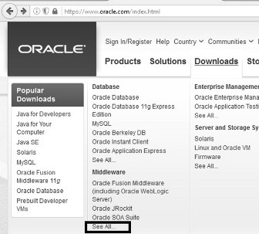

**Figure 2.1** Finding the GoldenGate Software Download

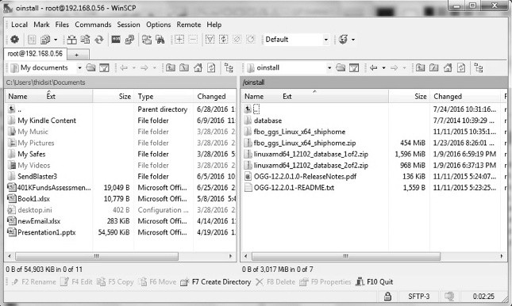

**Figure 2.2**

Moving GoldenGate Software to a Server

* Click the Accept License Agreement radio button at the top of the page.
* The version selected for this book is the Linux 64-bit version of Oracle GoldenGate, titled Oracle GoldenGate V12.2.0.1.1 for Oracle on Linux x86-64.
* At this stage a login may be forced; if an account is not already avail-able, then do create a free account.
* At the end of the process, a prompt to download a zip fi le will be encountered; select to download. The fi le will be called something like fbo_ggs_Linux_x64_shiphome.zip. Ship the downloaded fi le onto a server (if used) and into a path that it can be installed from as the Oracle Database super-user, such as the oracle Linux user in Linux, as shown in Figure 2.2.

### 2.2.2 Installing GoldenGate Software

Begin the installation process by extracting the zip fi le on both source and target servers, which in Linux uses the unzip command as follows:

unzip fbo_ggs_Linux_x64_shiphome.zip

Once the zip fi le is unzipped, check that the ORACLE_HOME and ORACLE_SID variables are set on a source server something like this:

[oracle@bigdata oinstall-bigdata]$ set | grep ORACLE

ORACLE_HOME=/u01/app/oracle/product/12.1.0/dbhome_1

ORACLE_SID=bigdata

And on a target server:

[oracle@failover oinstall-failover]$ set | grep ORACLE

ORACLE_HOME=/u01/app/oracle/product/12.1.0/dbhome_1

ORACLE_SID=failover

Next add the GoldenGate requirements to the .bash_profi le, as in the example .bash_profi le shown in Figure 2.3, which includes lines that are added for GoldenGate.

The next step is to run the Oracle Universal Installer (OUI) tool runInstaller for GoldenGate. You will need to execute it in X Windows either

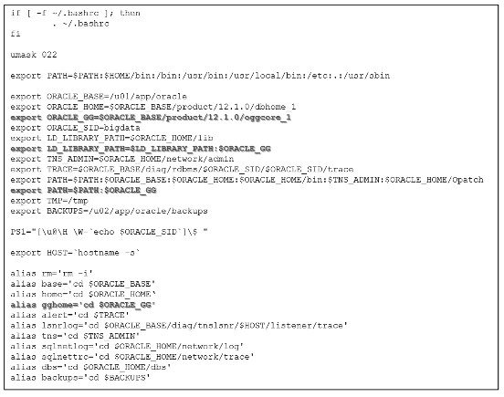

**Figure 2.3**

Linux .bash_profi

le for Oracle Database with GoldenGate Added

directly on your server with an attached and appropriate screen, or using terminal emulation, such as Virtual Network Computing (VNC); the following link can help you to get VNC working:

<http://www.oracletroubleshooter.com/using-vncserver>

*For most *nix commands, you can fi nd the long format name of the command using the man page for that command in the operating system. Type man vncserver into a Linux shell to fi nd that VNC is an acronym for Virtual Network Computing.*

The unzipped GoldenGate download fi le should have been decompressed into a subdirectory, such as the following:

[oracle@bigdata.localdomain Disk1-bigdata]$ pwd

/oinstall/fbo_ggs_Linux_x64_shiphome/Disk1 [oracle@bigdata.localdomain Disk1-bigdata]$ ls install response runInstaller stage

So now cd (Change Directory) into the subdirectory and run the installer connected fi rst as root and then as the oracle Linux user:

xhost + su – oracle cd /oinstall/fbo_ggs_Linux_x64_shiphome/Disk1 . runInstaller

The trail of graphics takes you through an easy-to-understand, step-bystep process. Remember to do the following:

* Select Oracle 12c.
* Pick the correct GoldenGate home (see Figure 2.3)—the installer might select the Oracle Database home, which is incorrect.
* Don’t forget that there is a software (GoldenGate) and a database location, which are two separate things. The OUI will create the new directory if not already done so manually.
* Click various Next, Install, and Finish buttons at obvious junctures.
* Don’t forget to run the OUI tool in the same way on both the source and the target servers.

*See the video “Installing Oracle GoldenGate with the OUI”:* [*www.ezoracletutor.com*](http://www.ezoracletutor.com/)

Remember, there is also what is called a *silent installation* (command line in a shell) available for Oracle GoldenGate, but it is more complex and harder to use. You can fi nd information on that installation in the Oracle manuals.

### 2.2.3 Testing GoldenGate Software

Test the GoldenGate command utility GGSCI on all source and target servers:

cd $ORACLE_GG ggsci

The result should look like that below, where the necessary working directories can be subsequently verifi ed, as well as created on both source and target server installations:

GGSCI (bigdata.localdomain) 1> create subdirs Creating subdirectories under current directory /u01/app/ oracle/product/12.1.0/oggcore_1

Parameter files /u01/app/oracle/ product/12.1.0/oggcore_1/dirprm: already exists Report files /u01/app/oracle/ product/12.1.0/oggcore_1/dirrpt: already exists Checkpoint files /u01/app/oracle/ product/12.1.0/oggcore_1/dirchk: already exists Process status files /u01/app/oracle/ product/12.1.0/oggcore_1/dirpcs: already exists SQL script files /u01/app/oracle/ product/12.1.0/oggcore_1/dirsql: already exists Database definitions files /u01/app/oracle/ product/12.1.0/oggcore_1/dirdef: already exists Extract data files /u01/app/oracle/ product/12.1.0/oggcore_1/dirdat: already exists Temporary files /u01/app/oracle/ product/12.1.0/oggcore_1/dirtmp: already exists Credential store files /u01/app/oracle/ product/12.1.0/oggcore_1/dircrd: already exists Masterkey wallet files /u01/app/oracle/ product/12.1.0/oggcore_1/dirwlt: already exists Dump files /u01/app/oracle/ product/12.1.0/oggcore_1/dirdmp: already exists GGSCI (bigdata.localdomain) 2>

There are many commands available in the GGSCI tool, which can be accessed using the HELP command inside GGSCI, as shown in Figure 2.4 (on next page).

## 2.3 Setting up Oracle Database for GoldenGate

Thus far in this chapter, only the GoldenGate software has been installed, and there is still much more to do. The next step in using GoldenGate is to confi gure the software and make it work, beginning with the Oracle Database networking layer.

### 2.3.1 Oracle Transparent Network Substrate (TNS)

The fi rst point is to establish the Oracle TNS connection between both a source and a target database. On both servers, there needs to be connectivity to both the source and the target database by changing the tnsnames. ora fi le on each server. Begin by adding the IP address plus host name value pairs into the /etc/hosts fi les on each server, assuming IP addresses are not used in the Oracle software’s tnsnames.ora fi les:

# Do not remove the following line, or various programs # that require network functionality will fail.

127.0.0.1 localhost.localdomain localhost bigdata ::1 localhost.localdomain localhost6 localhost bigdata

10.29.102.156 bigdata.localdomain bigdata

10.29.102.158 failover.localdomain failover

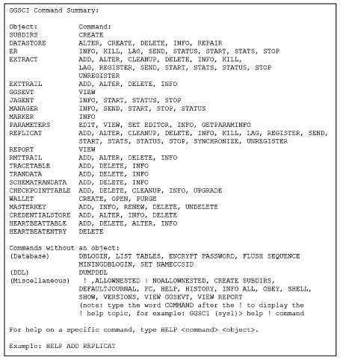

**Figure 2.4** Inside GGSCI, Type HELP to Show All Options Under the GGSCI Command Summary

And change the $ORACLE_HOME/network/admin/tnsnames.ora fi les on both servers to allow the source and the target to communicate with each other through TNS at the Oracle software layer:

LISTENER_BIGDATA =

(ADDRESS = (PROTOCOL = TCP)(HOST = bigdata.localdomain) (PORT = 1742))

BIGDATA =

(DESCRIPTION =

(ADDRESS = (PROTOCOL = TCP)(HOST = bigdata.localdomain) (PORT = 1742))

(CONNECT_DATA = (SERVER = DEDICATED) (SERVICE_NAME = bigdata))

)

FAILOVER =

(DESCRIPTION =

(ADDRESS = (PROTOCOL = TCP)(HOST = failover.

localdomain)(PORT = 1863))

(CONNECT_DATA = (SERVER = DEDICATED) (SERVICE_NAME = failover))

)

The registered listener is different for the target server:

LISTENER_FAILOVER =

(ADDRESS = (PROTOCOL = TCP)(HOST = failover.localdomain)

(PORT = 1863))

At this stage both servers should be *tnsping’able* from both as below:

[oracle@bigdata.localdomain dbs-bigdata]$ tnsping failover

TNS Ping Utility for Linux: Version 12.1.0.2.0 -

Production on 04-SEP-2016 12:04:17 Copyright (c) 1997, 2014, Oracle. All rights reserved.

Used parameter files: /u01/app/oracle/product/12.1.0/dbhome_1/network/admin/ sqlnet.ora

Used TNSNAMES adapter to resolve the alias

Attempting to contact (DESCRIPTION = (ADDRESS = (PROTOCOL =

TCP)(HOST = failover.localdomain)(PORT = 1863)) (CONNECT_

DATA = (SERVER = DEDICATED) (SERVICE_NAME = failover)))

OK (0 msec)

*Extract and Replicat process parameter fi les can be used to encrypt usernames and passwords for connections between source and target database.*

### 2.3.2 Replication Logging

Oracle Database redo logs store changes to metadata, such as a table creation in the form of a CREATE TABLE command. DML commands are stored as effi ciently as possible, where INSERT stores the INSERT data only, UPDATE stores the changed column value and row address only, and DELETE stores the address of the deleted row only. Redo log change vectors are stored to be as effi cient as possible, but only to be *replayable* back into a source database in order to recover that failed source database, and to bring that failed Oracle Database back to a desired state and point in time again. The trouble with change vectors when replicating is that the information stored to recover a source database is not enough information when replicating to a different database. For example, a DELETE command needs more than the source database internal logical row address in order to fi nd a row to be deleted—it needs the fi lter to delete that row in addition to the table name—internal logical addressing values are different between source and target databases. In reality, replication needs the entire DELETE command DML statement so that the DELETE transaction can be replicated from a source to a target database without having to refer to the source database as the task is performed. Oracle calls this extra logging *supplemental logging,* meaning that more information is generated into the Oracle source database redo logs to enable replication to a target database, and it comes in three fl avors:

* **Database-level supplemental logging.** Mandatory and essentially adds supplemental logging to Oracle database redo logs. Forces all transactions to be logged and adds row chaining information.
* **Schema-level supplemental logging.** Confi gured inside GoldenGate software with a number of options:
  + Additionally logs all primary key and valid unique indexes for all tables in a schema, but DDL replication is not supported. This is the minimum required for schema-level logging, maintaining uniqueness of values that are required to be unique, and using the ADD SCHEMATRANDATA GGSCI command with the NOSCHEDULINGCOLS option (non-integrated Replicat only).
  + Additionally logs primary key, unique key, and foreign key (referential integrity) information, meaning that all keys and values are logged and DDL is supported, which allows generation of all key values inside the target. This is the default setting and uses the

ADD SCHEMATRANDATA GGSCI command.

* + Additionally logs all columns in all tables in a schema, regardless of whether a column value is changed or is not in a transaction, using the ADD SCHEMATRANDATA GGSCI command with the ALLCOLS option.

*Replication allows selection of the level of detail to be replicated, such as an entire database, or one or more specifi c schemas, or even as specifi c as one or more tables within specifi c schemas within a database.*

* **Table-level supplemental logging.** Confi gured inside GoldenGate software with the same options as schema-level logging, but with the very simple difference that one can replicate table by table as opposed to schema by schema, implying that one could replicate a single schema in a database, but also a single table or a group of tables.

#### Database-Level Supplemental Logging

Redo logs in Oracle Database allow for transactional consistency and realtime recoverability in the case of local failure. It is important to note that when writing data to a table in an Oracle Database, the redo logs are the most important written record and are thus always written to fi rst, storing each and every change to the database as reusable or *replayable* change vectors of transactions. Check fi rst that archive logging is enabled in source and target databases in SQLPLUS:

ARCHIVE LOG LIST;

If the result shown is “No Archive Mode”:

sqlplus / as sysdba SQL> archive log list;

Database log mode No Archive Mode

Automatic archival Disabled

Archive destination USE_DB_RECOVERY_FILE_DEST

Oldest online log sequence 206

Current log sequence 208 SQL> then enable archive logging using the following commands:

SHUTDOWN IMMEDIATE;

STARTUP MOUNT;

ALTER DATABASE ARCHIVELOG;

ALTER DATABASE OPEN;

Supplemental logging can be confi gured on both source and target, depending on the confi guration of GoldenGate:

SQL> SELECT supplemental_log_data_min, force_logging FROM v$database;

SUPPLEME FORCE_LOGGING

-------- ---------------------------------------

NO NO

If supplemental or forced logging is not implemented (set to NO as above and not YES), then change as below:

ALTER DATABASE ADD SUPPLEMENTAL LOG DATA;

ALTER DATABASE FORCE LOGGING;

Forced logging ensures that all changes are written to redo logs. Note that supplemental logging is only needed on the source, but it’s prudent to confi gure on source and target databases. Now verify at least one log fi le switch on both source and target just in case:

ALTER SYSTEM SWITCH LOGFILE;

##### Using Flashback

Oracle allows replication of specialized data types by use of fl ashback technology, which allows an object to be fl ashed backwards to a point in time in the past by reading both data and rollback spaces (records of recently noncommitted transactions). Specialized Oracle Database data types include user-defi ned datatypes, nested tables, and XMLType datatypes. Further details can be found on fl ashback at the following URL:

[https://docs.oracle.com/goldengate/1212/gg-winux/GIORA/ setup.htm#GIORA374](https://docs.oracle.com/goldengate/1212/gg-winux/GIORA/setup.htm#GIORA374)

Set the size of the amount of undo (rollback) information retained to allow for larger transactions (on source and target):

ALTER SYSTEM SET UNDO_RETENTION=86400 SCOPE=BOTH;

##### The STREAMS_POOL_SIZE Parameter

Even though Oracle Database automates low-level memory parameters such as the streams pool, current GoldenGate documentation denotes that the streams pool parameter requires 1GB plus an extra 25% for each extract process:

ALTER SYSTEM SET STREAMS_POOL_SIZE=1280M SCOPE=BOTH;

*Many online sources cite disabling the recycle bin for GoldenGate, but this does not apply to Oracle11g and beyond.*

#### Schema-level Supplemental Logging

Where database-level supplemental logging allows replication of an entire database, schema-level logging will enable replication of specifi c schemas, such as a single application schema. In reality, one does not have to replicate an entire database—schema-level replication can be a more effi cient option, and even less intrusive and complicated. The fi rst thing needed is a GoldenGate schema owner on the source database that supports replication of DDL—make these changes in Oracle using SQLPLUS for both source and target:

CREATE BIGFILE TABLESPACE ggate

DATAFILE '/u02/app/oracle/oradata/bigdata/ggate01.

dbf' SIZE 1G AUTOEXTEND ON;

CREATE USER ggate IDENTIFIED BY ggate

DEFAULT TABLESPACE ggate TEMPORARY TABLESPACE TEMP;

GRANT DBA, CONNECT, RESOURCE, UNLIMITED TABLESPACE TO ggate;

GRANT EXECUTE ON UTL_FILE TO ggate;

GRANT FLASHBACK ANY TABLE TO ggate;

Add a similar user to the target database as follows, where one could use the same username on both source and target, but for the purposes of avoiding confusion, separate names are used in this book:

CREATE BIGFILE TABLESPACE ggate

DATAFILE '/u02/app/oracle/oradata/failover/ggate01.

dbf' SIZE 1G AUTOEXTEND ON;

CREATE USER ggate IDENTIFIED BY ggate

DEFAULT TABLESPACE ggate TEMPORARY TABLESPACE TEMP; GRANT DBA, CONNECT, RESOURCE, UNLIMITED TABLESPACE TO ggate; GRANT EXECUTE ON UTL_FILE TO ggate;

GRANT FLASHBACK ANY TABLE TO ggate;

##### Enable GoldenGate Confi guration Parameter

There is a parameter new to Oracle12c that applies to both the capture (Extract on the source) as well as the apply (Replicat on the target) servers:

ALTER SYSTEM SET enable_goldengate_replication=true

SCOPE=both;

If the above parameter is not set, then the following commands:

cd $ORACLE_GG ggsci

DBLOGIN USERID ggate, PASSWORD ggate

ADD SCHEMATRANDATA email

may produce the following errors:

GGSCI (bigdata.localdomain as ggate@bigdata) 2> ADD

SCHEMATRANDATA email ERROR: Operation not supported because enable_goldengate_ replication is not set to true.

The next step is to execute the GGSCI on the source database server, logging in with the DBLOGIN command using the alias of a user with the privilege of enabling schema-level supplemental logging:

[oracle@bigdata.localdomain ~-bigdata]$ $ORACLE_GG/ggsci

Oracle GoldenGate Command Interpreter for Oracle

Version 12.2.0.1.1

OGGCORE_12.2.0.1.0_PLATFORMS_151211.1401_FBO

Linux, x64, 64bit (optimized), Oracle 12c on Dec 12 2015

02:56:48 Operating system character set identified as UTF-8.

Copyright (C) 1995, 2015, Oracle and/or its affiliates.

All rights reserved.

GGSCI (bigdata.localdomain) 1> DBLOGIN USERID ggate Password:

Successfully logged into database.

GGSCI (bigdata.localdomain as ggate@bigdata) 2>

Next issue commands against schemas in the source database, confi guring data capture on the source:

ADD SCHEMATRANDATA email

The result should look something like this:

GGSCI (bigdata.localdomain as ggate@bigdata) 2> ADD SCHEMATRANDATA email 2016-11-11 01:00:57 INFO OGG-01788 SCHEMATRANDATA has been added on schema email. 2016-11-11 01:00:57 INFO OGG-01976 SCHEMATRANDATA for scheduling columns has been added on schema email. GGSCI (bigdata.localdomain as ggate@bigdata) 3>

There are other options for schema-level supplemental logging:

ADD SCHEMATRANDATA <schema> [ ALLCOLS | NOSCHEDULINGCOLS ]

No options are used for the EMAIL schema above, which will force all primary keys to be logged even if unchanged (helps to locate unique rows), in addition to only logging foreign and unique key values if at least a foreign or unique key was changed in a database operation. The ALLCOLS option logs everything in all tables for a schema (all columns), every time something is changed in a row, which can create a lot of overhead by logging everything that is changed as well as everything that is not changed. The following command adds to a schema called BIGDATA:

ADD SCHEMATRANDATA bigdata ALLCOLS

and the result is as follows:

GGSCI (bigdata.localdomain as ggate@bigdata) 3> ADD

SCHEMATRANDATA bigdata ALLCOLS 2016-11-11 01:11:31 INFO OGG-01788 SCHEMATRANDATA has been added on schema bigdata. 2016-11-11 01:11:31 INFO OGG-01976 SCHEMATRANDATA for scheduling columns has been added on schema bigdata. 2016-11-11 01:11:31 INFO OGG-01977 SCHEMATRANDATA for all columns has been added on schema bigdata. GGSCI (bigdata.localdomain as ggate@bigdata) 4>

Similarly, the NOSCHEDULINGCOLS option is the minimum for schemalevel logging, logging only primary and unique index values (for valid indexes only). This is perhaps a more sensible option for a BigData environment because there is so much information being generated, but do not execute this line now (it is commented out for that reason):

--ADD SCHEMATRANDATA bigdata NOSCHEDULINGCOLS

#### Table-Level Supplemental Logging

First, table-level logging cannot be used within a schema that is schemalogging enabled; this is because schema-level logging overrides individual table-level logging. Second, table-level logging has the same default as schema-level logging when not using any options for the ADD SCHEMATRANDATA command. Thus primary keys are logged even if unchanged. Foreign and unique key values are only logged if at least a foreign or unique key was changed in a database operation:

ADD TRANDATA <schema>.<table>

Table-level supplemental logging uses the ADD TRANDATA command with the following options:

ADD TRANDATA <schema>.<table> [,COLS (columns)] [,NOKEY]

[,ALLCOLS|NOSCHEDULINGCOLS]

As with schema-level logging, the ALLCOLS option logs everything in a table every time something is changed in a row, and the NOSCHEDULINGCOLS option logs only primary and unique index values (for valid indexes only). The COLS option will log non-key columns that can be used for fi ltering and changes, as well as the primary key—unique indexes must be created on the target database for columns defi ned by the COLS clause. The NOKEY clause is added, which blocks primary and unique key logging (KEYCOLS clause required in a table). So one can add table-level logging to a single table as follows:

ADD TRANDATA dmevents.earthquake And this is the response from GGSCI:

GGSCI (bigdata.localdomain as ggate@bigdata) 3> ADD

TRANDATA dmevents.earthquake

2016-11-14 00:51:55 WARNING OGG-06439 No unique key is defined for table EARTHQUAKE. All viable columns will

be used to represent the key, but may not guarantee uniqueness. KEYCOLS may be used to define the key.

Logging of supplemental redo data enabled for table DMEVENTS.EARTHQUAKE.

TRANDATA for scheduling columns has been added on table 'DMEVENTS.EARTHQUAKE'.

TRANDATA for instantiation CSN has been added on table 'DMEVENTS.EARTHQUAKE'.

GGSCI (bigdata.localdomain as ggate@bigdata) 4>

There is schema-level logging on EMAIL and BIDDATA schemas, as well as table-level logging on DMEVENTS schema tables. And this is the response from GGSCI for a table that does have uniqueness defi ned:

GGSCI (bigdata.localdomain as ggate@bigdata) 10> ADD

TRANDATA dmevents.volcano

Logging of supplemental redo data enabled for table DMEVENTS.VOLCANO.

TRANDATA for scheduling columns has been added on table 'DMEVENTS.VOLCANO'.

TRANDATA for instantiation CSN has been added on table 'DMEVENTS.VOLCANO'.

GGSCI (bigdata.localdomain as ggate@bigdata) 11>

And this is the response from GGSCI for the table that already has a primary key, but the uniqueness combines the existing primary key and columns added by the column clause. In this case the intention is to augment the primary key, such as when a primary key is a surrogate; a surrogate key is often an integer auto-counter and to the naked eye is semantically meaningless:

GGSCI (bigdata.localdomain as ggate@bigdata) 25> ADD

TRANDATA dmevents.volcano COLS(name,magnitude)

2016-11-14 01:11:50 WARNING OGG-00706 Failed to add supplemental log group on table DMEVENTS.VOLCANO due to ORA-00957: duplicate column name SQL ALTER TABLE "DMEVENTS"."VOLCANO" ADD SUPPLEMENTAL LOG GROUP "GGS_92635"

("NAME","ERUPTION","NAME","MAGNITUDE") ALWAYS /* GOLDENGATE_DDL_REPLICATION */.

TRANDATA for instantiation CSN has been added on table 'DMEVENTS.VOLCANO'.

GGSCI (bigdata.localdomain as ggate@bigdata) 26>

One can also not add too many columns with the COLS clause to enhance the uniqueness within a table, fi rst deleting the previous defi nition to allow for replacement:

GGSCI (bigdata.localdomain as ggate@bigdata) 12> DELETE

TRANDATA dmevents.volcano

Logging of supplemental redo log data disabled for table DMEVENTS.VOLCANO.

TRANDATA for scheduling columns has been disabled on table 'DMEVENTS.VOLCANO'.

GGSCI (bigdata.localdomain as ggate@bigdata) 13> ADD

TRANDATA dmevents.volcano COLS(magnitude)

Logging of supplemental redo data enabled for table DMEVENTS.VOLCANO.

TRANDATA for scheduling columns has been added on table 'DMEVENTS.VOLCANO'.

TRANDATA for instantiation CSN has been added on table 'DMEVENTS.VOLCANO'.

GGSCI (bigdata.localdomain as ggate@bigdata) 27>

When implementing table-level logging, one can grant fl ashback to specifi c tables on a table-by-table basis from SQLPLUS:

sqlplus / as sysdba

GRANT FLASHBACK ON dmevents.volcano TO ggate;

**2.4 So What’s Next?**

This chapter has demonstrated how to download and install GoldenGate software, as well as some basic Oracle Database confi guration that is required to enable GoldenGate software. This information is important as a step in the process of showing how to build a basic GoldenGate installation. The next chapter digs into the confi guration of capture and apply processing, where data change is captured on a source database and then applied on a target database.

# Chapter 3 Confi guring GoldenGate

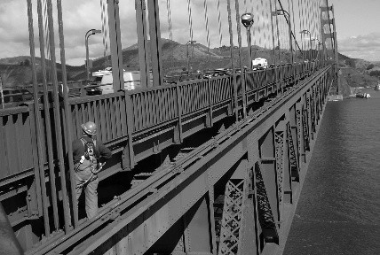

The goal of this chapter is to go through the process of basic confi guration of GoldenGate, including Capture and Apply, plus different types and combinations of Capture and Apply, leading into process groups and fi nally a brief test of replication in action.

37

## 3.1 The Architecture of Capture (Extract) and Apply (Replicat)

The capture process is the process that gathers information about changes to the source database—it extracts information as a record of changes made to the source database using the Extract process on the source database. The apply process applies changes onto the target database as they are extracted from the source—it replicates or duplicates changes to mimic changes made to the source onto the target database using the Replicat process.

GoldenGate calls the Extract process and its associated fi les a group, which can, but does not have to, include data pump processing, where data pump can be used to read source Extract trail fi les and send changes over a network to a target. Figure 3.1 shows a basic process fl ow from source to target of: (1) source capture (Extract) to local trail, (2) to data pump, (3) data pump across a network to a target remote trail, and (4) to apply (Replicat) on a target.

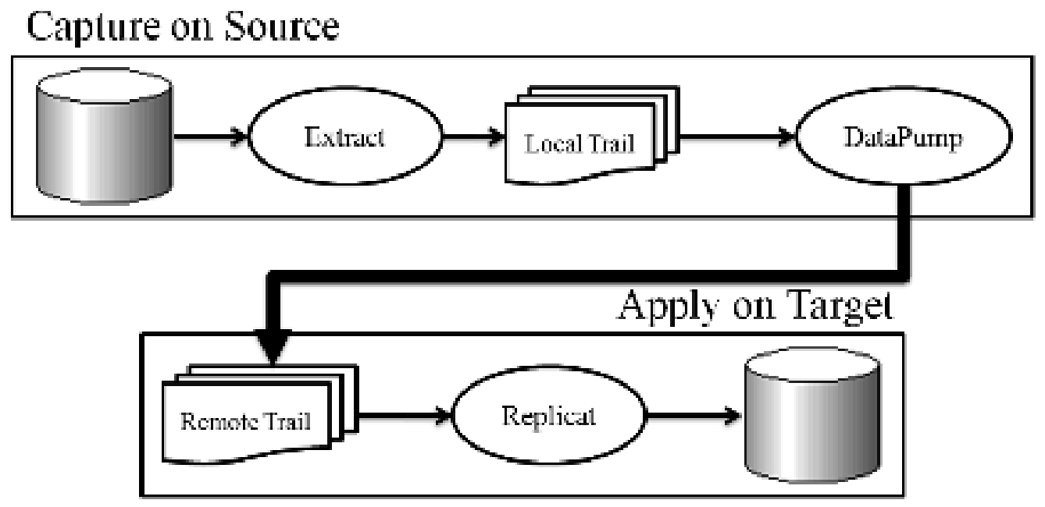

**Figure 3.1** Basic GoldenGate Process Flow from Source to Target

### 3.1.1 Capture Method Architecture

There are two capture modes that Extract can execute with: (1) classic capture, and (2) integrated capture modes—the choice of which depends on specifi c issues between source and target databases, which includes data types, confi guration of databases, and Oracle® Database versions.

#### Classic Capture

As shown in Figure 3.2, the GoldenGate capture Extract process reads Oracle Database archive and redo logs in order to generate changes from the source to pass to the target. Changes can optionally be pushed through a local trail and data pump process to help isolate source from target and reduce dependency in case of failure.

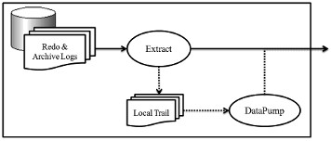

**Figure 3.2** How Classic Capture Works on the Source

Classic capture does not support multitenant databases and has some restrictions with respect to complex data types, as described by the following URL in Chapter 1 of the Oracle GoldenGate Installation Guide for Oracle Database 12:

[https://docs.oracle.com/goldengate/1212/gg-winux/GIORA/system_ requirements.htm#GIORA122](https://docs.oracle.com/goldengate/1212/gg-winux/GIORA/system_requirements.htm#GIORA122)

#### Integrated Capture

As shown in Figure 3.3, integrated capture is a more capable Extract method, with none of the restrictions of classic capture. Integrated capture works with Oracle Database Logminer processing, which reads the Oracle Database archive and redo log fi les, as opposed to reading only the logs directly. Thus the Logminer process interprets all the information properly to allow for more comprehensive and fully integrated data capture on the source.

*Integrated Capture and Apply are intended for use with Oracle12c; non-integrated replication is used in Oracle11g and other databases.*

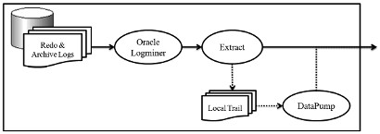

**Figure 3.3** How Integrated Capture Works on the Source

### 3.1.2 Apply Method Architecture

As well as two capture modes, there are also two apply modes: (1) nonintegrated, and (2) integrated; both modes use SQL coding and built-in Oracle Database Replication, and the latter includes Oracle Streams.

#### Non-Integrated Apply

As shown in Figure 3.4, non-integrated apply mode simply reads the trail of changes from the remote trail on the target server, and then applies those changes as SQL code DDL and DML statements executed against the target database. Non-integrated apply mode can execute multiple Replicat processes to move data in parallel. Non-integrated apply processing is generally more benefi cial in small transactional change databases, such as online transaction processing (OLTP) type applications.

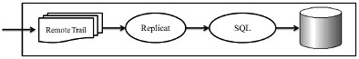

**Figure 3.4** How Non-Integrated Apply Works on the s

#### Integrated Replicat Apply

As shown in Figure 3.5, integrated apply mode uses Oracle Replication and Streams technology to allow creation of coordinated Apply processes that move changes to a target database in parallel, asynchronously and automatically coordinating between multiple apply processes without confl ict in the sequence of transactions. The resulting effect is that integrated apply mode is best for parallel operations that involve large amounts of I/O loads. The perfect example of this type of database is a data warehouse database, in that data warehouses are often heavily partitioned databases with large I/O transactions that easily benefi t from automated asynchronous splitting of change across multiple apply process threads; in other words, parallel processing partitioned databases with heavy I/O load.

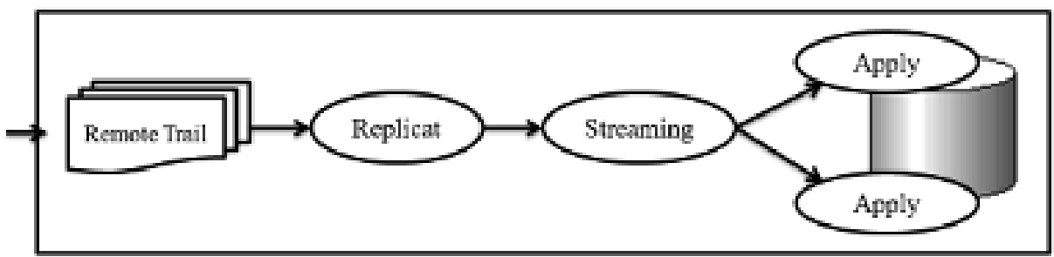

**Figure 3.5** How Integrated Apply Works on the Target

### 3.1.3 Mixing Methods of Capture and Apply

A discussion of mixing the various capture and apply methods is out of the scope of this book, but it is important to note that classic capture does not have to include an Oracle database at the source—it does at the target. The reasons for this are that integrated capture is custom built for Oracle Database and caters to all of Oracle’s complex and unusual data types; those extra data types are often not present or perhaps are built differently in other relational databases.

*The Oracle12c recommended confi guration for Golden Gate is integrated capture on an Oracle source database, replicating to integrated Replicat on an Oracle target database. Also, the target database executes a single Replicat process for each source database involved.*

### 3.2 Confi guring Classic Capture

Confi guration of classic capture involves a parameter fi le that is applied to the process, which implements the capturing function—it is called the Extract process. The parameter fi le must be created on the source database server by connecting to GGSCI, and then creating the Extract process parameter fi le as shown below:

cd $ORACLE_GG ggsci edit params ext1

And now create the Extract process parameter fi le for a schema called BIGDATA in the source database, including the LOGALLSUPCOLS parameter to ensure that logs are captured with all detail on the source server:

-- define the extract process

EXTRACT ext1

-- connect as a DDL supporting database user

USERID ggate, PASSWORD ggate

-- this is the extract trail on the source

EXTTRAIL /u01/app/oracle/product/12.1.0/oggcore_1/dirdat/lt

-- this is for DML capturing all tables and all sequences in the bigdata schema

TABLE bigdata.*;

SEQUENCE bigdata.*;

-- setting up DDL support for all objects in the bigdata user

LOGALLSUPCOLS

DDL INCLUDE MAPPED OBJNAME bigdata.*

DDL capture is enabled using the DDL parameter, where DDL is explicitly included or excluded, as in this example from above:

DDL INCLUDE MAPPED OBJNAME bigdata.*

Including the DDL parameter in the Extract parameter fi le captures and applies all DDL commands, depending on specifi cally detailed DDL requirements for GoldenGate replication, the specifi cs of which are well beyond the scope of this book and can be found at this link:

[https://docs.oracle.com/goldengate/1212/gg-winux/GIORA/ddl.](https://docs.oracle.com/goldengate/1212/gg-winux/GIORA/ddl.htm#GIORA959)

[htm#GIORA959](https://docs.oracle.com/goldengate/1212/gg-winux/GIORA/ddl.htm#GIORA959)

*DDL support is cited on many websites requiring various procedures be executed, which applies to pre-Oracle12c Database versions only.*

#### *3.2.1 Adding Data Pump to the Extract Confi guration*

Figure 3.1 showed that data pump optionally connects the local trail on the source server to the remote trail on a target server. Data pump is optional, but it creates a logging trail, and thus the same parameter fi le contains connection information to a target server. Editing these parameters: edit params ext1

and change by adding data pump confi guration to the existing extract confi guration:

-- hostname and port for trail )(define in /etc/hosts). 7809 is default port for GoldenGate

RMTHOST failover, MGRPORT 7809

-- path and name for trail (as per create subdirs on target as in Chapter 2)

RMTTRAIL /u01/app/oracle/product/12.1.0/oggcore_1/dirdat/rt Now check the manager process parameters: edit params mgr

This should be in the fi le as defi ned above for the RMTHOST setting:

PORT 7809

Next add confi guration parameters for Extract, data pump, the manager process, and the remote trail on a target server. Examining the parameter fi les subdirectory (subdir) on the source server should show all the fi les and their contents:

[oracle@bigdata.localdomain dirdat-bigdata]$ cd /u01/app/ oracle/product/12.1.0/oggcore_1/dirprm [oracle@bigdata.localdomain dirprm-bigdata]$ ls -la total 16 drwxr-x-- - 2 oracle oinstall 4096 Dec 24 16:47 . drwxr-xr-x 26 oracle oinstall 4096 Jul 27 11:20 ..

-rw-r-- -- - 1 oracle oinstall 702 Dec 24 16:47 ext1.prm -rw-r-- r-- 1 oracle oinstall 9 Jul 27 11:20 mgr.prm

[oracle@bigdata.localdomain dirprm-bigdata]$ cat mgr.prm

PORT 7809

[oracle@bigdata.localdomain dirprm-bigdata]$ cat ext1.prm

-- define the extract process

EXTRACT ext1

-- connect as a DDL supporting database user

USERID ggate, PASSWORD ggate

-- this is the extract trail on the source

EXTTRAIL /u01/app/oracle/product/12.1.0/oggcore_1/dirdat/lt

-- this is for DML capturing all tables and all sequences in the bigdata schema

LOGALLSUPCOLS

TABLE bigdata.*;

SEQUENCE bigdata.*;

-- setting up DDL support for all objects in the bigdata schema

DDL INCLUDE MAPPED OBJNAME bigdata.*

-- hostname and port for trail )(define in /etc/hosts). 7809 is default port for GoldenGate

RMTHOST failover, mgrport 7809

-- path and name for trail (as per create subdirs on target as in Chapter 2

RMTTRAIL /u01/app/oracle/product/12.1.0/oggcore_1/dirdat/lt

Connect to GGSCI again, and see what is running by executing a simple command to display all currently available information:

cd $ORACLE_GG ggsci info all

Something like the following should result:

GGSCI (bigdata.localdomain) 1> info all

Program Status Group Lag at Chkpt Time Since Chkpt

MANAGER STOPPED

GGSCI (bigdata.localdomain) 2>

#### *3.2.2 Limitations of Classic Capture*

Classic capture is limited in a number ways, including Transparent Data Encryption (TDE), Oracle RAC, Automatic Storage Management (ASM), data availability, archived log mode, Oracle Data Guard, and log bottlenecks. Classic capture requires more manual involvement and complexity than integrated capture:

* **Transparent Data Encryption (TDE).** Classic capture uses Oracle logmining to enable TDE between source and target, and requires encryption key exchanges between source and target, as well as some extra procedure executions.
* **Oracle Real Application Clusters (RAC).** Classic capture leaves out some complexities otherwise resolved by integrated capture.
* **Automated Storage Management (ASM).** There are some classic capture complexities reading logs, as well as some complexities with Oracle Data Vault. The TRANSLOGOPTIONS parameter set to the DBLOGREADER option is used in the Extract process parameter fi le.
* **Availability of Data.** This implies that data must always be available on the source for the Extract process to capture. Use archive log mode to prevent rapidly recycling redo logs causing entries to be missed by the Extract process. An Oracle Database that is not in archived log mode is at risk and not recommended. RMAN can be used to retain older logs, but archivelog mode is still a requirement.
* **Archive Log Only Mode.** Classic capture can be confi gured to read from archive logs only, excluding redo logs. This method is not confi gurable in integrated capture mode, and there are some limitations using Archive Log Only (ALO) mode only when Oracle RAC is involved.
* **Active Data Guard (ADG) Only Mode.** Classic capture mode can Extract metadata as well as log data in real-time using Oracle ADG.
* **Log Read Bottlenecks.** These can occur because a source database is writing to redo logs at the same time that the Extract process is reading from those same redo log fi les; this creates signifi cant I/O bottleneck problems. The only solution is faster hardware for redo logs (faster disks and faster disk controllers), or perhaps something like RAID that does not include parity.

## 3.3 Confi guring Integrated Capture

Confi guration of integrated capture involves a parameter fi le applied to the process, which implements the capturing function called the Extract process. An important difference to understand is that the mining process does not have to be instantiated on the source server and can be implemented further down the replication event chain.

*A multitenant database is simply treated as being multiple source and target databases, except that GoldenGate parameter fi les reference generic objects using the container databases.*

The Extract process parameter fi le can be created on the source database server as follows, beginning by connecting to GGSCI to create the Extract process parameter fi le:

cd $ORACLE_GG ggsci edit params ext1

As with the classic capture confi guration, the Extract process parameters are the same, with the only change being the DDL INCLUDE MAPPED setting that simply includes everything:

-- define the extract process

EXTRACT ext1

-- connect as a DDL supporting database user

USERID ggate, PASSWORD ggate

-- this is the extract trail on the source

EXTTRAIL /u01/app/oracle/product/12.1.0/oggcore_1/dirdat/lt

-- this is for DML capturing all tables and all sequences in the bigdata schema

LOGALLSUPCOLS

TABLE bigdata.*;

SEQUENCE bigdata.*;

-- setting up DDL support for all objects

DDL INCLUDE MAPPED

Changes for a multitenant database require that objects are accessible by container database using the addition of the SOURCECATALOG parameter—for example, one could confi gure something such as this:

-- for a pluggable database called CONTAINER1

SOURCECATALOG CONTAINER1

TABLE dmevents.*;

TABLE dmfinance.*;

-- for a pluggable database called CONTAINER2

SOURCECATALOG CONTAINER2

TABLE bigdata.*;

TABLE email.*;

DDL INCLUDE MAPPED SOURCECATALOG CONTAINER1 INCLUDE MAPPED

SOURCECATALOG CONTAINER2

The logmining function can be placed on the source database or further down the replication chain, which requires specialized changes to Extract parameters using the TRANSLOGOPTIONS parameter.

*Confi guring the logmining function to mine log fi les away from the source database can be useful to separate functionality and create a more robust architecture, such as mining (reading) log fi les from a standby server. The result is the removal of the logmining processing from a busy source system, which is beyond the scope of this book.*

Adding data pump to the Extract process confi guration is the same for both classic and integrated capture.

## 3.4 Confi guring Apply

The Replicat process is the application of change on the target side of the replication process within GoldenGate, executing transactions on a target database as captured on and copied from a source database. Much like the Extract process, the Replicat process is confi gured using a parameter fi le on the target server that determines the behavior of the Replicat process.

The fi rst step is to execute GGSCI on the target server and create a Replicat process parameter fi le as in the following:

cd $ORACLE_GG ggsci edit params rep1

Next add the appropriate parameters inside GGSCI where the ASSUMETARGETDEFS parameter applies the assumption that tables on source and target have the same metadata defi nitions and structure—the SOURCEDEFS parameter allows for mapping of differences:

-- define the replicat process

REPLICAT rep1

-- connect as a DDL supporting database user

USERID ggate, PASSWORD ggate

ASSUMETARGETDEFS

-- source and target databases use the same schema names in this case

MAP bigdata.*, TARGET bigdata.*;

The MAP parameter maps from source to target database objects using the following structure:

MAP [container.]<schema.><object>, TARGET <schema.>object;

Also, the optional DBOPTIONS INTEGRATEDPARAMS parameter settings allow for specialized integrated parameter settings. Non-integrated and integrated modes are the same with this confi guration; the parameter can be added as follows:

-- define the replicat process

REPLICAT rep1

-- connect as a DDL supporting database user

USERID ggate, PASSWORD ggate

ASSUMETARGETDEFS

DBOPTIONS INTEGRATEDPARAMS(PARALLELISM 2)

-- source and target databases use the same schema names in this case

MAP bigdata.*, TARGET bigdata.*;

*Given the limited scope of this book, assume integrated Extract and integrated Replicat have the most sensible confi guration options for simplicity in the use of the latest version of Oracle (12c), on both source and target servers.*

### 3.4.1 Limitations of Non-Integrated Apply

There are some limitations that are appropriate to the choice of confi guring with non-integrated Apply, and they are as follows:

• **Checkpoint Table.** Required for non-integrated Replicat but not for integrated Replicat. The checkpoint table is confi gured on the target database as follows, fi rst by editing a GLOBAL parameter fi le:

cd $ORACLE_GG ggsci

edit params ./GLOBAL and adding the following and saving:

GGSCHEMA ggate CHECKPOINTTABLE ggate.CHECKPOINT then connecting as the same user and adding the checkpoint table:

DBLOGIN USERID ggate, PASSWORD ggate ADD CHECKPOINTTABLE ggate.CHECKPOINT shown by the following executed commands:

GGSCI (failover.localdomain) 2> DBLOGIN USERID ggate, PASSWORD ggate Successfully logged into database.

GGSCI (failover.localdomain as ggate@failover) 3> ADD

CHECKPOINTTABLE ggate.CHECKPOINT

Successfully created checkpoint table ggate.CHECKPOINT.

GGSCI (failover.localdomain as ggate@failover) 4>

*The checkpoint table and GLOBAL fi le can be re-moved to implement Integrated Capture for O racle12c Database.*

GGSCI (failover.localdomain as ggate@failover) 5> delete checkpointtable ggate.CHECKPOINT

This checkpoint table may be required for other installations.

Are you sure you want to delete this checkpoint table? yes

Successfully deleted checkpoint table ggate.CHECKPOINT.

Remove the checkpoint table from the parameter fi le as follows:

GGSCI (failover.localdomain as ggate@failover) 7> edit params

./GLOBAL

* **Disable Triggers and Referential Integrity on Target Tables.** In nonintegrated Apply mode, triggers and cascading constraints must be disabled in the target database. Triggers and cascading constraints are very out of date and not generally compatible with large-scale or complex modern databases.
* **Constraint Checking on Target Tables.** This option is even more risky than the option above (Disable Triggers and Referential Integrity on Target Tables), because constraints may have to be deferred, which implies a potential for replication of inconsistent data.

## 3.5 Confi guration Limitations for Both Capture and Apply

There are some specifi c confi guration issues related to row uniqueness, Oracle Database sequences, complex data types, as well as some specifi c objects and commands—all are detailed as follows:

* **Unique Rows.** In order for a row to be locatable by a change replicated from the source, a source and target table undergoing an UPDATE or DELETE statement must have a unique value to use that exists on both source and target. Without a unique value, a row cannot be located. In order of decreasing precedence, unless indicated otherwise, GoldenGate will use the primary key followed by the fi rst unique key (with data type restrictions). If no key exists, GoldenGate creates a unique key of all usable columns, excluding some specialized data types that can create a large amount of overhead. In short, create primary keys on tables or your system may suffer some serious performance issues. As another option, the Extract TABLE and Replicat MAP parameters allow the inclusion of a KEYCOLS clause, which permits a table to have a specifi c set of columns defi ned for uniqueness if primary and unique keys are unwanted or not present.
* **Oracle Database Sequences.** Oracle sequences are auto counters that require specifi c confi guration in GoldenGate on both the source and target databases:

cd $ORACLE_GG ggsci

edit params ./GLOBAL GGSCHEMA ggate

Still in the $ORACLE_GG home directory, execute the sequence.sql script in SQLPLUS on the source, entering the GGATE user when prompted:

SQLPLUS / AS SYSDBA

@sequence.sql

It looks like this:

SQL> @sequence.sql Please enter the name of a schema for the GoldenGate database objects: ggate Setting schema name to GGATE

Execute the following grant on the source database in SQLPLUS:

GRANT EXECUTE on ggate .updateSequence to bigdata,email,dmevents; and on the target by selecting the GGATE user for the target:

SQLPLUS / AS SYSDBA

@sequence.sql GRANT EXECUTE on ggate .updateSequence to bigdata,email,dmevents;

Lastly, on the source database in SQLPLUS, you have to make the following change to ensure that sequence changes are forcibly logged in the source server but are also able to automatically replicate to the target as they change on the source:

ALTER TABLE sys.seq$ ADD SUPPLEMENTAL LOG DATA (PRIMARY KEY)

COLUMNS;

* **Issues with Complex Data Types.** There are specifi c issues with respect to replicating complex data types, including multi byte strings, spatial objects, timestamps, LOBs, XML types, and userdefi ned types. Potential solutions can be found at this URL:

[https://docs.oracle.com/goldengate/1212/gg-winux/GIORA/ additional_config.htm#GIORA376](https://docs.oracle.com/goldengate/1212/gg-winux/GIORA/additional_config.htm#GIORA376)

* **Issues with Objects.** There are specifi c issues when replicating certain types of infrequently used objects, as well as certain types of operations on those objects. Included are interval partitioned tables, virtual columns, updatable views, mapping redo and archive logs to separate locations on source and target (never a sensible option), TRUNCATE command issues, and DDL on sequences, there is more information at this URL:

[https://docs.oracle.com/goldengate/1212/gg-winux/GIORA/ additional_config.htm#GIORA383](https://docs.oracle.com/goldengate/1212/gg-winux/GIORA/additional_config.htm#GIORA383)

## 3.6 Process Group Confi guration

Confi guration of process groups involves adding all the pieces that make up the replication process. The pieces include a minimum of a single primary Extract process group, a single data pump process group, and a single Replicat process group. This discussion will cover a little more than just those three, including how to register the Extract process group with data mining on the source, adding the primary Extract on the source, adding the local trail on the source, adding the data pump Extract group on the source, adding the remote trail on a target, and fi nally adding the Replicat group on a target.

• **Register Extract with Data Mining on the Source.** Integrated Apply needs registration of the Extract process with the logmining server on the source database:

DBLOGIN USERID ggate

REGISTER EXTRACT ext1 DATABASE and the result would look something like this:

GGSCI (bigdata.localdomain) 3> DBLOGIN USERID ggate Password:

Successfully logged into database.

GGSCI (bigdata.localdomain as ggate@bigdata) 4> REGISTER

EXTRACT ext1 DATABASE 2017-01-13 02:04:29 INFO OGG-02003 Extract EXT1 successfully registered with database at SCN 3998529.

If there are errors with existing extracts and the Extract process has been registered more than once, it might become necessary to fi nd the offending process and kill it. There are also CONTAINER and SCN options for multiple pluggable container databases, where one can begin the Extract process at a particular SCN; omitting the SCN option starts the Extract at the point that the Extract process is registered.

REGISTER EXTRACT <name> DATABASE [ CONTAINER(db1, db2) ] [SCN

<scn> ]

* **Add Primary Extract on the Source.** Capture data as it occurs on the source by adding the Extract process as follows:

ADD EXTRACT ext1 INTEGRATED TRANLOG BEGIN NOW Other options are as follows:

ADD EXTRACT <name>

{ TRANLOG | INTEGRATED TRANLOG }

{ BEGIN { NOW | yyyy-mm-dd[ hh:mi:ss ] | SCN }

[ THREADS n ]

TRANLOG applies classic capture. BEGIN implies extract processing starts at a specifi c time stamp or SCN, or at the point of Extract process addition. The THREADS option is used for multiple redo log threads and classic capture mode in Oracle RAC.

* **Adding Local Trail on Source.** The automatically created local trail has source captured data written to it by the Extract process:

ADD EXTTRAIL /u01/app/oracle/product/12.1.0/oggcore_1/dirdat/ lt, EXTRACT ext1

* **Adding Remote Trail on Source.** The remote trail is placed on the source server and uses data pump to talk to the target:

ADD RMTTRAIL /u01/app/oracle/product/12.1.0/oggcore_1/dirdat/ rt, EXTRACT ext1

* **Adding Replicat on Target.** The Replicat process runs on the target, reading changes from the remote trail and re-executing (replicating) those changes on the target system:

DBLOGIN USERID ggate ADD REPLICAT rep1 INTEGRATED, EXTTRAIL /u01/app/oracle/ product/12.1.0/oggcore_1/dirdat/rt

There are three points to note: (1) the INTEGRATED option can be omitted to use classic Capture, (2) the external trail (EXTTRAIL) is the remote trail on the source machine, and (3) the Replicat process (REPLICAT parameter) is allowed a maximum 8 character length name. The result would look something like this:

GGSCI (failover.localdomain as ggate@failover) 3> ADD REPLICAT rep1 INTEGRATED, EXTTRAIL /u01/app/oracle/product/12.1.0/ oggcore_1/dirdat/rt REPLICAT (Integrated) added.

GGSCI (failover.localdomain as ggate@failover) 4> info all Program Status Group Lag at Chkpt Time Since Chkpt

MANAGER STOPPED

REPLICAT STOPPED REPL1 00:00:00 00:00:07

GGSCI (failover.localdomain as ggate@failover) 5>

## 3.7 Starting Up Oracle GoldenGate Replication

The current confi guration so far in this book is for the source server with the Extract parameter fi le as follows:

EXTRACT ext1

USERID ggate, PASSWORD ggate

EXTTRAIL /u01/app/oracle/product/12.1.0/oggcore_1/dirdat/lt

TABLE bigdata.*;

SEQUENCE bigdata.*;

DDL INCLUDE MAPPED

LOGALLSUPCOLS

RMTHOST failover, mgrport 7809 RMTTRAIL /u01/app/oracle/product/12.1.0/oggcore_1/dirdat/rt and the Replicat parameters placed on the target server as follows:

REPLICAT rep1

USERID ggate, PASSWORD ggate

ASSUMETARGETDEFS

DBOPTIONS INTEGRATEDPARAMS(PARALLELISM 2)

MAP bigdata.*, TARGET bigdata.*;

Initially a typing (spelling) error was placed in the Replicat parameter fi le where the PARALLELISM parameter was typed incorrectly as PARRELIM and the GGSCI utility log fi le was scanned to isolate the error using this command:

VIEW GGSEVT

Scrolling to the bottom of the log fi le the exact error was located, shown in the sequence below that leads to the exact description of the error:

2017-01-16 15:51:45 INFO OGG-00995 Oracle GoldenGate Delivery for Oracle, rep1.prm: REPLICAT REP1 starting.

2017-01-16 15:51:45 INFO OGG-03059 Oracle GoldenGate Delivery for Oracle, rep1.prm: Operating system character set identified as UTF-8. 2017-01-16 15:51:45 INFO OGG-02695 Oracle GoldenGate Delivery for Oracle, rep1.prm: ANSI SQL parameter syntax is used for parameter parsing.

2017-01-16 15:51:45 **ERROR** OGG-10141 Oracle GoldenGate Delivery for Oracle, rep1.prm: (rep1.prm) line 6 column 28:

Parsing error, value "'PARALLELIM'" syntax error.

2017-01-16 15:51:45 ERROR OGG-01668 Oracle GoldenGate

Delivery for Oracle, rep1.prm: PROCESS ABENDING.

Viewing errors is important, and the VIEW GGSEVT command is a useful option to start with in fi nding simplistic errors. As a result of consistent errors with the confi guration built so far in this book, it makes sense to revert to a simpler confi guration using integrated Extract on the source and non-integrated Replicat on the target. There is some possibility indicated by Google searching that integrated Replicat has bugs in Oracle Database and Oracle GoldenGate 12.1.0.2. The easy way to solve this problem is to get around it by rebuilding from scratch—see Chapter 7 for deinstalling and reinstalling GoldenGate from scratch. Note that Chapter 2 shows how to add the various layers of supplemental logging for the BIGDATA, EMAIL, and DMEVENTS schemas that are removed by dropping and recreating the GGATE tablespace and the GGATE user.

***3.7.1 Deinstall and Rebuild Replication*** Stop all GGSCI processes on source and target:

ggsci stop ER * stop manager

Remove the Extract and Replicat processes on source and target. On the source:

UNREGISTER EXTRACT ext1 DATABASE

DELETE EXTRACT ext1 and on the target:

UNREGISTER REPLICAT rep1 DATABASE

DELETE REPLICAT rep1

Remove all the schema and table-level supplemental logging, because it is stored with the GGATE username inside the source database and the GGATE user will be recreated:

ggsci DBLOGIN USERID ggate, password ggate

DELETE TRANDATA dmevents.earthquake

DELETE TRANDATA dmevents.volcano

DELETE SCHEMATRANDATA email

DELETE SCHEMATRANDATA bigdata

Now remove DDL replication procedures on the source:

sqlplus / as sysdba @ddl_disable.sql;

@ddl_remove.sql;

@marker_remove.sql;

Remove GoldenGate software on both servers:

/u01/app/oracle/product/12.1.0/oggcore_1/deinstall/deinstall.sh

and now drop and recreate the GGATE tablespace and user from the source (it might be necessary to restart a database to forcibly disconnect processes):

DROP USER ggate CASCADE;

DROP TABLESPACE ggate INCLUDING CONTENTS AND DATAFILES;

CREATE BIGFILE TABLESPACE ggate

DATAFILE '/u02/app/oracle/oradata/bigdata/ggate01.dbf' SIZE 1G

AUTOEXTEND ON;

CREATE USER ggate IDENTIFIED BY ggate

DEFAULT TABLESPACE ggate TEMPORARY TABLESPACE TEMP;

GRANT DBA, CONNECT, RESOURCE, UNLIMITED TABLESPACE TO ggate;

GRANT EXECUTE ON UTL_FILE TO ggate; GRANT FLASHBACK ANY TABLE TO ggate; and on the target:

DROP USER ggate CASCADE;

DROP TABLESPACE ggate INCLUDING CONTENTS AND DATAFILES;

CREATE BIGFILE TABLESPACE ggate

DATAFILE '/u02/app/oracle/oradata/failover/ggate01.dbf' SIZE

1G AUTOEXTEND ON;

CREATE USER ggate IDENTIFIED BY ggate

DEFAULT TABLESPACE ggate TEMPORARY TABLESPACE TEMP;

GRANT DBA, CONNECT, RESOURCE, UNLIMITED TABLESPACE TO ggate;

GRANT EXECUTE ON UTL_FILE TO ggate;

GRANT FLASHBACK ANY TABLE TO ggate;

Next reinstall GoldenGate as described in Chapter 7, and set up the schema- and table-level logging as added at the end of Chapter 7:

cd $ORACLE_GG ggsci DBLOGIN USERID ggate, PASSWORD ggate

ADD SCHEMATRANDATA email

ADD SCHEMATRANDATA bigdata ALLCOLS

ADD TRANDATA dmevents.earthquake

ADD TRANDATA dmevents.volcano COLS(magnitude)

### 3.7.2 A Simple Installation of Extract and Replicat

Let’s begin by running the GoldenGate scripts that support DDL replication on the source database only:

cd $ORACLE_GG sqlplus / as sysdba SQL> @marker_setup.sql

SQL> @ddl_setup.sql

SQL> @role_setup.sql

SQL> grant GGS_GGSUSER_ROLE to ggate;

SQL> @ddl_enable.sql

*The marker_setup.sql, ddl_setup.sql and role_setup.sql scripts all require an input of the central metadata schema, which in this case is the GGATE schema.*

Create an extraction user on the source:

create user capture identified by capture default tablespace users temporary tablespace temp;

grant connect,resource,unlimited tablespace to capture; and create an application user on the source:

create user appli identified by appli default tablespace users temporary tablespace temp;

grant connect,resource,unlimited tablespace to appli;

*appli is used because “apply” is a reserved word in Oracle Database.*

Start the manager on the source and target:

ggsci info all

If the manager process is not listed as running then start the manager process:

START MANAGER

with the result as follows:

GGSCI (bigdata.localdomain) 2> info all

Program Status Group Lag at Chkpt Time Since Chkpt

MANAGER RUNNING

Create the Extract process on the source and the extract trail on the source, and link it into the Extract process, and fi nally edit to create to the extract parameters on the source:

ADD EXTRACT ext1, TRANLOG, BEGIN NOW ADD EXTTRAIL /u01/app/oracle/product/12.1.0/oggcore_1/dirdat/ lt, EXTRACT ext1 EDIT PARAMS ext1

and this is the content of the ext1 extract parameters fi le:

EXTRACT ext1 USERID ggate, password ggate rmthost failover, mgrport 7809 rmttrail /u01/app/oracle/product/12.1.0/oggcore_1/dirdat/lt -- This supports collection of DDL from the CAPTURE schema ddl include mapped objname capture.*

-- This supports collection of DML from the CAPTURE schema table capture.*;

Next move onto the target server to create the checkpoint table (nonintegrated replication), by editing the ./GLOBAL parameters fi le, adding the checkpoint table in GGSCI, adding the Replicat process, and fi nally creating the Replicat process parameters:

ggsci EDIT PARAMS ./GLOBAL and add these lines to the ./GLOBAL parameters fi le:

GGSCHEMA ggate

CHECKPOINTTABLE ggate.CHECKPOINT

Now connect as the GGATE user in GGSCI:

DBLOGIN USERID ggate, PASSWORD ggate

ADD CHECKPOINTTABLE ggate.CHECKPOINT

Add the Replicat group and link between the extract trail and the checkpoint table:

ADD REPLICAT rep1, EXTTRAIL /u01/app/oracle/product/12.1.0/ oggcore_1/dirdat/lt, CHECKPOINTTABLE ggate.CHECKPOINT

and edit the Replicat parameters fi le:

EDIT PARAMS rep1

and this is the Replicat parameter fi le on the target:

REPLICAT rep1

ASSUMETARGETDEFS

USERID ggate, PASSWORD ggate DISCARDFILE /u01/app/oracle/product/12.1.0/oggcore_1/dirdat/ rep1_discard.txt, APPEND, MEGABYTES 10 DDL

-- Maps tables from source to target MAP CAPTURE.*, TARGET APPLI.*;

Now start the Extract process on the source:

START EXTRACT ext1

Once again, using the INFO ALL command, the result should look like this:

GGSCI (bigdata.localdomain) 15> info all

Program Status Group Lag at Chkpt Time Since Chkpt

MANAGER RUNNING

EXTRACT RUNNING EXT1 00:00:00 00:33:50

and start the Replicat process on the target:

START REPLICAT rep1 and, using the INFO ALL command, the result should look like this:

GGSCI (failover.localdomain as ggate@failover) 20> info all

Program Status Group Lag at Chkpt Time Since Chkpt

MANAGER RUNNING

REPLICAT RUNNING REP1 00:00:00 00:00:00

**Test the Replication Process** Test on the source in SQLPLUS:

sqlplus / as sysdba CONNECT capture/capture@bigdata

CREATE TABLE test(id INTEGER PRIMARY KEY);

INSERT INTO test(id) VALUES(1);

COMMIT;

and on the target, but do not expect an instant replication, as it may take a few minutes to replicate change to the target:

sqlplus appli/appli@failover

SQL*Plus: Release 12.1.0.2.0 Production on Tue Mar 14 15:03:06 2017 Copyright (c) 1982, 2014, Oracle. All rights reserved.

Last Successful login time: Tue Mar 14 2017 15:02:45 -04:00 Connected to:

Oracle Database 12c Enterprise Edition Release 12.1.0.2.0 -

64bit Production

With the Partitioning, OLAP, Advanced Analytics and Real

Application Testing options

SQL> select * from test;

ID

-- -- -- -- --

1

As a fi nal test, all the initial schemas described and logged in Chapter 7 can be added into the replication process, beginning with editing the Extract parameters fi le on the source:

EXTRACT ext1 USERID ggate, password ggate rmthost failover, mgrport 7809 rmttrail /u01/app/oracle/product/12.1.0/oggcore_1/dirdat/lt ddl include mapped objname capture.*, include mapped objname bigdata.*, include mapped objname email.*, include mapped objname dmevents.* table capture.*; table bigdata.*; table email.*; table dmevents.*;

and editing the Replicat parameters fi le on the target:

REPLICAT rep1

ASSUMETARGETDEFS

USERID ggate, PASSWORD ggate DISCARDFILE /u01/app/oracle/product/12.1.0/oggcore_1/dirdat/ rep1_discard.txt, APPEND, MEGABYTES 10 DDL

-- Maps tables from source to target

MAP CAPTURE.*, TARGET APPLI.*;

MAP bigdata.*, TARGET bigdata.*;

MAP email.*, TARGET email.*;

MAP dmevents.*, TARGET dmevents.*;

Start the manager processes on both the source and the target if they are currently stopped:

start mgr

Stop and start the Extract process on the source:

GGSCI (bigdata.localdomain) 15> stop extract ext1 Sending STOP request to EXTRACT EXT1 ...

Request processed.

GGSCI (bigdata.localdomain) 16> start extract ext1 Sending START request to MANAGER ...

EXTRACT EXT1 starting

GGSCI (bigdata.localdomain) 17> info all

Program Status Group Lag at Chkpt Time Since Chkpt

MANAGER RUNNING

EXTRACT RUNNING EXT1 00:00:00 00:00:07 Stop and start the Replicat process on the target:

GGSCI (failover.localdomain) 6> stop replicat rep1 Request processed.

GGSCI (failover.localdomain) 7> start replicat rep1 Sending START request to MANAGER ...

REPLICAT REP1 starting

GGSCI (failover.localdomain) 8> info all

Program Status Group Lag at Chkpt Time Since Chkpt

MANAGER RUNNING

REPLICAT RUNNING REP1 00:00:00 23:31:38

Grant all necessary privileges to each of the schemas on both source and target:

sqlplus / as sysdba

GRANT CONNECT, RESOURCE, UNLIMITED TABLESPACE TO bigdata;

GRANT CONNECT, RESOURCE, UNLIMITED TABLESPACE TO email;

GRANT CONNECT, RESOURCE, UNLIMITED TABLESPACE TO dmevents; Run these on the source for all schemas in the source database:

sqlplus / nolog CONNECT bigdata@bigdata

CREATE TABLE test(id INTEGER PRIMARY KEY);

INSERT INTO test(id) VALUES(1);

INSERT INTO test(id) VALUES(2);

INSERT INTO test(id) VALUES(3);

COMMIT;

CONNECT email@bigdata

CREATE TABLE test(id INTEGER PRIMARY KEY);

INSERT INTO test(id) VALUES(1);

INSERT INTO test(id) VALUES(2);

INSERT INTO test(id) VALUES(3);

COMMIT;

CONNECT dmevents@bigdata

CREATE TABLE test(id INTEGER PRIMARY KEY);

INSERT INTO test(id) VALUES(1);

INSERT INTO test(id) VALUES(2);

INSERT INTO test(id) VALUES(3);

COMMIT;

*If the TEST table is dropped on the source and does not exist on the target, then the replication will stall as a result of not being synchronized. One can simply create the TEST table on the target to allow the replication process to complete.*

Connecting to the target should show the data in the schema for the TEST table:

[oracle@failover.localdomain oggcore_1-failover]$ sqlplus bigdata@failover SQL*Plus: Release 12.1.0.2.0 Production on Sat Mar 25 14:38:25

2017 Copyright (c) 1982, 2014, Oracle. All rights reserved.

Enter password:

Last Successful login time: Fri Mar 24 2017 13:58:02 -04:00

Connected to:

Oracle Database 12c Enterprise Edition Release 12.1.0.2.0 -

64bit Production

With the Partitioning, OLAP, Advanced Analytics and Real

Application Testing options

SQL> select * from test;

ID

-- -- -- -- --

1

2

3

SQL>

**3.8 So What’s Next?**

This chapter has demonstrated how to confi gure the basics of GoldenGate, including both Capture and Apply sides of the replication process. This information is important because after installation in the previous chapter, this chapter extends into modifying that installation by confi guring what has been installed so far. The next chapter changes from the architectural setup of the fi rst three chapters onto administering GoldenGate as a currently running system.

# Chapter 4 Basic GoldenGate Administration



The goal of this chapter is to describe the basics of GoldenGate administration, in addition to that already covered in previous chapters. This chapter is divided up between coverage of confi guring GoldenGate credentials, using the GGSCI command line tool, and fi nally a brief section on backups.

67

## 4.1 Confi guring Credentials for GoldenGate

Parameter fi les for Extract and Replicat processes can access source and target databases, as specifi ed in their respective parameter fi les on each server as follows:

USERID ggate, PASSWORD ggate

One can also specify an Oracle® TNS name to connect to a database, allowing, for instance, to replicate between source and target databases on the same server. The following can be added to the Extract parameter fi le:

USERID ggate@bigdata, PASSWORD ggate

and the following into the Replicat parameter fi le:

USERID ggate@failover, PASSWORD ggate

where the tnsnames.ora confi guration contains two TNS name confi guration defi nitions like these:

BIGDATA =

(DESCRIPTION =

(ADDRESS = (PROTOCOL = TCP)(HOST = bigdata.localdomain) (PORT = 1742))

( CONNECT_DATA = (SERVER = DEDICATED) (SERVICE_NAME = bigdata))

)

FAILOVER =

(DESCRIPTION =

(ADDRESS = (PROTOCOL = TCP)(HOST = failover.localdomain) (PORT = 1863))

( CONNECT_DATA = (SERVER = DEDICATED) (SERVICE_NAME = failover))

)

### 4.1.1 Identities in the Credential Store

The next step is to centralize security using aliases within a credentials store. Run the following within GGSCI on the source:

cd $ORACLE_GG ggsci

add credentialstore

and it looks like this:

GGSCI (bigdata.localdomain) 14> add credentialstore Credential store created in ./dircrd/.

*GoldenGate allows storage of credentials into a credential store fi le within the subdir structure under the credential store fi les directory (dircrd).*

And now add a user:

alter credentialstore add user ggate, password ggate, alias extuser

and here is the result:

GGSCI (bigdata.localdomain) 15> alter credentialstore add user ggate, password ggate, alias extuser Credential store in ./dircrd/ altered.

And the result is an encrypted wallet fi le in the credential store directory:

[oracle@bigdata.localdomain oggcore_1-bigdata]$ ls dircrd cwallet.sso

Also, given that only a single instance of a user name is allowed in the credential store, then it follows that multiple aliases can be created for a single user, unless the ALIAS option is used:

GGSCI (bigdata.localdomain) 1> alter credentialstore add user ggate, password ggate, alias extuser2 Credential store in ./dircrd/ altered.

And next examine the contents of the wallet fi le in the credential store:

GGSCI (bigdata.localdomain) 2> info credentialstore Reading from ./dircrd/:

Default domain: OracleGoldenGate

Alias: extuser

Userid: ggate

Alias: extuser2

Userid: ggate

#### Connecting with Aliases

An alias can now be used to connect to GoldenGate, as opposed to using a USERID and PASSWORD, thus exchanging this:

DBLOGIN USERID ggate, PASSWORD ggate

for this:

DBLOGIN USERIDALIAS extuser as shown here:

GGSCI (bigdata.localdomain) 3> DBLOGIN USERID ggate, PASSWORD ggate Successfully logged into database.

GGSCI (bigdata.localdomain) 5> DBLOGIN USERIDALIAS extuser Successfully logged into database.

Next do the same on the target for the Replicat process:

add credentialstore alter credentialstore add user ggate, password ggate, alias abcuser info credentialstore GGSCI (failover.localdomain) 8> info credentialstore Reading from ./dircrd/:

Default domain: OracleGoldenGate

Alias: abcuser

Userid: ggate

If an error is made, as above, then help can be found using the HELP command, as shown in Figure 4.1.

And one can then remove the error and replace with a correction as follows:

delete credentialstore add credentialstore alter credentialstore add user ggate, password ggate, alias repuser info credentialstore

and it looks like this for the Replicat process:

GGSCI (failover.localdomain) 13> delete credentialstore

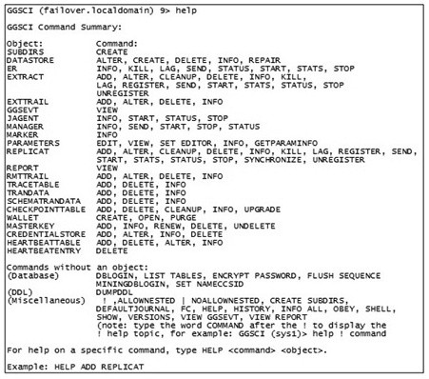

**Figure 4.1** GGSCI Available Commands

ERROR: Unable to delete credential store from ./dircrd/.

GGSCI (failover.localdomain) 14> add credentialstore Credential store created in ./dircrd/. GGSCI (failover.localdomain) 15> alter credentialstore add user ggate, password ggate, alias repuser Credential store in ./dircrd/ altered.

GGSCI (failover.localdomain) 16> info credentialstore Reading from ./dircrd/:

Default domain: OracleGoldenGate

Alias: repuser

Userid: ggate

#### Using Aliases in Parameter Files

The next step is to substitute the USERID entry in the source Extract process parameter fi le for an alias, replacing this:

USERID ggate@failover, PASSWORD ggate

with this, and thus reading the credentials into the Extract parameter fi le:

USERIDALIAS extuser

leaving the Extract process parameter fi le looking like this:

EXTRACT ext1 USERIDALIAS extuser rmthost failover, mgrport 7809 rmttrail /u01/app/oracle/product/12.1.0/oggcore_1/dirdat/lt ddl include mapped objname capture.*, include mapped objname bigdata.*, include mapped objname email.*, include mapped objname dmevents.* table capture.*; table bigdata.*; table email.*; table dmevents.*;

Next, one can also change the Replicat parameter fi le on the target server:

REPLICAT rep1

ASSUMETARGETDEFS

USERIDALIAS repuser DISCARDFILE /u01/app/oracle/product/12.1.0/oggcore_1/dirdat/ rep1_discard.txt, APPEND, MEGABYTES 10 DDL

--Maps tables from source to target

MAP CAPTURE.*, TARGET APPLI.*;

MAP bigdata.*, TARGET bigdata.*;

MAP email.*, TARGET email.*;

MAP dmevents.*, TARGET dmevents.*;

The Extract process was restarted and tested, and the same can be done with the Replicat process, restarting that Replicat process and testing it:

GGSCI (failover.localdomain as ggate@failover) 26> stop replicat rep1 Sending STOP request to REPLICAT REP1 ...

Request processed.

GGSCI (failover.localdomain as ggate@failover) 27> start replicat rep1 Sending START request to MANAGER ...

REPLICAT REP1 starting

GGSCI (failover.localdomain as ggate@failover) 28> DBLOGIN

USERIDALIAS repuser Successfully logged into database.

### 4.1.2 Password Encryption

There is more than one method of applying encryption for use with Oracle GoldenGate, where not only can database passwords be stored in encrypted form, but additionally all trail fi les can be sent across a network between source and target server in encrypted form. Encryption can also be stored locally on each server or centrally on a designated server. The simplest method of managing encrypted passwords is by using an encryption key stored in a local fi le, which can be used for password and trail encryption (trail encryption is out of the scope of this book). So in the GoldenGate home directory, generate one key using the following:

cd $ORACLE_GG . /keygen 128 1

The above returns a single key as follows:

[oracle@bigdata.localdomain oggcore_1-bigdata]$ ./keygen 128 1

0xDCA1D11DFBD43D644708B62E8CA6A725

Now save the key in a fi le in the GoldenGate home directory as a fi le called ENCKEYS, giving the key created a unique name like this:

[oracle@bigdata.localdomain oggcore_1-bigdata]$ cat ENCKEYS key1 0xDCA1D11DFBD43D644708B62E8CA6A725

The Extract trail on the source server can be encrypted by adding the following line to the Extract parameters fi le on the source, the demonstration of which is out of scope of this book:

ENCRYPTTRAIL AES128 KEYNAME key1

Encrypting a password in GoldenGate uses the ENCRYPT PASSWORD command inside GGSCI as follows:

ENCRYPT PASSWORD ggate AES128 ENCRYPTKEY key1

and the output should look like that shown below, describing an encrypted form of the password based on the encryption key created in the ENCKEYS fi le by using the keygen utility:

GGSCI (bigdata.localdomain) 2> ENCRYPT PASSWORD ggate AES128

ENCRYPTKEY key1 Encrypted password:

AADAAAAAAAAAAAFABEREACWDCIGHVGLAGGYHUGSAWAFDIFEIOIUBBEQHMILHSG

YCVCYEIISHFFXDOJNG

Algorithm used: AES128

The next step is to utilize the encrypted password so that the password is not stored in plain text in a fi le on a machine. Examine the DBLOGIN command syntax used for connecting in GGSCI to GoldenGate, clearly showing below the use of an encrypted password:

DBLOGIN { [SOURCEDB data_source] | [, database@host:port] |

USERID {/ | userid}[, PASSWORD password] [algorithm ENCRYPTKEY

{keyname | DEFAULT}] | USERIDALIAS alias [DOMAIN domain] |

[SYSDBA | SQLID sqlid] [SESSIONCHARSET character_set] }

So essentially, one can connect in GGSCI to an Oracle user by way of a user or an alias, as well as an encrypted password:

DBLOGIN USERID ggate, PASSWORD AADAAAAAAAAAAAFABEREACWDCIGHVGL

AGGYHUGSAWAFDIFEIOIUBBEQHMILHSGYCVCYEIISHFFXDOJNG, AES128, ENCRYPTKEY key1

and the result is a successful connection that does not expose a password, only the encrypted password:

GGSCI (bigdata.localdomain) 4> DBLOGIN USERID ggate, PASSWORD

AADAAAAAAAAAAAFABEREACWDCIGHVGLAGGYHUGSAWAFDIFEIOIUBBEQHMILHSG

YCVCYEIISHFFXDOJNG, AES128, ENCRYPTKEY key1 Successfully logged into database.

*Encrypted passwords do not apply to use of aliases in the Credential Store, because the credential store is already stored in the operating system as a binary encrypted wallet fi le.*

Placing an encrypted password into the Extract process parameter fi le is a simple matter of appropriately editing the Extract process parameter fi le on the source, and then restarting the Extract process:

EXTRACT ext1

USERID ggate, PASSWORD AADAAAAAAAAAAAFABEREACWDCIGHVGLAGGYHUGS AWAFDIFEIOIUBBEQHMILHSGYCVCYEIISHFFXDOJNG, AES128, ENCRYPTKEY key1 rmthost failover, mgrport 7809 rmttrail /u01/app/oracle/product/12.1.0/oggcore_1/dirdat/lt ddl include mapped objname capture.*, include mapped objname bigdata.*, include mapped objname email.*, include mapped objname dmevents.* table capture.*; table bigdata.*; table email.*; table dmevents.*;

Change the Extract process parameters fi le back and restart the Extract process:

EXTRACT ext1 USERIDALIAS extuser rmthost failover, mgrport 7809 rmttrail /u01/app/oracle/product/12.1.0/oggcore_1/dirdat/lt ddl include mapped objname capture.*, include mapped objname bigdata.*, include mapped objname email.*, include mapped objname dmevents.* table capture.*; table bigdata.*; table email.*; table dmevents.*;

In addition, we can remove the ENCKEYS fi les in the GoldenGate home directory $ORACLE_GGHOME using a command such as this:

[oracle@bigdata.localdomain oggcore_1-bigdata]$ rm -f ENCKEYS

## 4.2 Using the GGSCI Command Line Interface

Much of the needed information for working with GGSCI has been covered in previous chapters, but this section will fi ll in some of the gaps.

### 4.2.1 GGSCI Commands

All the commands available within the GGSCI command line interface are as shown in Table 4.1 (on next page), showing a list and application of each command type within the GGSCI command line interface.

Table 4.1 excludes a fi nal category of miscellaneous commands, which are as shown in the list of miscellaneous commands in Table 4.2.

A reference for all GGSCI commands can be found in

Chapter 1 of the Oracle GoldenGate book titled, Fusion

Middleware Reference for Oracle Golden-Gate for Windows® and *NIX, at the URL: [http://docs.oracle.com/ goldengate/c1221/gg-winux/GWURF/summary-oraclegoldengate-commands.htm](http://docs.oracle.com/goldengate/c1221/gg-winux/GWURF/summary-oraclegoldengate-commands.htm)

Demonstrating some of these commands inside GGSCI is as shown in the commands demonstrated below, executed from inside GGSCI:

cd $ORACLE_GG ggsci

The INFO ER * command returns information about all groups:

GGSCI (bigdata.localdomain) 1> info er *

EXTRACT EXT1 Last Started 2017-04-29 14:28 Status STOPPED

Checkpoint Lag 00:00:00 (updated 199:28:33 ago)

Log Read Checkpoint Oracle Redo Logs 2017-04-29 14:30:07 Seqno 284, RBA 4249600

SCN 0.4760913 (4760913)

and getting more specifi c about a particular group name pattern, which happens to be the only group on this source server:

GGSCI (bigdata.localdomain) 2> info er ext*

EXTRACT EXT1 Last Started 2017-04-29 14:28 Status STOPPED

Checkpoint Lag 00:00:00 (updated 199:32:08 ago)

Log Read Checkpoint Oracle Redo Logs 2017-04-29 14:30:07 Seqno 284, RBA 4249600

SCN 0.4760913 (4760913)

|  |  |  |  |  |  |  |  |  |  |  |  |  |  |  |  |  |  |  |  |  |  |  |  |  |  |  |  |  |  |  |  |  |  |
| --- | --- | --- | --- | --- | --- | --- | --- | --- | --- | --- | --- | --- | --- | --- | --- | --- | --- | --- | --- | --- | --- | --- | --- | --- | --- | --- | --- | --- | --- | --- | --- | --- | --- |
| **Table 4.1 GGSCI Available Commands** | |  |  |  |  |  |  |  |  |  |  |  |  |  |  |  |  | | --- | --- | --- | --- | --- | --- | --- | --- | --- | --- | --- | --- | --- | --- | --- | --- | | **GGSCI CommandDescription** | ManagerGoldenGate parent process | ExtractProcess to capture change in a source database | ReplicatProcess to apply change to a target database | ER *Issue Extract and Replicat commands to multiple Extract and Replicat groups | WalletEncryption and the master key wallet |  | TrailTrails used to store change made to a source before being applied to a target | les |  | guration for data produced from a source database | Checkpoint TableTracks the position of the Replicat process within a trail | Oracle Trace TableTracing prevents loopback between source and target databases | Data StoreMonitoring information storage | Monitor JAgentJAgent monitoring control | Automatic HeartbeatHeartbeat functionality between source and target databases | |  |  |  |  |  |  | Credential StoreCredential store details |  | ParameterParameter fi | DatabaseDatabase interaction | TrandataTransactional-level confi |  |  |  |  |  | |

|  |  |  |  |  |  |  |  |  |  |  |  |  |  |  |  |  |  |  |  |  |  |  |  |  |  |  |  |  |  |
| --- | --- | --- | --- | --- | --- | --- | --- | --- | --- | --- | --- | --- | --- | --- | --- | --- | --- | --- | --- | --- | --- | --- | --- | --- | --- | --- | --- | --- | --- |
| **Table 4.2 Miscellaneous Commands Available in the GGSCI Command Line Interface** | |  |  |  |  |  |  |  |  |  |  |  |  |  |  | | --- | --- | --- | --- | --- | --- | --- | --- | --- | --- | --- | --- | --- | --- | | **GGSCI CommandDescription** | Run previous command | le nesting | CREATE SUBDIRSDefault directory creation upon initial GoldenGate installation and confi  guration | FCChange and execute the previous command | HISTORYHistory of commands executed inside GGSCI | INFO ALLShow all process status settings | INFO MARKERProcess markers display | OBEYGroup lists of commands for later re-execution | SHELLRun shell commands inside GGSCI |  | VERSIONSOperating system and database versions | VIEW GGSEVTDisplay the ggserrlog fi  le | le created by Extract and Replicat processes | |  | ! | [  NO]ALLOWNESTEDOBEY command fi |  |  |  |  |  |  |  | SHOWAttributes display |  |  | VIEW REPORTDisplay discards fi | |

Here is a SHELL command executing a Linux ls command from inside the GGSCI tool:

GGSCI (bigdata.localdomain) 6> shell ls -larth total 618M -rw-r----- 1 oracle oinstall 1.5K Oct 15 2010 zlib.txt

-rw-r----- 1 oracle oinstall 759 Oct 15 2010 tcperrs

-rw-r----- 1 oracle oinstall 248 Oct 15 2010 sqlldr.tpl

-rw-r----- 1 oracle oinstall 1.7K Oct 15 2010 libxml2.txt … drwxr-x--- 2 oracle oinstall 4.0K Apr 29 14:28 dirrpt drwxr-x--- 2 oracle oinstall 4.0K Apr 29 14:30 dirpcs drwxr-xr-x 27 oracle oinstall 4.0K May 7 01:29 . -rw-r----- 1 oracle oinstall 365K May 7 22:02 ggserr.log

The SHOW command returns all attribute context settings inside the current instantiation of the GGSCI command:

GGSCI (bigdata.localdomain) 7> show

Parameter settings:

SET SUBDIRS ON

SET DEBUG OFF

Current directory: /u01/app/oracle/product/12.1.0/oggcore_1

Using subdirectories for all process files

Editor: vi

Reports (.rpt) /u01/app/oracle/product/12.1.0/ oggcore_1/dirrpt Parameters (.prm) /u01/app/oracle/product/12.1.0/ oggcore_1/dirprm Replicat Checkpoints (.cpr) /u01/app/oracle/product/12.1.0/ oggcore_1/dirchk Extract Checkpoints (.cpe) /u01/app/oracle/product/12.1.0/ oggcore_1/dirchk Process Status (.pcs) /u01/app/oracle/product/12.1.0/ oggcore_1/dirpcs

SQL Scripts (.sql) /u01/app/oracle/product/12.1.0/ oggcore_1/dirsql Database Definitions (.def) /u01/app/oracle/product/12.1.0/ oggcore_1/dirdef Dump files (.dmp) /u01/app/oracle/product/12.1.0/ oggcore_1/dirdmp Masterkey wallet files (.wlt) /u01/app/oracle/product/12.1.0/ oggcore_1/dirwlt Credential store files (.crd) /u01/app/oracle/product/12.1.0/ oggcore_1/dircrd

The VERSIONS command returns the versions of the operating system and database:

GGSCI (bigdata.localdomain) 8> versions Operating System:

Linux

Version #1 SMP Wed Aug 3 22:33:10 PDT 2016, Release

2.6.39-400.283.2.el5uek

Node: bigdata.localdomain

Machine: x86_64 Database:

ERROR: Not logged into database, use DBLOGIN.

Some of the VERSIONS command information requires a database connection within GGSCI:

GGSCI (bigdata.localdomain) 10> dblogin useridalias extuser Successfully logged into database.

GGSCI (bigdata.localdomain as ggate@bigdata) 11> versions Operating System:

Linux

Version #1 SMP Wed Aug 3 22:33:10 PDT 2016, Release

2.6.39-400.283.2.el5uek

Node: bigdata.localdomain

Machine: x86_64 Database:

Oracle Database 12c Enterprise Edition Release 12.1.0.2.0 -

64bit Production

PL/SQL Release 12.1.0.2.0 - Production

CORE 12.1.0.2.0 Production

TNS for Linux: Version 12.1.0.2.0 - Production

NLSRTL Version 12.1.0.2.0 – Production

### 4.2.2 More on the Manager Process

Inside the GGSCI tool, the Manager process can be stopped and started using the following, where MGR and MANAGER are synonymous and case is irrelevant:

START MANAGER START MGR start manager start mgr STOP MANAGER STOP MGR stop manager stop mgr

Using the ! mark with the STOP MANAGER command removes the prompt:

GGSCI (bigdata.localdomain) 19> stop mgr Manager process is required by other GGS processes.

Are you sure you want to stop it (y/n)?y

Sending STOP request to MANAGER ...

Request processed. Manager stopped.

and with the prompt removed:

GGSCI (bigdata.localdomain) 20> start mgr Manager started.

GGSCI (bigdata.localdomain) 21> stop mgr!

Sending STOP request to MANAGER ...

Request processed.

Manager stopped.

The Manager process can also be started in an operating system shell using the MGR command, as follows:

mgr paramfile /u01/app/oracle/product/12.1.0/oggcore_1/dirprm/ mgr.prm

*There is an optional reportfi le argument that can store a report called the “Manager process report,” which is normally stored in the report fi les (/u01/app/oracle/ product/ 12.1.0/oggcore_1/dirrpt ) subdirectory.*

#### Process Parameters

The current Manager process parameters fi le thus far built for this book contain a single line, which is just a port, which is the default GoldenGate port for communicating between source and target databases. The Manager process parameter fi le can be edited using the EDIT PARAMS MGR command inside GGSCI, as well as editing the fi le that can be listed on screen using the cat command as shown below: cat /u01/app/oracle/product/12.1.0/oggcore_1/dirprm/mgr.prm

and the result looks like this:

[oracle@bigdata.localdomain oggcore_1-bigdata]$ cat /u01/app/ oracle/product/12.1.0/oggcore_1/dirprm/mgr.prm PORT 7809

In addition, there are a number of other useful Manager process parameters, as described below:

* AUTOSTART automatically starts Extract and Replicat processes when the Manager process starts. AUTORESTART does the same but only after abnormal termination.
* PURGEOLDEXTRACTS clears trails after processing is complete, without which the trail fi les can grow to consume too much, even perhaps all, available disk space and cause a server crash.
* STARTUPVALIDATIONONDELAY[SECS] delays validation of other processes after the Manager process has begun, such as Extract and Replicat processes.

And below is an example Manager process parameters fi le on the source for the Extract process:

PORT 7809

ACCESSRULE, PROG *, ALLOW

AUTOSTART

STARTUPVALIDATIONDELAY 2 PURGEOLDEXTRACTS /u01/app/oracle/product/12.1.0/oggcore_1/ dirdat/lt*

and on a target for a Replicat process:

PORT 7809

ACCESSRULE, PROG *, ALLOW

AUTOSTART

STARTUPVALIDATIONDELAY 2

The above confi guration will yield an error on the source when starting the Extract process, if the Replicat process is not fi rst started on a target.

### 4.2.3 More on the Extract and Replicat Processes

Sometimes when starting and stopping the Extract and Replicat processes, those processes cannot be stopped easily and can only be killed with the following syntax, but note that replicated changes could be lost: kill { extract | replicat } <group-names>

In addition, commands can be executed using a wildcard catering to all items within a group, such as killing all processes on a server: stop er *

or killing the processes if no response is received:

kill er *

Conversely, the following command will start up all group processes on the server concerned: start extract *

Wildcards can also be used with other commands—for example, where the following command will start all processes named as *1, such as an Extract process called ext1 and an Extract process called anotherext1: start extract *1

*Deleting, registering, and unregistering Extract and Replicat process groups has already been covered in a previous chapter.*

### 4.2.4 Automation in GGSCI

Automation can be executed using the HISTORY command, as a script redirected in a shell into GGSCI, and also as a fi le name added as the parameter to the OBEY command within the GGSCI tool.

#### The GGSCI HISTORY Command

The HISTORY command can be used inside GGSCI to display and re-execute commands that have already been typed into a currently open GGSCI session, meaning that simply executing the GGSCI tool without anything started results in no command history:

GGSCI (bigdata.localdomain) 1> history

GGSCI Command History

1: history

So some processing was executed to start the Manager on the source, start the Manager on the target, start Replicat on the target, followed by starting Extract on the source, and fi nally stopping everything on both source and target—so the source history is:

GGSCI (bigdata.localdomain) 11> history

GGSCI Command History

2: help

3: start mgr

4: info all

5: start extract ext1

6: info all

7: view ggsevt

8: info all

9: start extract ext1

10: info all

11: history

12: stop ER *

13: info all

14: stop mgr

15: info all

16: history

and the target history is:

GGSCI (failover.localdomain) 4> history

GGSCI Command History

1: start mgr

2: start replicat rep1

3: info all

4: history

5: stop ER *

6: info all 7: stop mgr!

8: info all

9: history

So on the source one could re-execute a previous command using the ! command on the target and pull up the history again:

GGSCI (failover.localdomain) 10> !9 history GGSCI Command History

1: start mgr

2: start replicat rep1

3: info all

4: history

5: stop ER *

6: info all 7: stop mgr!

8: info all

9: history

10: history

The FC command can be used to edit and re-execute that edited command—the Enter key must be hit twice when the number line 11 [GGSCI (failover.localdomain) 11..] line appears, as shown below, substituting stop mgr! with start mgr:

GGSCI (failover.localdomain) 11> FC 14 GGSCI (failover.localdomain) 11> stop mgr!

GGSCI (failover.localdomain) 11..start mgr GGSCI (failover.localdomain) 11..

Manager started.

GGSCI (failover.localdomain) 22> info all

Program Status Group Lag at Chkpt Time Since Chkpt

MANAGER RUNNING

REPLICAT STOPPED REP1 00:00:00 00:10:17

*More details on how to use the FC command can be found*

*at the URL:* [*https://docs.oracle.com/goldengate/1212/ggwinux/GWURF/ggsci_commands.htm#GWURF110*](https://docs.oracle.com/goldengate/1212/ggwinux/GWURF/ggsci_commands.htm#GWURF110)

#### Automating GGSCI Commands in Scripts Using the OBEY Command

A fi le containing commands can be redirected into the GGSCI utility from what GoldenGate calls an OBEYfi le:

ggsci < OBEYfile.in

The following OBEYfi le example will stop the Extract and Manager processes on the source server using a script and return to the operating system prompt:

$ cat obeyextract.txt stop extract ext1 stop mgr! info all

The result is as shown below, where the stop mgr! command does not return a prompt:

$ ggsci < obeyextract.txt

Oracle GoldenGate Command Interpreter for Oracle

Version 12.2.0.1.1 OGGCORE_12.2.0.1.0_PLATFORMS_151211.1401_FBO

Linux, x64, 64bit (optimized), Oracle 12c on Dec 12 2015

02:56:48 Operating system character set identified as UTF-8.

Copyright (C) 1995, 2015, Oracle and/or its affiliates. All rights reserved.

GGSCI (bigdata.localdomain) 1> Sending STOP request to EXTRACT EXT1 ...

Request processed.

GGSCI (bigdata.localdomain) 2> Sending STOP request to MANAGER ...

Request processed.

Manager stopped.

GGSCI (bigdata.localdomain) 3>

Program Status Group Lag at Chkpt Time Since Chkpt

MANAGER STOPPED

EXTRACT STOPPED EXT1 00:00:00 00:00:03

The OBEY command can be used within the GGSCI tool to execute a set of commands as a script:

GGSCI (bigdata.localdomain) 5> OBEY obeyextract.txt

GGSCI (bigdata.localdomain) 6> stop extract ext1 Sending STOP request to EXTRACT EXT1 ...

Request processed.

GGSCI (bigdata.localdomain) 7> stop mgr!

Sending STOP request to MANAGER ...

Request processed.

Manager stopped.

GGSCI (bigdata.localdomain) 8> info all

Program Status Group Lag at Chkpt Time Since Chkpt

MANAGER STOPPED

EXTRACT STOPPED EXT1 00:00:00 00:00:05

### 4.2.5 Working with Parameters and Parameter Files

Parameters and parameter fi les are divided up into eight separate sections:

* **GLOBALS.** Applies to an entire server and not each specifi c process
* **Manager.** Manages processes and resources for a server
* **Parameters.** Common to Extract and Replicat
* **Extract.** Specifi c to the Extract process
* **Replicat.** Specifi c to the Replicat process
* **Wildcard Exclusion.** Works on groups of processes
* **DEFGEN.** A fi le containing differences in defi nitions of data between source and target
* **DDL.** Control of DDL support

All of the GoldenGate parameters do not need to be listed in this book and can be referred to at this URL:

[http://docs.oracle.com/goldengate/c1221/gg-winux/GWURF/ summary-oracle-goldengate-parameters.htm#GWURF978](http://docs.oracle.com/goldengate/c1221/gg-winux/GWURF/summary-oracle-goldengate-parameters.htm#GWURF978)

Parameters can be viewed inside the GGSCI tool using the VIEW PARAMS <process name> fi le:

GGSCI (bigdata.localdomain) 9> view params ext1

EXTRACT ext1 USERIDALIAS extuser rmthost failover, mgrport 7809 rmttrail /u01/app/oracle/product/12.1.0/oggcore_1/dirdat/lt ddl include mapped objname capture.*, include mapped objname bigdata.*, include mapped objname email.*, include mapped objname dmevents.* table capture.*; table bigdata.*; table email.*; table dmevents.*;

Parameter fi les can also be cross-checked and verifi ed in the operating system using the CHECKPRM utility:

[oracle@bigdata.localdomain oggcore_1-bigdata]$ checkprm /u01/ app/oracle/product/12.1.0/oggcore_1/dirprm/ext1.prm 2017-04-29 15:05:05 INFO OGG-10139 Parameter file /u01/ app/oracle/product/12.1.0/oggcore_1/dirprm/ext1.prm: Validity check: PASS. Runtime parameter validation is not reflected in the above check.

## 4.3 GoldenGate Backups

The simplest method of backup for a GoldenGate installation is to back up all source and target databases, but also to include backup copies of the entire GoldenGate home directory with all GoldenGate processes not running at the time of the backup snapshot. Group all fi les and compress the result using a simple tar command, with compression such as that below:

[oracle@bigdata.localdomain oggcore_1-bigdata]$ cd /backups [oracle@bigdata.localdomain oggcore_1-bigdata]$ tar cvfz / backups/ggate.tar.gz $ORACLE_GG/*

**4.4 So What’s Next?**

This chapter has demonstrated some basic administration and confi guration of Oracle GoldenGate covering credentials, as well as the use of the GGSCI tool. This information is important to cover before proceeding further, because it is necessary to fi ll in some detail not covered in previous chapters. The next chapter will begin to dig into real-life scenarios utilizing GoldenGate, beginning with how to initially load the state of a current source database into a replicated target database.

# Chapter 5 Loading Data into GoldenGate



The goal of this chapter is to load data from a source database into a target, and thus it makes sense to begin from scratch with both a new database as well as a cleanly deinstalled and reinstalled GoldenGate installation; instructions in Chapter 7 can be used to clean up and recreate the previously built GoldenGate installation. Two loading examples are included in this chapter, which include a cold copy of an entire database using data pump, as well as a hot copy of a single table using SQL*Loader.

93

## 5.1 Cold Copying a Database with Data Pump

The simple way to create a target database is to build it from scratch, creating a new database on the target, restoring from the source, and adding in the GoldenGate confi guration on the target to initiate the replication process. Start with a full export on the source database, beginning by fi nding the default DATA_PUMP_DIR location as shown in Figure 5.1.

Export the application schemas on the source:

expdp system/password@bigdata schemas=dimensions,email,facts, facts_events,finance directory=DATA_PUMP_DIR dumpfile=source. dmp logfile=source.log

Copy the exported fi le to the target server into the target server DATA_PUMP_DIR:

scp source.dmp oracle@failover.localdomain:/u02/app/oracle/ admin/failover/dpdump/

Import the application schemas on the target into a cleanly installed database:

impdp system/***@failover schemas=

dimensions,email,facts,facts_events,finance directory=DATA_ PUMP_DIR dumpfile=source.dmp logfile=source.log And now set the transaction logging on the source:

cd $ORACLE_GG ggsci DBLOGIN USERID ggate, PASSWORD ggate

ADD SCHEMATRANDATA dimensions

ADD SCHEMATRANDATA email

ADD SCHEMATRANDATA facts

ADD SCHEMATRANDATA facts_events

ADD SCHEMATRANDATA finance

Start up replication on both source and target, and test on the source:

START MGR

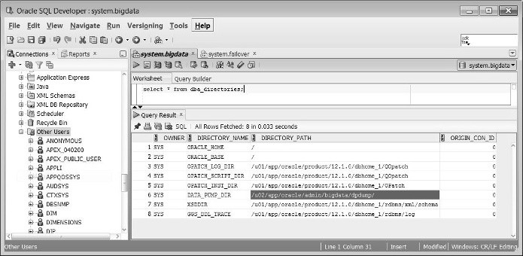

**Figure 5.1**

Finding the DATA_PUMP_DIR Location

START EXTRACT ext1 INFO ALL on the target:

START MGR

START REPLICAT rep1

INFO ALL

Test on the source:

sqlplus facts/facts@bigdata CREATE TABLE test(id INTEGER PRIMARY KEY);

INSERT INTO test(id) VALUES(1);

COMMIT;

Validate on the target:

sqlplus facts/facts@failover SELECT * FROM test;

### 5.1.1 Recovering with Data Pump up to a System Change Number (SCN)

An export can be used to create a copy of data at a specifi c point in time using an SCN number retrieved as follows, starting on the source:

sqlplus / as sysdba SQL> select current_scn from v$database;

CURRENT_SCN

-----------

5727018

Next export up to the SCN using fl ashback, where the export will fl ashback in time to an SCN, not including any changes after that SCN:

expdp system/****@bigdata schemas=dimensions,email, facts,facts_events,finance directory=DATA_PUMP_DIR

dumpfile=source.flashback.dmp logfile=source.flashback.log flashback_scn=5727018

Copy the fi le from the source to the target:

scp /u02/app/oracle/admin/bigdata/dpdump/source.flashback.dmp oracle@failover:/u02/app/oracle/admin/failover/dpdump/

Import the same way on the target but this time creating a new schema called TMP:

impdp system/****@failover schemas=dimensions remap_ schema=dimensions:tmp directory=DATA_PUMP_DIR dumpfile=source. flashback.dmp logfile=source.flashback.log

Now change the parameter fi le on the source in GGSCI:

ggsci edit params ext1

Add the TMP schema:

EXTRACT ext1 USERID ggate, password ggate rmthost failover, mgrport 7809 rmttrail /u01/app/oracle/product/12.1.0/oggcore_1/dirdat/lt ddl include mapped objname capture.*, include mapped objname dimensions.*, include mapped objname email.*, include mapped objname facts.* , include mapped objname facts_events.* , include mapped objname finance.* table DIMENSIONS.*; table EMAIL.*; table FACTS.*; table FACTS_EVENTS.*; table FINANCE.*; table TMP.*; and change the Replicat parameters on the target by running GGSCI:

ggsci edit params rep1 and adding the mapping for the TMP schema:

REPLICAT rep1

ASSUMETARGETDEFS

USERID ggate, PASSWORD ggate DISCARDFILE /u01/app/oracle/product/12.1.0/oggcore_1/dirdat/ rep1_discard.txt, APPEND, MEGABYTES 10 DDL

--Maps tables from source to target

MAP CAPTURE.*, TARGET APPLI.*;

MAP DIMENSIONS.*, TARGET DIMENSIONS.*;

MAP EMAIL.*, TARGET EMAIL.*;

MAP FACTS.*, TARGET FACTS.*;

MAP FACTS_EVENTS.*, TARGET FACTS_EVENTS.*;

MAP FINANCE.*, TARGET FINANCE.*; MAP TMP.*, TARGET TMP.*; and simply start up Extract on the source:

start mgr start extract ext1 and start up Replicat on the target up to the appropriate CSN:

start mgr

start replicat rep1, aftercsn 5727018

*A GoldenGate Commit Sequence Number (CSN) is the equivalent of an Oracle System Change Number (SCN).*

Now clean up by dropping the TMP user and removing TMP from the Extract and Replicat parameter fi les.

## 5.2 Hot Copying a Single Table with SQL*Loader

A hot copy allows for the replication of not as yet replicated changes, down to the individual table-level, from source to target. Begin by creating a new schema on the source:

drop user test cascade; create user test identified by test; GRANT UNLIMITED TABLESPACE TO test; create table test.testload(string1 varchar2(32)); insert into test.testload values('testing this one'); commit;

And next create a new schema on the target:

drop user test2 cascade; create user test2 identified by test; GRANT UNLIMITED TABLESPACE TO test2;

create table test2.testload(string1 varchar2(32));

Next add the following line to the target manager process parameter fi le on the target:

edit params mgr and add the following line and restart the manager process:

**ACCESSRULE, PROG *, IPADDR 10.29.102.156, ALLOW** Next start the manager on both source and target: start mgr

Next on the target database: grant lock any table to ggate;

On the source use SOURCEISTABLE to read rows from table to table:

add extract ext2, sourceistable

Add these parameters to the new Extract process ext2 on the source:

EXTRACT ext2

USERID ggate, password ggate

RMTHOST failover, MGRPORT 7809

RMTTASK replicat, GROUP rep2

TABLE test.*;

Add these parameters to the new Replicat process rep2 on the target:

REPLICAT rep2

USERID ggate, password ggate

BULKLOAD

ASSUMETARGETDEFS

MAP test.*, TARGET test2.*;

Start the Extract process on the source: **start extract ext2**

Running VIEW SSGEVT, this is what appears on the source:

2018-03-16 00:28:07 INFO OGG-00975 Oracle GoldenGate Manager for Oracle, mgr.prm: EXTRACT EXT2 starting.

2018-03-16 00:28:07 INFO OGG-01017 Oracle GoldenGate

Capture for Oracle, ext2.prm: Wildcard resolution set to IMMEDIATE because SOURCEISTABLE is used.

2018-03-16 00:28:07 INFO OGG-00992 Oracle GoldenGate Capture for Oracle, ext2.prm: EXTRACT EXT2 starting.

2018-03-16 00:28:07 INFO OGG-03059 Oracle GoldenGate Capture for Oracle, ext2.prm: Operating system character set identified as UTF-8. 2018-03-16 00:28:07 INFO OGG-02695 Oracle GoldenGate Capture for Oracle, ext2.prm: ANSI SQL parameter syntax is used for parameter parsing.

2018-03-16 00:28:08 INFO OGG-03522 Oracle GoldenGate Capture for Oracle, ext2.prm: Setting session time zone to source database time zone '-05:00'. 2018-03-16 00:28:08 INFO OGG-06508 Oracle GoldenGate

Capture for Oracle, ext2.prm: Wildcard MAP (TABLE) resolved (entry test.*): TABLE “TEST”.”TESTLOAD”.

2018-03-16 00:28:08 WARNING OGG-06439 Oracle GoldenGate Capture for Oracle, ext2.prm: No unique key is defined for table TESTLOAD. All viable columns will be used to represent the key, b ut may not guarantee uniqueness. KEYCOLS may be used to define the key. 2018-03-16 00:28:08 INFO OGG-06509 Oracle GoldenGate Capture for Oracle, ext2.prm: Using the following key columns for source table TEST.TESTLOAD: STRING1. 2018-03-16 00:28:08 INFO OGG-01851 Oracle GoldenGate Capture for Oracle, ext2.prm: filecaching started: thread ID:

139679175055680.

2018-03-16 00:28:08 INFO OGG-01815 Oracle GoldenGate Capture for Oracle, ext2.prm: Virtual Memory Facilities for: COM anon alloc: mmap(MAP_ANON) anon free: munmap file alloc: mmap(MAP_SHARED) file free: munmap target directories: /u01/app/oracle/product/12.1.0/oggcore_1/dirtmp.

2018-03-16 00:28:08 INFO OGG-00993 Oracle GoldenGate Capture for Oracle, ext2.prm: EXTRACT EXT2 started.

2018-03-16 00:28:10 INFO OGG-00987 Oracle GoldenGate Command Interpreter for Oracle: GGSCI command (oracle): info all.

On the target system, fi nd a similar trail of information showing success using the VIEW REPORT command, as follows:

**************************************************************

** Run Time Messages **

************************************************************** 2018-03-16 13:13:44 INFO OGG-03522 Setting session time zone to source database time zone '-05:00'.

2018-03-16 13:13:44 WARNING OGG-02760 ASSUMETARGETDEFS is ignored because trail file contains table definitions.

2018-03-16 13:13:44 INFO OGG-06506 Wildcard MAP resolved (entry test.*): MAP “TEST”.”TESTLOAD”, TARGET test2.”TESTLOAD”.

2018-03-16 13:14:08 WARNING OGG-06439 No unique key is defined for table TESTLOAD. All viable columns will be used to represent the key, but may not guarantee uniqueness. KEY COLS may be used to define the key.

2018-03-16 13:14:08 INFO OGG-02756 The definition for table TEST.TESTLOAD is obtained from the trail file.

2018-03-16 13:14:08 INFO OGG-06511 Using following columns in default map by name: STRING1.

2018-03-16 13:14:08 INFO OGG-06510 Using the following key columns for target table TEST2.TESTLOAD: STRING1.

2018-03-16 13:14:08 INFO OGG-00178 owner = “TEST2”, table = “TESTLOAD”.

Now that the load is completed, which is very useful for individual tables, start the Replicat process on the source:

start replicat rep2 info replicat rep2 and you should get something like this:

GGSCI (failover.localdomain) 32> start replicat rep2 Sending START request to MANAGER ...

REPLICAT REP2 starting

GGSCI (failover.localdomain) 33> info replicat rep2

REPLICAT REP2 Initialized 2018-03-16 12:54 Status

STOPPED

Checkpoint Lag 00:00:00 (updated 00:30:44 ago)

Log Read Checkpoint Not Available

Task SPECIALRUN

GGSCI (failover.localdomain) 34>

Next we can stop and remove the ext2 and rep2 processes and restart the initial ext1 and rep1 processes on the source and target servers, respectively—on the source: delete extract ext2 and remove the parameters in the parameter fi le: edit params ext2

On the target do the same:

delete replicat rep2 edit params rep2

Next remove the change from the target manager process parameter fi le:

ACCESSRULE, PROG *, IPADDR 10.29.102.156, ALLOW and start the original Extract and Replicat process and test—on the target: start replicat rep1 and on the source: start extract ext1

And test on the source:

sqlplus dimensions/dimensions@bigdata INSERT INTO test(id) VALUES(9); Commit; and on the target:

[oracle@failover.localdomain oggcore_1-failover]$ sqlplus dimensions/dimensions@bigdata

SQL*Plus: Release 12.1.0.2.0 Production on Fri Mar 16 13:42:21

2018 Copyright (c) 1982, 2014, Oracle. All rights reserved. Last Successful login time: Fri Mar 16 2018 00:53:37 -04:00

Connected to:

Oracle Database 12c Enterprise Edition Release 12.1.0.2.0 -

64bit Production

With the Partitioning, OLAP, Advanced Analytics and Real

Application Testing options SQL> select * from dimensions.test;

ID

----------

1

2

3

5

9

## 5.3 Other Load Options

There are numerous other methods of loading data from source to target in addition to export and SQL*Loader, which include the following:

* Copying and restoring a shut down cold copy of all database fi les.
* Using something called transportable tablespaces to copy an Oracle® database at the fi le level in the operating system.
* Using an RMAN backup from the source to recover on the target, and then recover up to an Oracle Database System Change Number (SCN). An SCN represents a point in time of the logging history of an Oracle database, and recovering up to an SCN writes log entries back into a restored database, then reapplies past changes to that database that are used to roll the target forward in time until the database is recovered.
* GoldenGate allows copying of data into and out of non-Oracle data-bases such as SQL Server, which is known as heterogeneous replication. Homogeneous replication includes the same database engine and version on both the source and target servers.

In reality, the easiest way to instantiate a target GoldenGate replicated database is to copy the source to the target in the simplest way, start up GoldenGate, and it is done. It is, however, possible to use a hot copy, leaving both the source and target databases running and applying changes to the target after the initial load of the target from a fi xed-in-time copy.

Parallel processing can be used in Oracle databases to speed up loading of large amounts of data on large machines with many CPUs, where in its simplest form multiple Extract and Replicat processes can be used to parallel process multiple parallel streams of data copying from a source to a target server.

**5.4 So What’s Next?**

This chapter has demonstrated some basic methods of loading a target database from an Oracle source to a target master-to-slave replication confi guration. This information is important to cover because it allows for a simple introduction of instantiation of a target replicated database, similar to the topic of the next chapter of synchronization.

# Chapter 6 Applying Replication



The goal of this chapter is to describe different ways in which GoldenGate can be applied that do not involve only replication. These applications include live reporting, standby, distribution, data warehouse consolidation, and high availability.

107

## 6.1 Using GoldenGate for Live Reporting

GoldenGate can be used to create two separate databases (source and target), updated automatically in one direction, where the target is used as the reporting database. The result is the removal of the overhead of the reporting function from the source database, freeing up resources for processing to allow the source database to perform the primary function of the business, and that primary function might not be backup or reporting. In addition, reporting can be more effi cient when separated from different types of functionality on the source, particularly for a transaction processing database supporting a busy website. Figure 6.1 shows a simplistic view of the most basic GoldenGate applied confi guration, the demonstration of which is described in previous chapters.

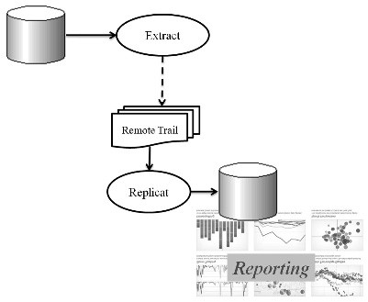

**Figure 6.1** Removing Live Reporting to a GoldenGate Target

Figure 6.2 shows a live reporting connection to the source database (BIGDATA) and a reporting database, which as already stated can help to remove reporting activity from the source database, taking pressure off the primary activity of the business.

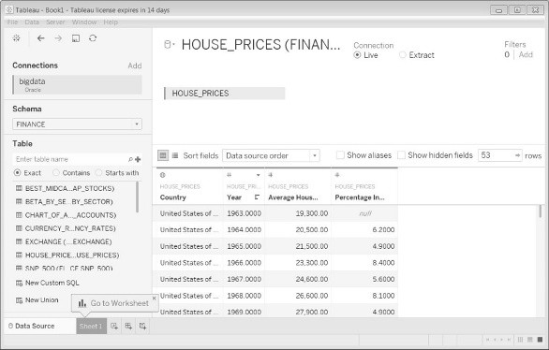

**Figure 6.2**

Reporting on the Source Can Overtax the Resources of the Source Database

As shown in Figure 6.3, add the target database (FAILOVER), thereby relieving the added pressure of reporting activity from the source database.

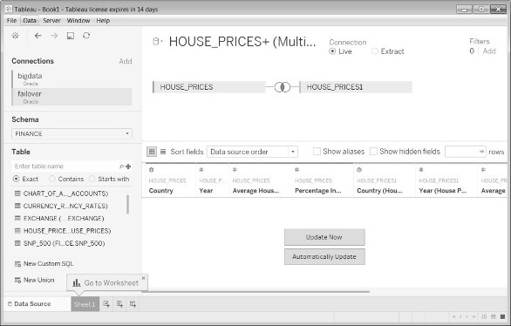

**Figure 6.3**

Adding the Target Database to the Reporting Tool

Figure 6.4 now removes the source connection from the reporting tool and executes a report on the target only.

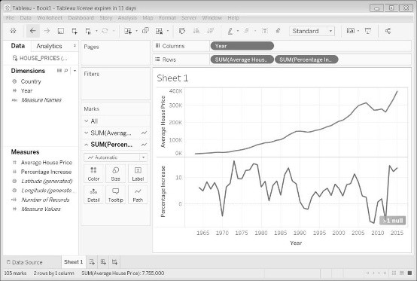

**Figure 6.4**

The target Database Can Execute Reports and Remove Some Processing from the Source

## 6.2 Using GoldenGate for a Standby/ Failover Database

The architecture of standby with GoldenGate is very simple, in that the processes from source to target are created and enabled, but the processes in reverse, from target to source, are created but disabled until a switchover (if required), as shown in Figure 6.5.

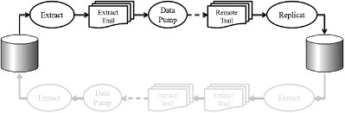

**Figure 6.5** Active Standby from Source to Target

*GoldenGate as a standby is not an automated fail over. Oracle Standby (not GoldenGate) does allow an automated switchover. Oracle standby functions directly from log fi les, whereas GoldenGate is slower, creating trail fi les and possible data pump processes as additional interim steps.*

When and if there is a reason to switch source and target, then the source processes are disabled, followed by the target processes being enabled, thus reversing the source and target databases, as shown in Figure 6.6.

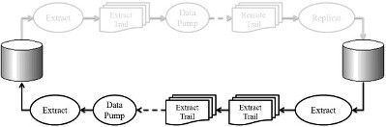

**Figure 6.6** Temporary Standby from Target to Source

When the problem is resolved or source database maintenance is completed, then the best option is to switch back to the original default confi guration. GoldenGate excels as a standby database option when the two databases are completely different, such as Oracle® on the source and MySQL on the target, because GoldenGate replicates at the transactional level, and even though slower than the log shipping and recovery architecture of a real standby database in Oracle Database, GoldenGate provides a simplicity and versatility that physical copying using Oracle Standby simply cannot match.

### 6.2.1 Implementing Standby for Two Oracle Databases Using GoldenGate

The fi rst thing to do is to make sure that the manager is running on both source and target, as well as the Extract on the source and Replicat on the target. So on the source:

GGSCI (bigdata.localdomain) 4> info all

Program Status Group Lag at Chkpt Time Since Chkpt

MANAGER RUNNING EXTRACT RUNNING EXT1 00:00:00 75:37:54 and on the target:

GGSCI (failover.localdomain) 3> info all

Program Status Group Lag at Chkpt Time Since Chkpt

MANAGER RUNNING

REPLICAT RUNNING REP1 00:00:00 00:00:01

And let’s test replication from source to target. So on the source in SQLPLUS:

SQL> INSERT INTO test(id) VALUES(99); 1 row created.

SQL> commit; Commit complete.

and on the target:

SQL> select * from test;

ID

----------

1

2

3

5

9

99

6 rows selected.

Next we must confi gure the target, but without turning it on, beginning with schema-level logging:

cd $ORACLE_GG ggsci DBLOGIN USERID ggate, PASSWORD ggate

ADD SCHEMATRANDATA dimensions

ADD SCHEMATRANDATA email

ADD SCHEMATRANDATA facts

ADD SCHEMATRANDATA facts_events

ADD SCHEMATRANDATA finance

Execute these procedures on the target:

sqlplus / as sysdba @marker_setup.sql

@ddl_setup.sql @role_setup.sql grant GGS_GGSUSER_ROLE to ggate; @ddl_enable.sql

Create the Extract process on the target, the extract trail on the target, link it into the Extract process, and fi nally edit (create) the extract parameters on the target:

ADD EXTRACT ext2, TRANLOG, BEGIN NOW ADD EXTTRAIL /u01/app/oracle/product/12.1.0/oggcore_1/dirdat/ lt, EXTRACT ext2 EDIT PARAMS ext2

This is the content of the ext2 extract parameters fi le on the target:

EXTRACT ext2 USERID ggate, password ggate rmthost failover, mgrport 7809 rmttrail /u01/app/oracle/product/12.1.0/oggcore_1/dirdat/lt ddl include mapped objname dimensions.*, include mapped objname email.*, include mapped objname facts.* , include mapped objname facts_events.* , include mapped objname finance.* table DIMENSIONS.*; table EMAIL.*; table FACTS.*; table FACTS_EVENTS.*; table FINANCE.*;

Create the checkpoint table on the source in the global parameters fi le:

ggsci EDIT PARAMS ./GLOBAL

And add these lines to the ./GLOBAL parameters fi le on the source:

GGSCHEMA ggate

CHECKPOINTTABLE ggate.CHECKPOINT

Connect as the GGATE user on the source:

DBLOGIN USERID ggate, PASSWORD ggate

ADD CHECKPOINTTABLE ggate.CHECKPOINT

Next add the Replicat group on the source and link between the extract trail and the checkpoint table:

ADD REPLICAT rep2, EXTTRAIL /u01/app/oracle/product/12.1.0/ oggcore_1/dirdat/lt, CHECKPOINTTABLE ggate.CHECKPOINT Edit the Replicat parameters fi le on the source:

EDIT PARAMS rep2

Add these parameters to the Replicat parameters fi le on the source:

REPLICAT rep2

ASSUMETARGETDEFS

USERID ggate, PASSWORD ggate DISCARDFILE /u01/app/oracle/product/12.1.0/oggcore_1/dirdat/ rep1_discard.txt, APPEND, MEGABYTES 10 DDL

--Maps tables from source to target

MAP DIMENSIONS.*, TARGET DIMENSIONS.*;

MAP EMAIL.*, TARGET EMAIL.*;

MAP FACTS.*, TARGET FACTS.*;

MAP FACTS_EVENTS.*, TARGET FACTS_EVENTS.*;

MAP FINANCE.*, TARGET FINANCE.*; So we now have this on the source:

GGSCI (bigdata.localdomain as ggate@bigdata) 6> info all

Program Status Group Lag at Chkpt Time Since Chkpt

MANAGER RUNNING

EXTRACT RUNNING EXT1 00:00:00 00:00:03

REPLICAT STOPPED REP2 00:00:00 00:01:52

and this on the target:

GGSCI (failover.localdomain) 3> info all

Program Status Group Lag at Chkpt Time Since Chkpt

MANAGER RUNNING

EXTRACT STOPPED EXT2 00:00:00 00:04:59

REPLICAT RUNNING REP1 00:00:00 00:00:00

Let’s make sure that the original source-to-target replication still works.

So on the source:

SQL> insert into test(id) values(101); 1 row created.

SQL> commit; Commit complete.

and the new row appears on the target:

SQL> select * from test;

ID

----------

1

2

3

5

9

99

101

7 rows selected.

Now let’s make the switchover in the following sequence beginning with the source:

STOP EXTRACT ext1 On the target:

STOP REPLICAT rep1 On the source:

START REPLICAT rep2 On the target:

START EXTRACT ext2

The source should now look like this:

GGSCI (bigdata.localdomain) 6> info all

Program Status Group Lag at Chkpt Time Since Chkpt

MANAGER RUNNING

EXTRACT STOPPED EXT1 00:00:00 00:00:40

REPLICAT RUNNING REP2 00:00:00 00:00:08

and the target should now look like this:

GGSCI (failover.localdomain) 3> info all

Program Status Group Lag at Chkpt Time Since Chkpt

MANAGER RUNNING

EXTRACT RUNNING EXT2 00:00:00 00:15:35

REPLICAT STOPPED REP1 00:00:00 00:00:35 And the target is now the primary:

SQL> insert into test(id) values(102); 1 row created.

SQL> commit; Commit complete. with the source being the secondary:

SQL> select * from test;

ID

----------

1

2

3

5

9

99

101

102

8 rows selected.

The process can be reversed by stopping the ext2 and rep2 processes and by restarting the ext1 and rep1 processes. We can then run these on the target in SQLPLUS:

@ddl_disable.sql;

@ddl_remove.sql;

@marker_remove.sql;

And in GGSCI on the target:

DBLOGIN USERID ggate, PASSWORD ggate

DELETE SCHEMATRANDATA dimensions

DELETE SCHEMATRANDATA email

DELETE SCHEMATRANDATA facts

DELETE SCHEMATRANDATA facts_events DELETE SCHEMATRANDATA finance On the target:

DELETE EXTRACT ext2

UNREGISTER EXTRACT ext2 DATABASE On the source:

DELETE REPLICAT rep2

UNREGISTER REPLICAT rep2 DATABASE

And fi nally restart ext1 on the source and rep1 on the target, and then test on the source:

SQL> insert into test(id) values(105); 1 row created.

SQL> commit; Commit complete. and on the target:

SQL> select * from test;

ID

----------

1

2

3

5

9

99

101

102

105

9 rows selected.

That is a clear demonstration of a standby database implementation using Oracle GoldenGate.

## 6.3 Using GoldenGate for Data Distribution to Many Targets

Distribution can be confi gured to execute replication from a single source database to two or more other master-to-slave replications. Distribution can be used to (1) spread data to multiple locations for ease of access, (2) localized performance, (3) backup copies, (4) for reporting, or (5) even to allow for network or hardware failure onto one of the targets, or (6) even a combination of all of these. Figure 6.7 shows a basic structure in which a single source database of replicating changes sends changes from one source and on to three separate target databases all at the same time.

***6.3.1 Implementing Data Distribution to Two Targets*** So begin with the source machine:

GGSCI (bigdata.localdomain) 6> info all

Program Status Group Lag at Chkpt Time Since Chkpt

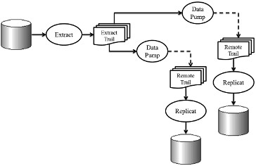

**Figure 6.7** Distributing Data from a Single Source to Two or More Targets

MANAGER RUNNING

EXTRACT RUNNING EXT1 00:00:00 38:47:44

Next we need to add two data pumps on the source, where each data pump talks to each separate target:

ADD EXTRACT pump1, EXTTRAILSOURCE /u01/app/oracle/ product/12.1.0/oggcore_1/dirdat/l1, BEGIN NOW ADD EXTRACT pump2, EXTTRAILSOURCE /u01/app/oracle/ product/12.1.0/oggcore_1/dirdat/l2, BEGIN NOW

Next create two remote trails on the source, again one for each target:

ADD RMTTRAIL /u01/app/oracle/product/12.1.0/oggcore_1/dirdat/ l1, EXTRACT pump1 ADD RMTTRAIL /u01/app/oracle/product/12.1.0/oggcore_1/dirdat/ l2, EXTRACT pump2

Next create the parameter fi les for each data pump process on the source using the EDIT PARAMS command, beginning with the fi rst data pump process:

EXTRACT pump1

USERID ggate, password ggate

RMTHOST bigdatavm1, MGRPORT 7809 RMTTRAIL /u01/app/oracle/product/12.1.0/oggcore_1/dirdat/l1 ddl include mapped objname capture.*, include mapped objname dimensions.*, include mapped objname email.*, include mapped objname facts.* , include mapped objname facts_events.* , include mapped objname finance.* table DIMENSIONS.*; table EMAIL.*; table FACTS.*; table FACTS_EVENTS.*; table FINANCE.*; and for the second data pump process:

EXTRACT pump2

USERID ggate, password ggate

RMTHOST bigdatavm2, MGRPORT 7809 RMTTRAIL /u01/app/oracle/product/12.1.0/oggcore_1/dirdat/l2 ddl include mapped objname capture.*, include mapped objname dimensions.*, include mapped objname email.*, include mapped objname facts.* , include mapped objname facts_events.* , include mapped objname finance.* table DIMENSIONS.*; table EMAIL.*; table FACTS.*; table FACTS_EVENTS.*; table FINANCE.*;

Next comment out all the commands in the Extract process that have been moved to the data pump processes:

EXTRACT ext1

USERID ggate, password ggate

--rmthost failover, mgrport 7809

--rmttrail /u01/app/oracle/product/12.1.0/oggcore_1/dirdat/lt --ddl include mapped objname capture.*, include mapped objname dimensions.*, include mapped objname email.*, include mapped objname facts.* , include mapped objname facts_events.* , include mapped objname finance.* --table DIMENSIONS.*;

--table EMAIL.*;

--table FACTS.*;

--table FACTS_EVENTS.*;

--table FINANCE.*;

Now create checkpoint tables on each target beginning with the global parameters fi les:

ggsci EDIT PARAMS ./GLOBAL and add these lines to the ./GLOBAL parameters fi les on each target:

GGSCHEMA ggate

CHECKPOINTTABLE ggate.CHECKPOINT

And next connect as the GGATE user in GGSCI on each target and add the checkpoint table to each target:

DBLOGIN USERID ggate, PASSWORD ggate

ADD CHECKPOINTTABLE ggate.CHECKPOINT

Next add the Replicat group on each target and link between the appropriate extract trail on the source and the appropriate checkpoint table on the target. In this case, the CHECKPOINT tables are named the same on both targets, beginning with the fi rst target:

ADD REPLICAT rep1, EXTTRAIL /u01/app/oracle/product/12.1.0/ oggcore_1/dirdat/l1, CHECKPOINTTABLE ggate.CHECKPOINT and on the second target:

ADD REPLICAT rep2, EXTTRAIL /u01/app/oracle/product/12.1.0/ oggcore_1/dirdat/l2, CHECKPOINTTABLE ggate.CHECKPOINT

Now we have to edit the Replicat process parameters on each target server using the EDIT PARAMS command inside GGSCI. Beginning on the fi rst target:

REPLICAT rep1

ASSUMETARGETDEFS

USERID ggate, PASSWORD ggate DISCARDFILE /u01/app/oracle/product/12.1.0/oggcore_1/dirdat/ rep1_discard.txt,APPEND,MEGABYTES 10 DDL

--Maps tables from source to target

MAP DIMENSIONS.*, TARGET DIMENSIONS.*;

MAP EMAIL.*, TARGET EMAIL.*;

MAP FACTS.*, TARGET FACTS.*;

MAP FACTS_EVENTS.*, TARGET FACTS_EVENTS.*; MAP FINANCE.*, TARGET FINANCE.*; and on the second target:

REPLICAT rep2

ASSUMETARGETDEFS

USERID ggate, PASSWORD ggate DISCARDFILE /u01/app/oracle/product/12.1.0/oggcore_1/dirdat/ rep2_discard.txt,APPEND,MEGABYTES 10 DDL

--Maps tables from source to target

MAP DIMENSIONS.*, TARGET DIMENSIONS.*;

MAP EMAIL.*, TARGET EMAIL.*;

MAP FACTS.*, TARGET FACTS.*;

MAP FACTS_EVENTS.*, TARGET FACTS_EVENTS.*;

MAP FINANCE.*, TARGET FINANCE.*;

And now to start it all up and test it in this sequence, begin with the fi rst target:

START MGR START REPLICAT rep1 the second target:

START MGR

START REPLICAT rep2

and on the source:

START MGR

START EXTRACT pump1

START EXTRACT pump2

START EXTRACT ext1

The source will look like this:

GGSCI (bigdata.localdomain) 19> info all

Program Status Group Lag at Chkpt Time Since Chkpt

MANAGER RUNNING

EXTRACT RUNNING EXT1 00:00:00 00:00:04

EXTRACT RUNNING PUMP1 00:00:00 00:00:02

EXTRACT RUNNING PUMP2 00:00:00 00:00:01

The fi rst target will look like this:

GGSCI (bigdatavm1.localdomain as ggate@vmdb1) 14> info all

Program Status Group Lag at Chkpt Time Since Chkpt

MANAGER RUNNING

REPLICAT RUNNING REP1 00:00:00 00:00:08

and the second target will look like this:

GGSCI (bigdatavm2.localdomain as ggate@vmdb2) 12> info all

Program Status Group Lag at Chkpt Time Since Chkpt

MANAGER RUNNING

REPLICAT RUNNING REP2 00:00:00 00:00:00

And now test and run on the source in SQLPLUS, as shown in Figure 6.8, and on the fi rst target, as shown in Figure 6.9, and on the second target, as shown in Figure 6.10.

The last step would be to clean up the previous additional confi guration and set everything back to the original master-to-slave GoldenGate confi guration, beginning with the source:

*[text continues on page 129]*

**Figure 6.8**

Distributing Data from a Single Source to Two or More Targets—Testing on the Source

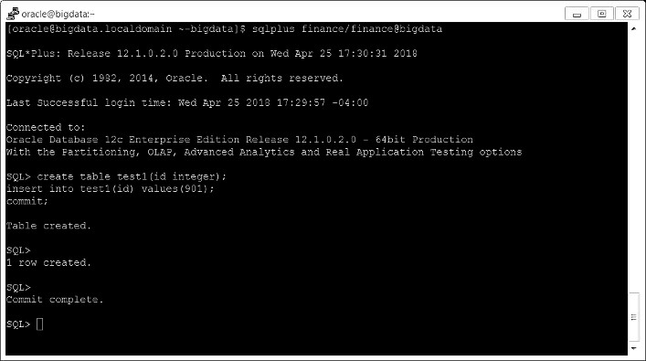

**Figure 6.9**

Distributing Data from a Single Source to Two or More Targets—Testing the First Target

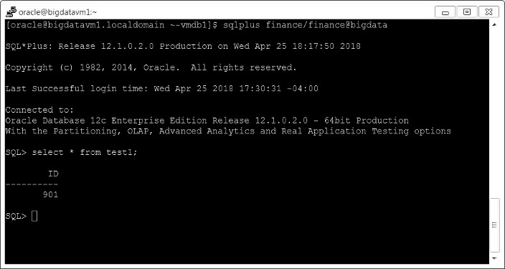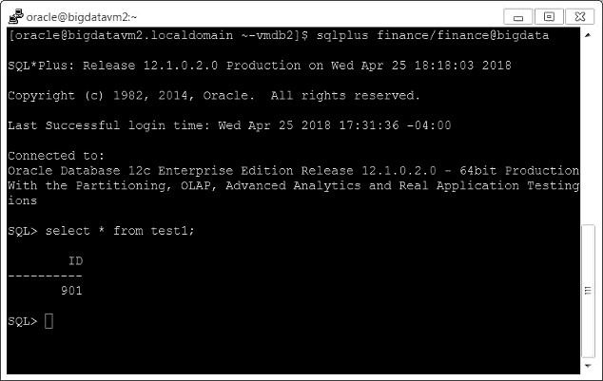

**Figure 6.10**

Distributing Data from a Single Source to two or More Targets—Testing the Second Target

GGSCI (bigdata.localdomain) 11> info all Program Status Group Lag at Chkpt Time Since Chkpt

MANAGER RUNNING

EXTRACT STOPPED EXT1 00:00:00 00:00:23

EXTRACT ABENDED PUMP1 00:00:00 16:18:07

EXTRACT ABENDED PUMP2 00:00:00 16:18:16

GGSCI (bigdata.localdomain) 12> delete extract pump1 Deleted EXTRACT PUMP1.

GGSCI (bigdata.localdomain) 13> delete extract pump2 Deleted EXTRACT PUMP2.

Parameters are edited and removed for the two data pump extracts, and previously added comments are removed for the ext1 Extract process:

GGSCI (bigdata.localdomain) 14> edit params pump1

GGSCI (bigdata.localdomain) 15> edit params pump2

GGSCI (bigdata.localdomain) 16> edit params ext1

GGSCI (bigdata.localdomain) 17>

Finally, we remove the Replicat processes and their associated parameters from the two target servers like this:

GGSCI (bigdatavm1.localdomain) 1> info all Program Status Group Lag at Chkpt Time Since Chkpt

MANAGER STOPPED

REPLICAT ABENDED REP2 00:00:00 16:48:22

GGSCI (bigdatavm1.localdomain) 2> DBLOGIN USERID ggate,

PASSWORD ggate Successfully logged into database.

GGSCI (bigdatavm1.localdomain as ggate@vmdb2) 3> delete replicat rep1 Deleted REPLICAT REP2.

GGSCI (bigdatavm1.localdomain as ggate@vmdb2) 4> edit params rep1

It is also prudent to restart all three databases to clear out any lingering GoldenGate processing.

## 6.4 Using GoldenGate to Consolidate a Warehouse from Many Sources

Consolidating data from multiple sources on to a single target is the general architecture that is commonly used to move data from multiple sources of information into a single target database that allows for analysis and reporting as a data warehouse. A typical data warehouse architecture using GoldenGate is as shown in Figure 6.11.

### 6.4.1 Implementing Data Warehouse Consolidation with GoldenGate

In this case, there are three separate source servers that will pump data changes across a network, which will be consolidated into a single target data warehouse server. Typically, a data warehouse will process and load data from one of many data sources, sometimes disparate data sources, including any kind of database such as Oracle, SQL Server, Hadoop, or even text fi les or other documents. The fi rst step is to create an Extract process on all three sources and then change the parameters appropriately, applying schema-level logging:

cd $ORACLE_GG ggsci DBLOGIN USERID ggate, PASSWORD ggate

ADD SCHEMATRANDATA dimensions

ADD SCHEMATRANDATA email

ADD SCHEMATRANDATA facts

ADD SCHEMATRANDATA facts_events

ADD SCHEMATRANDATA finance

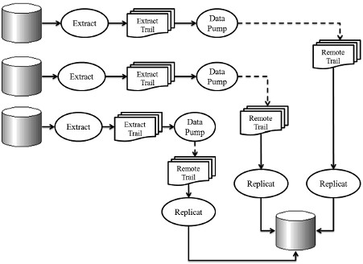

**Figure 6.11** Consolidating from Multiple Sources into a Single Data Warehouse

Next run scripts to support DDL processing, adding the GGATE schema name where prompted:

cd $ORACLE_GG sqlplus / as sysdba @marker_setup.sql

@ddl_setup.sql @role_setup.sql grant GGS_GGSUSER_ROLE to ggate; @ddl_enable.sql

Start the manager process on all three sources if not already started:

ggsci info all

START MANAGER

On all three sources, create an Extract process, an extract trail linking into each Extract process, and edit the extract parameters on each source, starting with the fi rst source:

ADD EXTRACT ext1, TRANLOG, BEGIN NOW ADD EXTTRAIL /u01/app/oracle/product/12.1.0/oggcore_1/dirdat/ l1, EXTRACT ext1 EDIT PARAMS ext1

And edit the parameters on the fi rst source:

EXTRACT ext1 USERID ggate, password ggate and on the second source:

ADD EXTRACT ext2, TRANLOG, BEGIN NOW ADD EXTTRAIL /u01/app/oracle/product/12.1.0/oggcore_1/dirdat/ l2, EXTRACT ext2 EDIT PARAMS ext2

And edit the parameters on the second source:

EXTRACT ext2

USERID ggate, password ggate

And make these changes on the third source:

ADD EXTRACT ext3, TRANLOG, BEGIN NOW ADD EXTTRAIL /u01/app/oracle/product/12.1.0/oggcore_1/dirdat/ l3, EXTRACT ext3 EDIT PARAMS ext3

And edit the parameters on the third source:

EXTRACT ext3

USERID ggate, password ggate

Next add one data pump on all three sources:

ADD EXTRACT pump1, EXTTRAILSOURCE /u01/app/oracle/ product/12.1.0/oggcore_1/dirdat/l1, BEGIN NOW ADD EXTRACT pump2, EXTTRAILSOURCE /u01/app/oracle/ product/12.1.0/oggcore_1/dirdat/l2, BEGIN NOW ADD EXTRACT pump3, EXTTRAILSOURCE /u01/app/oracle/ product/12.1.0/oggcore_1/dirdat/l3, BEGIN NOW and create three remote trails, one on each source:

ADD RMTTRAIL /u01/app/oracle/product/12.1.0/oggcore_1/dirdat/ l1, EXTRACT pump1 ADD RMTTRAIL /u01/app/oracle/product/12.1.0/oggcore_1/dirdat/ l2, EXTRACT pump2 ADD RMTTRAIL /u01/app/oracle/product/12.1.0/oggcore_1/dirdat/ l3, EXTRACT pump3

Next create the parameter fi les for each data pump process on each source using the EDIT PARAMS command, beginning with the fi rst data pump process on the fi rst source:

EXTRACT pump1

USERID ggate, password ggate

RMTHOST bigdatavm1, MGRPORT 7809 RMTTRAIL /u01/app/oracle/product/12.1.0/oggcore_1/dirdat/l1 ddl include mapped objname capture.*, include mapped objname dimensions.*, include mapped objname email.*, include mapped objname facts.* , include mapped objname facts_events.* , include mapped objname finance.* table DIMENSIONS.*; table EMAIL.*; table FACTS.*; table FACTS_EVENTS.*; table FINANCE.*; and for the second data pump process on the second source:

EXTRACT pump2

USERID ggate, password ggate

RMTHOST bigdatavm2, MGRPORT 7809

RMTTRAIL /u01/app/oracle/product/12.1.0/oggcore_1/dirdat/l2 ddl include mapped objname capture.*, include mapped objname dimensions.*, include mapped objname email.*, include mapped objname facts.* , include mapped objname facts_events.* , include mapped objname finance.* table DIMENSIONS.*; table EMAIL.*; table FACTS.*; table FACTS_EVENTS.*; table FINANCE.*; and for the third data pump process on the third source:

EXTRACT pump3

USERID ggate, password ggate

RMTHOST bigdatavm2, MGRPORT 7809 RMTTRAIL /u01/app/oracle/product/12.1.0/oggcore_1/dirdat/l3 ddl include mapped objname capture.*, include mapped objname dimensions.*, include mapped objname email.*, include mapped objname facts.* , include mapped objname facts_events.* , include mapped objname finance.* table DIMENSIONS.*; table EMAIL.*; table FACTS.*; table FACTS_EVENTS.*; table FINANCE.*;

Moving to the target, we create a checkpoint table beginning by editing the global parameters fi le:

ggsci EDIT PARAMS ./GLOBAL

and add these lines to the ./GLOBAL parameters fi les on each target (if not already edited):

GGSCHEMA ggate

CHECKPOINTTABLE ggate.CHECKPOINT

And next connect as the GGATE user in GGSCI on the target and add the checkpoint table (if not already created):

DBLOGIN USERID ggate, PASSWORD ggate

ADD CHECKPOINTTABLE ggate.CHECKPOINT

Next we add the three Replicat groups for each source onto the target and link between the appropriate extract trail on the sources and the single checkpoint table on the target:

ADD REPLICAT rep1, EXTTRAIL /u01/app/oracle/product/12.1.0/ oggcore_1/dirdat/l1, CHECKPOINTTABLE ggate.CHECKPOINT ADD REPLICAT rep2, EXTTRAIL /u01/app/oracle/product/12.1.0/ oggcore_1/dirdat/l2, CHECKPOINTTABLE ggate.CHECKPOINT ADD REPLICAT rep3, EXTTRAIL /u01/app/oracle/product/12.1.0/ oggcore_1/dirdat/l3, CHECKPOINTTABLE ggate.CHECKPOINT

Now we have to edit the three Replicat process parameters on the source server using the EDIT PARAMS command inside GGSCI:

REPLICAT rep1

ASSUMETARGETDEFS

USERID ggate, PASSWORD ggate DISCARDFILE /u01/app/oracle/product/12.1.0/oggcore_1/dirdat/ rep1_discard.txt,APPEND,MEGABYTES 10 DDL

--Maps tables from source to target

MAP DIMENSIONS.*, TARGET DIMENSIONS.*;

MAP EMAIL.*, TARGET EMAIL.*;

MAP FACTS.*, TARGET FACTS.*;

MAP FACTS_EVENTS.*, TARGET FACTS_EVENTS.*;

MAP FINANCE.*, TARGET FINANCE.*;

For the second Replicat process on the source:

REPLICAT rep2

ASSUMETARGETDEFS

USERID ggate, PASSWORD ggate

DISCARDFILE /u01/app/oracle/product/12.1.0/oggcore_1/dirdat/ rep1_discard.txt,APPEND,MEGABYTES 10 DDL

--Maps tables from source to target

MAP DIMENSIONS.*, TARGET DIMENSIONS.*;

MAP EMAIL.*, TARGET EMAIL.*;

MAP FACTS.*, TARGET FACTS.*;

MAP FACTS_EVENTS.*, TARGET FACTS_EVENTS.*;

MAP FINANCE.*, TARGET FINANCE.*;

and for the third Replicat process on the source:

REPLICAT rep3

ASSUMETARGETDEFS

USERID ggate, PASSWORD ggate DISCARDFILE /u01/app/oracle/product/12.1.0/oggcore_1/dirdat/ rep1_discard.txt,APPEND,MEGABYTES 10 DDL

--Maps tables from source to target

MAP DIMENSIONS.*, TARGET DIMENSIONS.*;

MAP EMAIL.*, TARGET EMAIL.*;

MAP FACTS.*, TARGET FACTS.*;

MAP FACTS_EVENTS.*, TARGET FACTS_EVENTS.*;

MAP FINANCE.*, TARGET FINANCE.*;

The result should look like that as shown in Figure 6.12, with all three Replicat processes running.

And now start it all up and test it in this sequence, starting with the fi rst target:

START MGR

START EXTRACT pump1

START EXTRACT ext1

The result should look as shown in Figure 6.13 for all three source servers.

And now we can test the GoldenGate data warehouse confi guration that we have confi gured, starting with the fi rst source:

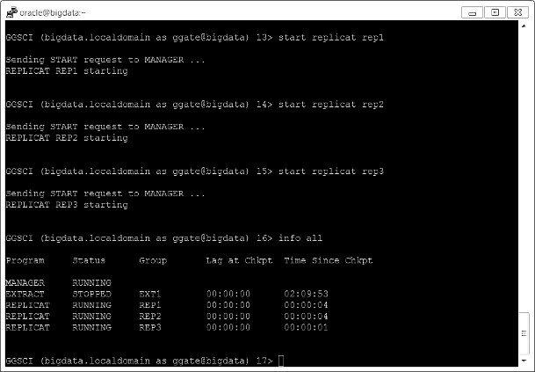

**Figure 6.12**

Starting All Three Replicat Processes on the Source

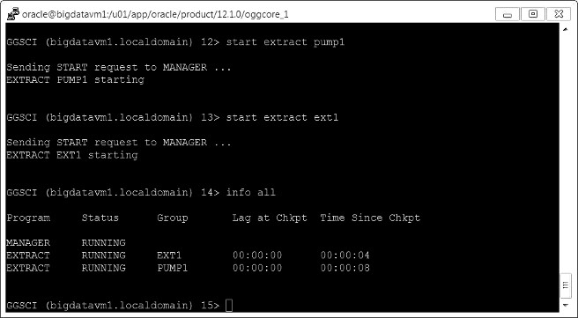

**Figure 6.13**

Starting the Extract and Data Pump Processes on All Three Sources

Applying Replication 139

sqlplus facts_events/facts_events@vmdb1 create table test1(id integer); insert into test1(id) values(801); commit; and the second source:

sqlplus facts_events/facts_events@vmdb2 create table test2(id integer); insert into test2(id) values(802); commit;

and fi nally the third source:

sqlplus facts_events/facts_events@vmdb3 create table test3(id integer); insert into test3(id) values(803); commit;

As of the writing of this book, this confi guration could not be persuaded to function 100%, where changes were not successfully replicated from any of the three sources to the individual target. The trouble with using Replication to consolidate changes is that those changes must be manually monitored in order to prevent confl icts; correcting and verifying this confi guration is beyond the scope of this chapter.

## 6.5 High Availability with Master-to-Master Replication

Master-to-master replication is generally complicated and often prone to synchronization problems between source and target, because in masterto-master database replication, changes can confl ict with each other and must be constantly monitored for and resolved through manual intervention. The other option to high availability, as opposed to master-to-master replication, is clustering of machines that allow multiple machines to share disk space, such as with Oracle RAC or even something like Hadoop and BigData, or even a non-clustered Cloud-based data warehouse like Snowfl ake or Redshift. The downside to clustering with something like Hadoop

140 Working with Oracle GoldenGate 12c

or Oracle RAC is that it is usually even more complicated than master-tomaster replication. Master-to-master replication can excel where source and target machines are not collocated (right next to each other), making master-to-master replication an effective option to achieve a highly available system that can service customers from more than once source at the same time, presenting a powerful and versatile service to customers, as shown in Figure 6.14.

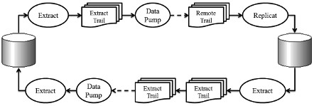

**Figure 6.14** Master-to-Master Replication Can Substitute for Non-Colocated

Source and Target Servers

### 6.5.1 Implementing Master-to-Master Replication with GoldenGate

Master-to-master replication always presents problems, regardless of whether we are using GoldenGate or another replication tool. There is some specifi c functionality that will present problems for master-to-master replication architectures: (1) functions such as TRUNCATE cannot be used because of lack of rollback and logging; (2) keys can have internally generated values, or missing values, or the same values for different data, and might be meaningless to a replicated database; and (3) triggers that generate internal and potentially uncontrollable cascading operations (including the specialized trigger-like function of cascade deletion) can cause generation of disparate data sets between source and target. Database replication is all about synchronization of change between a source and a target, and making changes that go both ways can create tremendous possibility for confl ict.

Applying Replication 141

**6.6 So What’s Next?**

This chapter has described and demonstrated some ways in which GoldenGate can be applied as a middleware software layer in order to architect multiple server structures, including live reporting, standby, distribution, data warehousing, and high availability. Not every architectural application is applicable for detailed implementation by example in a book such as this one—being too advanced in some areas; other resources online and in printed form can be used, including GoldenGate documentation from Oracle Corporation. The next chapter will wrap up this book with a number of sections that consolidate useful sequences of action.

**Chapter 7**

**Wrapping It Up**



The goal of this chapter is to describe sequences of steps that consolidate a basic deinstall of GoldenGate followed by a basic reinstall of GoldenGate, in addition to a list of references that were used in the writing of this book.

143

#### 7.1 Deinstalling GoldenGate

This section describes the sequential steps required in order to deinstall and remove GoldenGate software, as well as changes required to be made to a supporting Oracle® Database.

***7.1.1 Stop the GoldenGate Processes***

Stop all processes, ending with the manager process on both source and target systems (processes in this case are already removed):

cd $ORACLE_GG ggsci stop ER * stop manager and it looks like this below, which is already removed for this case:

GGSCI (bigdata.localdomain) 2> stop ER * No ER groups found, but some coordinated threads may have been excluded.

and the manager process is already stopped:

GGSCI (bigdata.localdomain) 3> stop manager Manager is already stopped.

### 7.1.2 Removing DDL

Execute SQLPLUS on both source and target to remove DDL replication from each database:

cd $ORACLE_GG sqlplus /as sysdba and inside SQLPLUS:

@ddl_disable.sql;

@ddl_remove.sql;

@marker_remove.sql;

### 7.1.3 Removing Objects

Now go back into GGSCI to remove table- and schema-level supplemental logging from source and target—but given the later dropping of the GGATE tablespace and user, this step is not strictly necessary; however, including this information here helps in understanding the separate steps:

cd $ORACLE_GG ggsci DBLOGIN USERID ggate

DELETE TRANDATA dmevents.earthquake

DELETE TRANDATA dmevents.volcano

DELETE SCHEMATRANDATA email

DELETE SCHEMATRANDATA bigdata

And now remove the Extract process on the source:

DELETE EXTRACT ext1 UNREGISTER EXTRACT ext1 DATABASE and the Replicat process on the target:

DELETE REPLICAT rep1

UNREGISTER REPLICAT rep1 DATABASE

### 7.1.4 Uninstalling Oracle GoldenGate

Find the path of GoldenGate and execute the deinstall.sh script using the full path name on both servers:

/u01/app/oracle/product/12.1.0/oggcore_1/deinstall/deinstall.sh The result should look something like this:

/u01/app/oracle/product/12.1.0/oggcore_1/deinstall/deinstall.sh

ALERT: Ensure all the processes running from the current Oracle Home are shutdown prior to running this software uninstallation script.

Proceed with removing Oracle GoldenGate home: /u01/app/oracle/ product/12.1.0/oggcore_1 (yes/no)? [no] yes Starting Oracle Universal Installer...

Checking swap space: must be greater than 500 MB. Actual

8197 MB Passed

Preparing to launch Oracle Universal Installer from /tmp/

OraInstall2017-01-24_12

-32-59AM. Please wait ...Oracle Universal Installer, Version

11.2.0.3.0 Production

Copyright (C) 1999, 2011, Oracle. All rights reserved.

Starting deinstall

Deinstall in progress (Tuesday, January 24, 2017 12:33:10 AM EST) ................................................... 100% Done.

Deinstall successful

End of install phases.(Tuesday, January 24, 2017 12:33:34 AM EST)

End of deinstallations

Please check '/u01/app/oraInventory/logs/silentInstall2017-0124_12-32-59AM.log' for more details.

### 7.1.5 Removing GGATE User and Tablespace in Oracle Database

It might be necessary to restart a database before removing the GGATE user:

DROP USER ggate CASCADE;

DROP TABLESPACE ggate INCLUDING CONTENTS AND DATAFILES;

## 7.2 Reinstalling GoldenGate

This section describes the sequential steps of reinstalling GoldenGate softw are onto a clean system.

### 7.2.1 Restart Oracle Databases

Forcibly restart to help clear any leftover connected processes:

sqlplus / as sysdba shutdown immediate; startup;

### 7.2.2 Recreate Tablespace

Recreate the GGATE tablespace on both source and target servers, starting on the source:

sqlplus / as sysdba

CREATE BIGFILE TABLESPACE ggate

DATAFILE '/u02/app/oracle/oradata/bigdata/ggate01.dbf'

SIZE 1G AUTOEXTEND ON;

CREATE USER ggate IDENTIFIED BY ggate

DEFAULT TABLESPACE ggate TEMPORARY TABLESPACE TEMP;

GRANT DBA, CONNECT, RESOURCE, UNLIMITED TABLESPACE TO ggate;

GRANT EXECUTE ON UTL_FILE TO ggate; GRANT FLASHBACK ANY TABLE TO ggate; and on the target:

CREATE BIGFILE TABLESPACE ggate

DATAFILE '/u02/app/oracle/oradata/failover/ggate01.dbf'

SIZE 1G AUTOEXTEND ON;

CREATE USER ggate IDENTIFIED BY ggate

DEFAULT TABLESPACE ggate TEMPORARY TABLESPACE TEMP;

GRANT DBA, CONNECT, RESOURCE, UNLIMITED TABLESPACE TO ggate;

GRANT EXECUTE ON UTL_FILE TO ggate;

GRANT FLASHBACK ANY TABLE TO ggate;

### 7.2.3 Reinstall GoldenGate Software

Rebuild GoldenGate software on both source and target, starting with VNC, following the instructions at the following URL:

<http://www.oracletroubleshooter.com/using-vncserver>If VNC is not running:

[root@bigdata ~]# ps -ef | grep vnc root 7554 4247 0 11:40 pts/1 00:00:00 grep vnc [root@bigdata ~]#

reset the VNC password by removing the password fi le and recreating it on both source and target:

[root@bigdata ~]# ls /root/.vnc bigdata.localdomain:1.log bigdata.localdomain:1.pid bigdata. localdomain:2.log bigdata.localdomain:2.pid passwd xstartup [root@bigdata ~]# rm /root/.vnc/passwd rm: remove regular file '/root/.vnc/passwd'? y [root@bigdata ~]# vncserver You will require a password to access your desktops.

Password:

Verify:

New 'bigdata.localdomain:1 (root)' desktop is bigdata. localdomain:1

Starting applications specified in /root/.vnc/xstartup

Log file is /root/.vnc/bigdata.localdomain:1.log

Connect to the oracle Linux user on both source and target, download (see Chapter 2) and unzip the GoldenGate software if needed:

su – oracle cd /oinstall

unzip fbo_ggs_Linux_x64_shiphome.zip

Use TightVNC (see Chapter 2 for TightVNC installation) to emulate source and target server screens to a client machine, as shown in Figure 7.1.

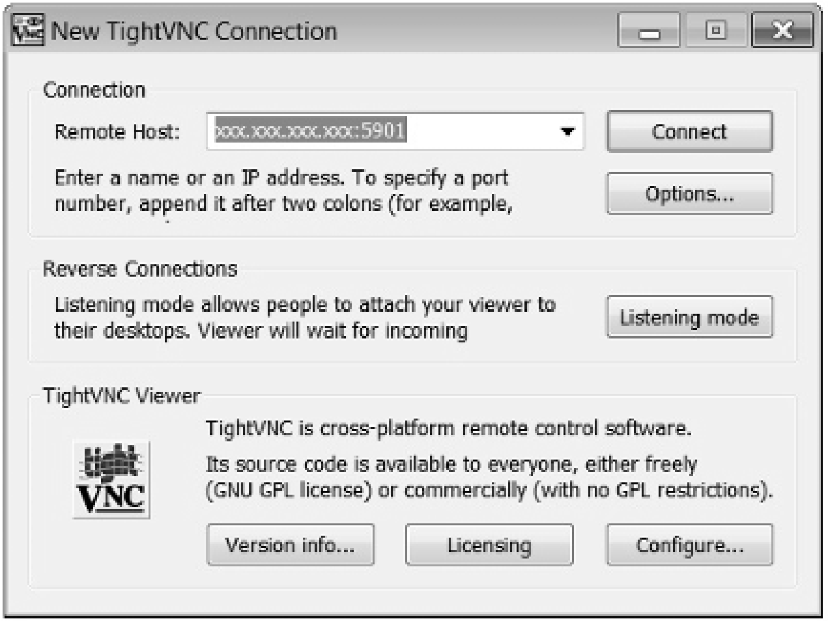

**Figure 7.1** Emulate a Server on a Client Machine

Connect to the server using the VNC password added when executing vncserver in the operating system, on both the source and target servers, as shown in Figure 7.2.

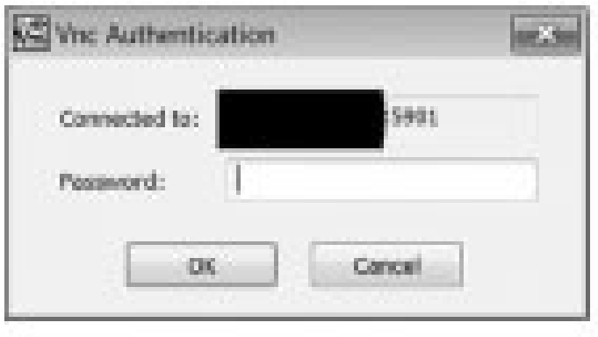

**Figure 7.2** Connect to a Server Using VNC and TightVNC

Open up an xterm terminal Window in the X terminal emulation on the Linux server, redirect the host DISPLAY, and connect to the oracle Linux user, as shown in Figure 7.3.

And this is the current .bash_profi le for the oracle Linux user, as shown in Figure 7.4.

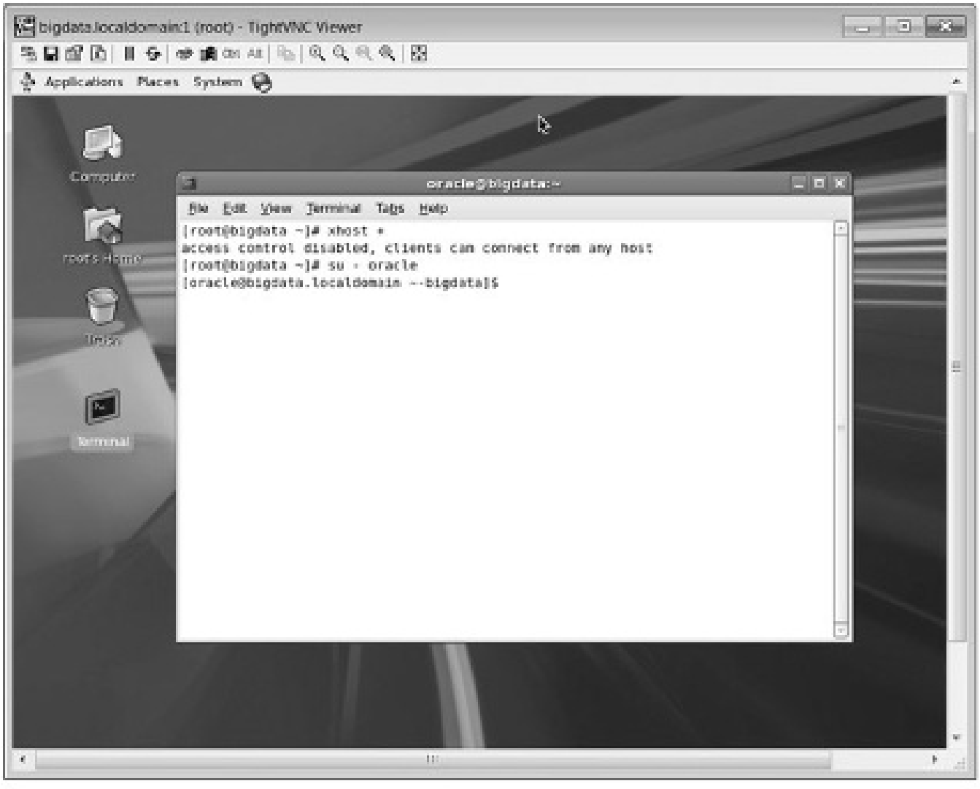

**Figure 7.3** Starting an xterm in TightVNC to Emulate Linux X to a Client Machine

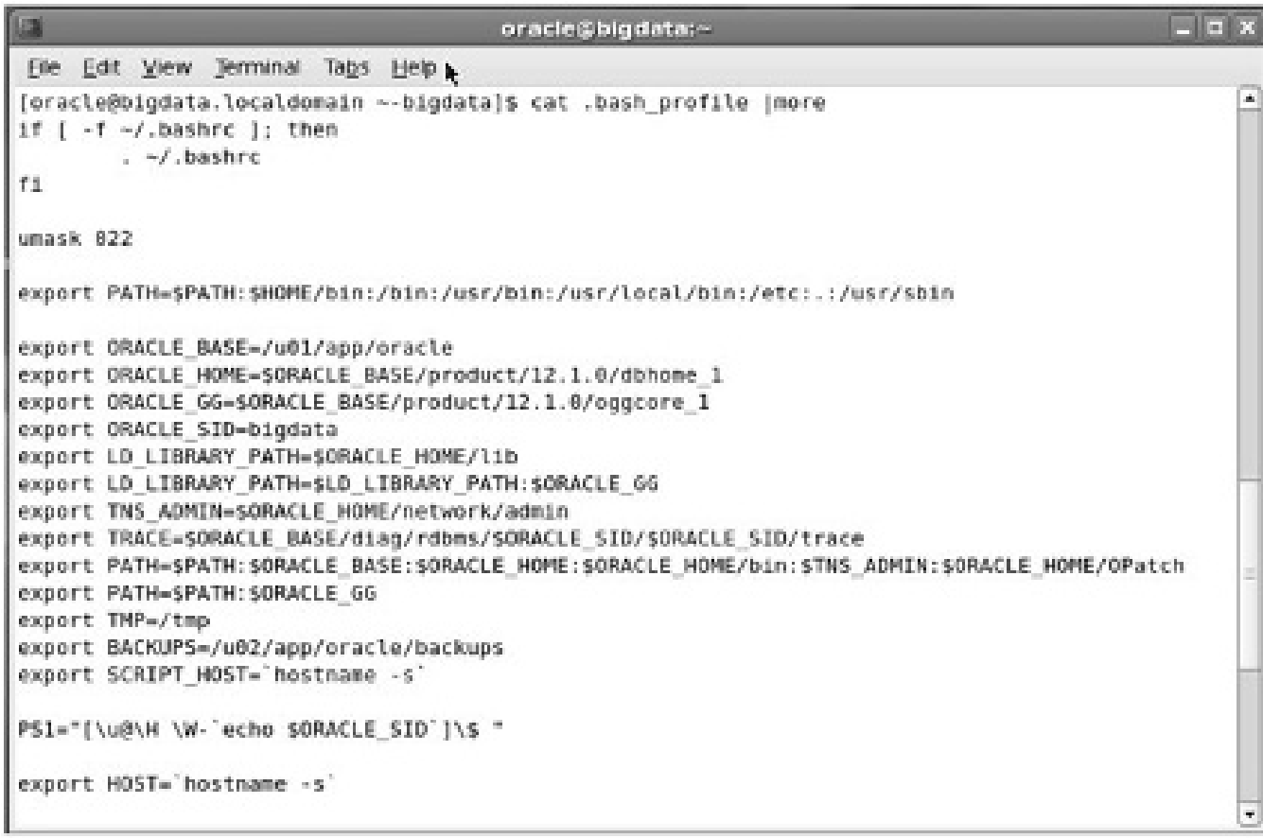

**Figure 7.4** The Oracle Linux user .bash_profi le for Oracle Database and GoldenGate

And these are the aliases currently in use on my servers inside my oracle Linux user .bash_profi le fi le:

[oracle@bigdata.localdomain ~-bigdata]$ alias alias alert='cd $TRACE' alias backups='cd $BACKUPS' alias base='cd $ORACLE_BASE' alias dbs='cd $ORACLE_HOME/dbs' alias dbstart='. $HOME/scripts/dbstart.sh' alias dbstop='. $HOME/scripts/dbstop.sh' alias gghome='cd $ORACLE_GG' alias ggsci='gghome; ggsci' alias home='cd $ORACLE_HOME' alias l.='ls -d .* --color=tty' alias ll='ls -l --color=tty' alias ls='ls --color=tty' alias lsnrlog='cd $ORACLE_BASE/diag/tnslsnr/$HOST/listener/trace' alias rm='rm -i' alias scripts='cd $HOME/scripts' alias sqlnetlog='cd $ORACLE_HOME/network/log' alias sqlnettrc='cd $ORACLE_HOME/network/trace' alias startgg='gghome; echo obey "start" | ./ggsci' alias stopgg='gghome; echo obey "stop" | ./ggsci' alias tns='cd $TNS_ADMIN' alias vi='vim' alias which='alias | /usr/bin/which --tty-only --read-alias --show-dot --show-tilde'

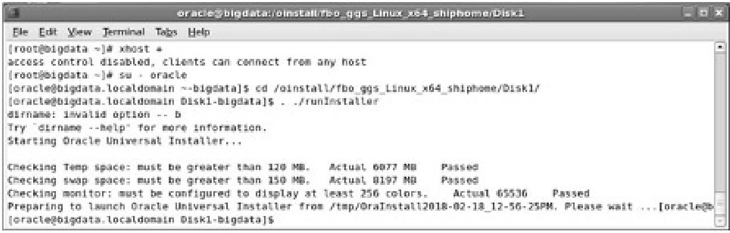

**Figure 7.5** Running the Runinstaller Script

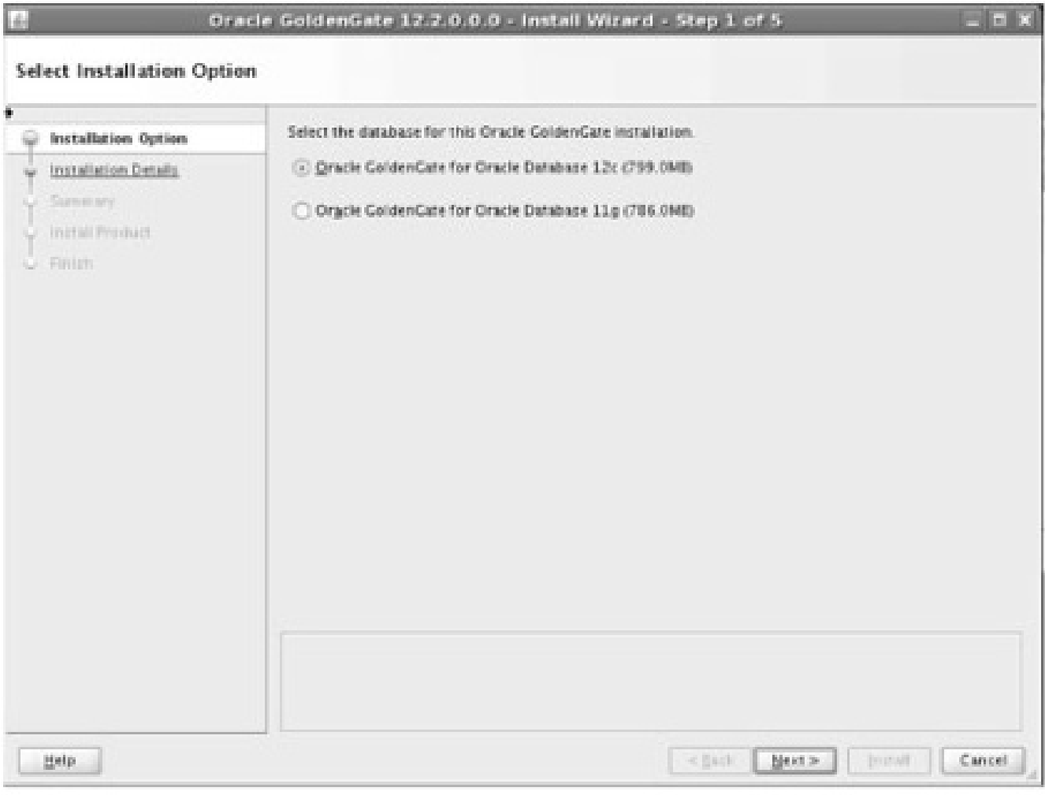

**Figure 7.6** GoldenGate Installation Screen 1

Now we can install GoldenGate software inside the TightVNC X emulator shown on the screens in sequence, as shown by the following and in Figure 7.5 and Figure 7.6.

cd /oinstall/fbo_ggs_Linux_x64_shiphome/Disk1 . runInstaller

Be sure to set the GoldenGate home to the correct path as highlighted in Figure 7.7 where the default might include the Oracle Database software home, which is incorrect.

Click the highlighted Install button when ready as shown in Figure 7.8, Figure 7.9, and Figure 7.10.

Don’t forget to execute the GoldenGate installation process on both source and target servers.

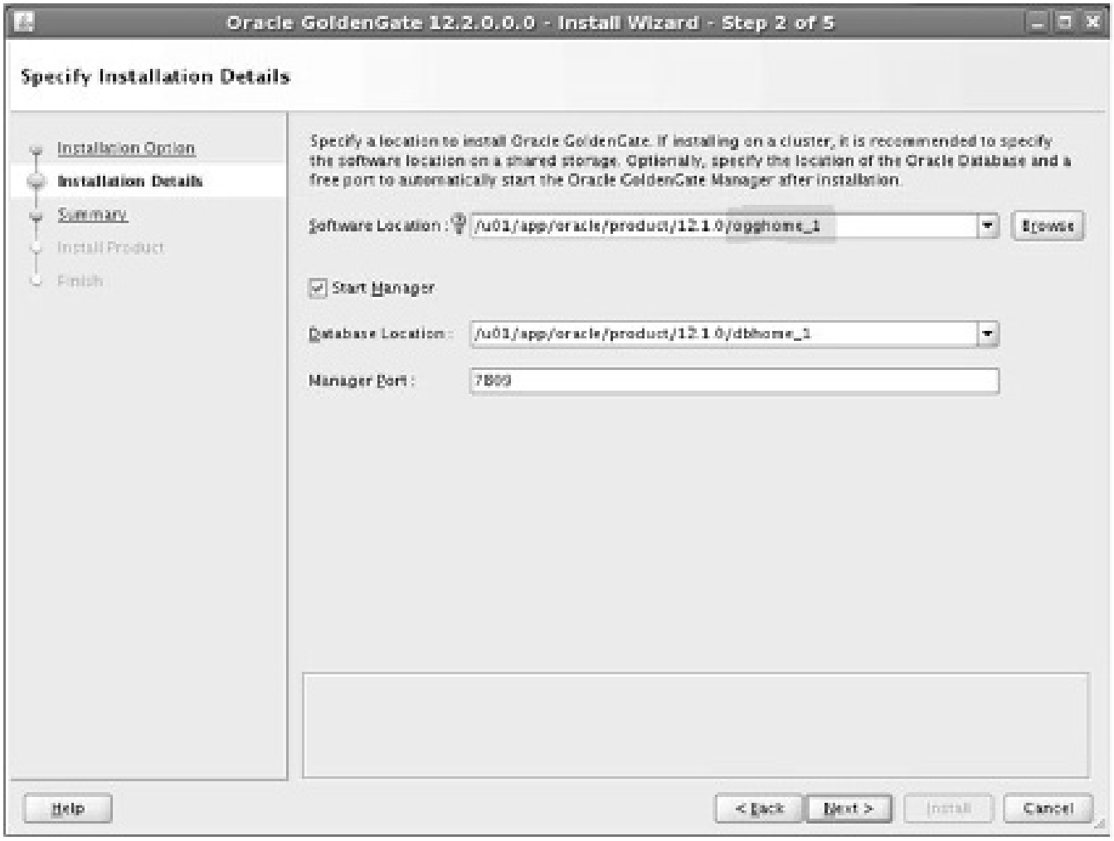

**Figure 7.7** GoldenGate Installation Screen 2

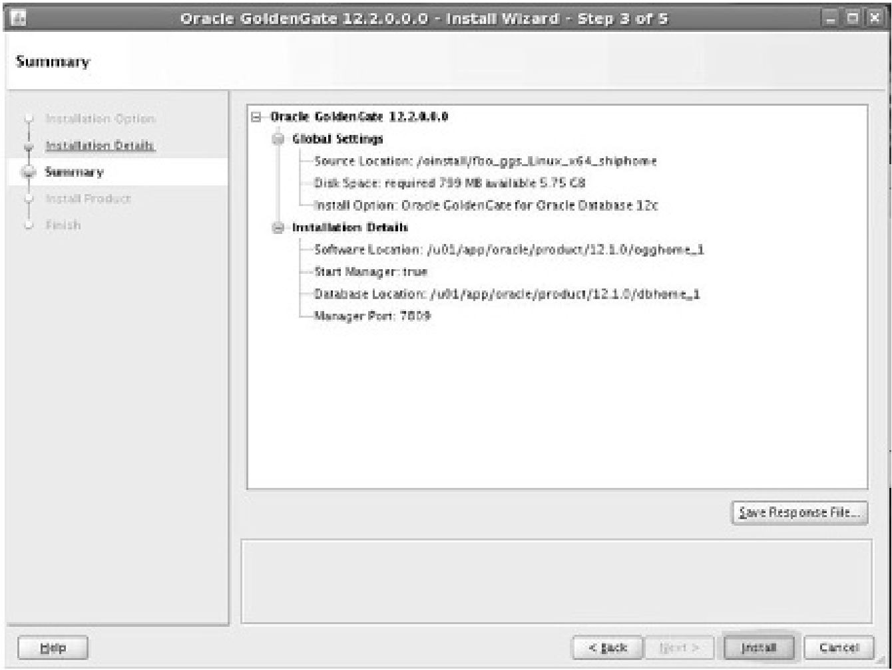

**Figure 7.8** GoldenGate Installation Screen 3

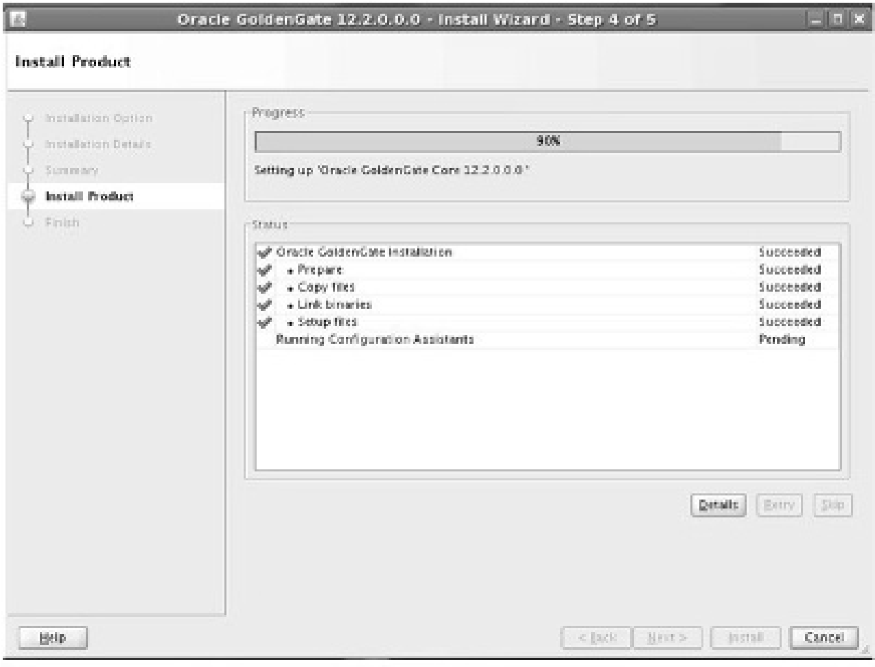

**Figure 7.9** GoldenGate Installation Screen 4

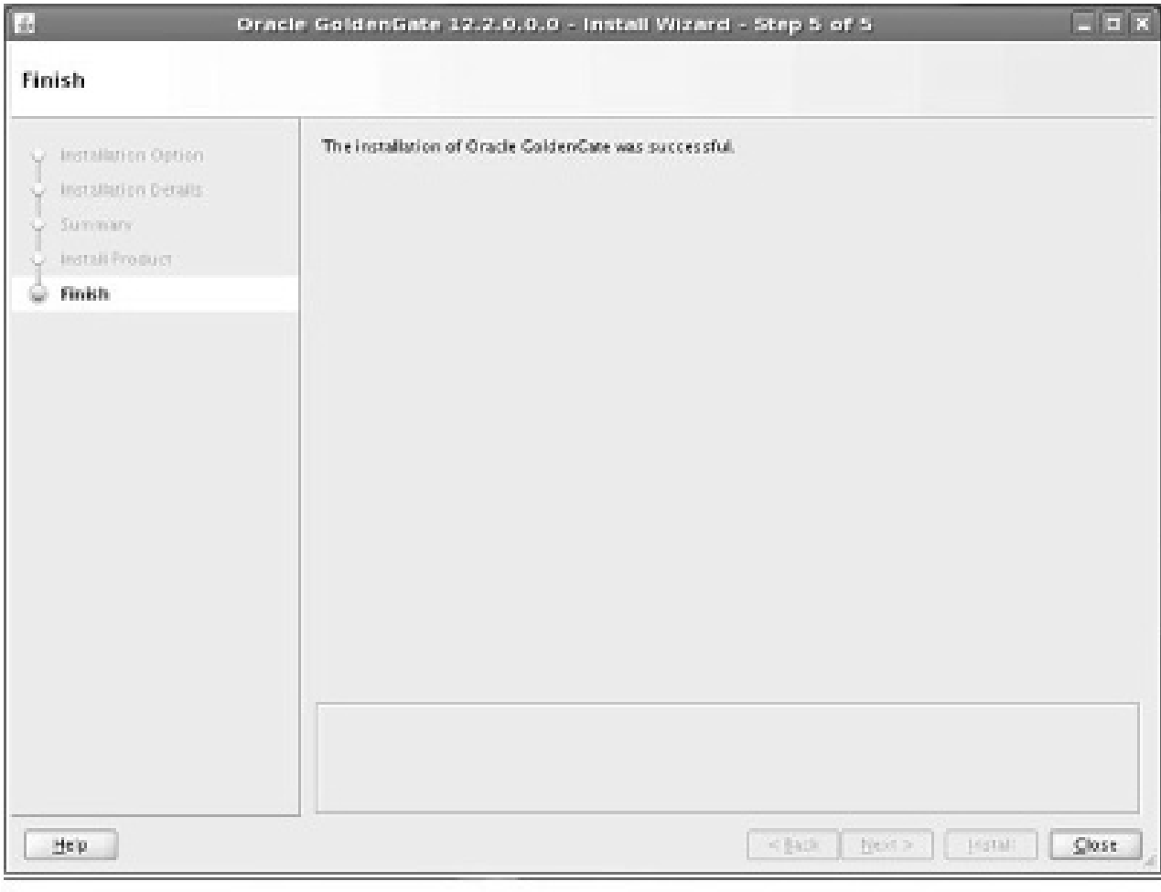

**Figure 7.10** GoldenGate Installation Screen 5

### 7.2.4 Database-Level Logging and Confi guration

Check and implement on both source and target if improperly set, beginning with checking that archive log mode is set:

sqlplus / as sysdba ARCHIVE LOG LIST;

If the result shown is no archive log mode:

SHUTDOWN IMMEDIATE;

STARTUP MOUNT;

ALTER DATABASE ARCHIVELOG; ALTER DATABASE OPEN;

supplemental logging must be confi gured on the source and target (assuming future standby reversal):

ALTER DATABASE ADD SUPPLEMENTAL LOG DATA;

ALTER DATABASE FORCE LOGGING;

Increase undo retention size on the source only to account for fl ashback:

ALTER SYSTEM SET UNDO_RETENTION=86400 SCOPE=BOTH;

Set the STREAMS_POOL_SIZE parameter on the source only:

ALTER SYSTEM SET STREAMS_POOL_SIZE=1280M SCOPE=BOTH;

Oracle12c requires a parameter on both source and target to enable GoldenGate:

ALTER SYSTEM SET enable_goldengate_replication=true

SCOPE=both;

### 7.2.5 Schema-Level Application Logging

Apply schema-level logging to non-Oracle application schemas on the source; below are databases in my database:

cd $ORACLE_GG ggsci DBLOGIN USERID ggate, PASSWORD ggate

ADD SCHEMATRANDATA dimensions

ADD SCHEMATRANDATA email

ADD SCHEMATRANDATA facts

ADD SCHEMATRANDATA facts_events

ADD SCHEMATRANDATA finance

### 7.2.6 Supporting DDL Replication

Run these commands on the source only, adding in the GGATE schema name where prompted:

cd $ORACLE_GG sqlplus / as sysdba @marker_setup.sql

@ddl_setup.sql @role_setup.sql grant GGS_GGSUSER_ROLE to ggate; @ddl_enable.sql

### 7.2.7 Extraction and Application Users

Create users on the source only:

create user capture identified by capture default tablespace users temporary tablespace temp; grant connect,resource,unlimited tablespace to capture;

create user appli identified by appli default tablespace users temporary tablespace temp;

grant connect,resource,unlimited tablespace to appli;

### 7.2.8 Confi gure and Start the Source

Create subdirs on both source and target, and start the manager process if it’s not yet started:

ggsci create subdirs info all START MANAGER

Create the Extract process on the source, the extract trail on the source, link it into the Extract process, and fi nally edit (create) the extract parameters on the source:

ADD EXTRACT ext1, TRANLOG, BEGIN NOW ADD EXTTRAIL /u01/app/oracle/product/12.1.0/oggcore_1/dirdat/ lt, EXTRACT ext1 EDIT PARAMS ext1

This is the content of the ext1 extract parameters fi le on the source:

EXTRACT ext1 USERID ggate, password ggate rmthost failover, mgrport 7809 rmttrail /u01/app/oracle/product/12.1.0/oggcore_1/dirdat/lt -- This supports collection of DDL from the CAPTURE schema ddl include mapped objname capture.*

-- This supports collection of DML from the CAPTURE schema table capture.*;

Create the checkpoint table on the target in the global parameters fi le:

ggsci EDIT PARAMS ./GLOBAL

And add these lines to the ./GLOBAL parameters fi le:

GGSCHEMA ggate

CHECKPOINTTABLE ggate.CHECKPOINT

Connect as the GGATE user in GGSCI:

DBLOGIN USERID ggate, PASSWORD ggate

ADD CHECKPOINTTABLE ggate.CHECKPOINT

Add the Replicat group on the target and link between the extract trail and the checkpoint table:

ADD REPLICAT rep1, EXTTRAIL /u01/app/oracle/product/12.1.0/ oggcore_1/dirdat/lt, CHECKPOINTTABLE ggate.CHECKPOINT

Edit the Replicat parameters fi le on the target:

EDIT PARAMS rep1

Add this to the Replicat parameter fi le on the target:

REPLICAT rep1

ASSUMETARGETDEFS

USERID ggate, PASSWORD ggate DISCARDFILE /u01/app/oracle/product/12.1.0/oggcore_1/dirdat/ rep1_discard.txt, APPEND, MEGABYTES 10 --Maps tables from source to target

MAP CAPTURE.*, TARGET APPLI.*;

Now check the manager process parameters on both source and target: edit params mgr

This should be in the fi le as defi ned above for the RMTHOST setting:

PORT 7809

Start the Extract process on the source:

START EXTRACT ext1

INFO ALL on the source should look like this:

GGSCI (bigdata.localdomain) 15> info all

Program Status Group Lag at Chkpt Time Since Chkpt

MANAGER RUNNING

EXTRACT RUNNING EXT1 00:00:00 00:33:50

Start the Replicat process on the target:

START REPLICAT rep1

INFO ALL on the target should look like this:

GGSCI (failover.localdomain as ggate@failover) 20> info all

Program Status Group Lag at Chkpt Time Since Chkpt

MANAGER RUNNING

REPLICAT RUNNING REP1 00:00:00 00:00:00

*Registration of EXTRACT and REPLICAT processes are not needed here because Integrated Apply is not in use in this configuration.*

If there were any errors then alter the Extract or Replicat process position to after the change and restart it as follows:

STOP EXTRACT ext1

ALTER EXTRACT ext1, BEGIN NOW

START EXTRACT ext1

or:

STOP REPLICAT rep1

ALTER EXTRACT rep1, BEGIN NOW

START EXTRACT rep1

### 7.2.9 Test Replication

Create a table on the source, add some rows and select replicated data at the target:

sqlplus / as sysdba CONNECT capture/capture@bigdata

CREATE TABLE test(id INTEGER PRIMARY KEY);

INSERT INTO test(id) VALUES(1);

COMMIT;

On the target (it could take a few minutes to replicate):

sqlplus appli/appli@failover

SQL*Plus: Release 12.1.0.2.0 Production on Tue Mar 14 15:03:06

2017 Copyright (c) 1982, 2014, Oracle. All rights reserved.

Last Successful login time: Tue Mar 14 2017 15:02:45 -04:00 Connected to:

Oracle Database 12c Enterprise Edition Release 12.1.0.2.0 -

64bit Production

With the Partitioning, OLAP, Advanced Analytics and Real

Application Testing options

SQL> select * from test;

ID

----------

1

### 7.2.10 Add New Schemas

New schemas in the database are added in the EXTRACT parameters fi le:

EXTRACT ext1 USERID ggate, password ggate rmthost failover, mgrport 7809 rmttrail /u01/app/oracle/product/12.1.0/oggcore_1/dirdat/lt ddl include mapped objname capture.*, include mapped objname dimensions.*, include mapped objname email.*, include mapped objname facts.* , include mapped objname facts_events.* , include mapped objname finance.* table DIMENSIONS.*; table EMAIL.*; table FACTS.*; table FACTS_EVENTS.*; table FINANCE.*;

And the REPLICAT parameters on the target:

REPLICAT rep1

ASSUMETARGETDEFS

USERID ggate, PASSWORD ggate DISCARDFILE /u01/app/oracle/product/12.1.0/oggcore_1/dirdat/ rep1_discard.txt, APPEND, MEGABYTES 10 DDL

--Maps tables from source to target

MAP CAPTURE.*, TARGET APPLI.*;

MAP DIMENSIONS.*, TARGET DIMENSIONS.*;

MAP EMAIL.*, TARGET EMAIL.*;

MAP FACTS.*, TARGET FACTS.*;

MAP FACTS_EVENTS.*, TARGET FACTS_EVENTS.*;

MAP FINANCE.*, TARGET FINANCE.*;

Stop and start the manager and Extract process on the source, plus the manager and Replicat processes on the target, and test:

sqlplus dimensions/dimensions@bigdata CREATE TABLE test(id INTEGER PRIMARY KEY);

INSERT INTO test(id) VALUES(1);

INSERT INTO test(id) VALUES(2);

INSERT INTO test(id) VALUES(3);

COMMIT;

CONNECT email/email@bigdata

CREATE TABLE test(id INTEGER PRIMARY KEY);

INSERT INTO test(id) VALUES(1);

INSERT INTO test(id) VALUES(2);

INSERT INTO test(id) VALUES(3);

COMMIT;

And verify replication on the target:

[oracle@failover.localdomain ~-failover]$ sqlplus / as sysdba

SQL*Plus: Release 12.1.0.2.0 Production on Tue Feb 20 01:53:58

2018 Copyright (c) 1982, 2014, Oracle. All rights reserved.

Connected to:

Oracle Database 12c Enterprise Edition Release 12.1.0.2.0 -

64bit Production

With the Partitioning, OLAP, Advanced Analytics and Real

Application Testing options SQL> select * from dimensions.test;

ID

----------

1

2

3 SQL> select * from email.test;

ID

----------

1

2

3

SQL>

### 7.2.11 Script Only Basic Replication

This additional section is a script included as a recently tested example of a sequence that creates a replicated schema called GPOWELL, built with a clean install of a new Oracle database on source and target, plus removing and reinstalling GoldenGate completely:

--source sqlplus / as sysdba CREATE BIGFILE TABLESPACE ggate DATAFILE '/u01/app/oracle/ oradata/vmdb1/ggate01.dbf' SIZE 1G AUTOEXTEND ON; CREATE USER ggate IDENTIFIED BY ggate DEFAULT TABLESPACE ggate

TEMPORARY TABLESPACE TEMP;

GRANT DBA, CONNECT, RESOURCE, UNLIMITED TABLESPACE TO ggate; GRANT EXECUTE ON UTL_FILE TO ggate;

GRANT FLASHBACK ANY TABLE TO ggate;

--target CREATE BIGFILE TABLESPACE ggate DATAFILE '/u01/app/oracle/ oradata/vmdb2/ggate01.dbf' SIZE 1G AUTOEXTEND ON; CREATE USER ggate IDENTIFIED BY ggate

DEFAULT TABLESPACE ggate TEMPORARY TABLESPACE TEMP;

GRANT DBA, CONNECT, RESOURCE, UNLIMITED TABLESPACE TO ggate;

GRANT EXECUTE ON UTL_FILE TO ggate;

GRANT FLASHBACK ANY TABLE TO ggate;

-source & target create user gpowell identified by gpowell; grant connect,resource,dba to gpowell; grant select any dictionary to gpowell; grant select_catalog_role to gpowell; grant unlimited tablespace to gpowell;

--source (& target for standby reversal) add schematrandata gpowell

--source (& target for standby reversal)

@marker_setup.sql

@ddl_setup.sql @role_setup.sql grant GGS_GGSUSER_ROLE to ggate; @ddl_enable.sql

ALTER DATABASE ADD SUPPLEMENTAL LOG DATA;

ALTER DATABASE FORCE LOGGING;

--source & target create subdirs

--source

ADD EXTRACT ext1, TRANLOG, BEGIN NOW ADD EXTTRAIL /u01/app/oracle/product/12.1.0/oggcore_1/dirdat/ lt, EXTRACT ext1

--why not add equivalent RMTTRAIL as well???

--source edit params ext1

EXTRACT ext1 USERID ggate, password ggate rmthost bigdatavm2, mgrport 7809 rmttrail /u01/app/oracle/product/12.1.0/oggcore_1/dirdat/lt ddl include mapped objname gpowell.* table gpowell.*;

--target

EDIT PARAMS ./GLOBAL

GGSCHEMA ggate

CHECKPOINTTABLE ggate.CHECKPOINT

DBLOGIN USERID ggate, PASSWORD ggate

ADD CHECKPOINTTABLE ggate.CHECKPOINT

--target ADD REPLICAT rep1, EXTTRAIL /u01/app/oracle/product/12.1.0/ oggcore_1/dirdat/lt, CHECKPOINTTABLE ggate.CHECKPOINT

--target

EDIT PARAMS rep1

--target

REPLICAT rep1

ASSUMETARGETDEFS

USERID ggate, PASSWORD ggate DISCARDFILE /u01/app/oracle/product/12.1.0/oggcore_1/dirdat/ rep1_discard.txt, APPEND, MEGABYTES 10 MAP GPOWELL.*, TARGET GPOWELL.*;

--define the replicat process

REPLICAT rep1

--connect as a DDL supporting database user

USERID ggate, PASSWORD ggate

ASSUMETARGETDEFS --source and target databases use the same schema names in this case MAP bigdata.*, TARGET bigdata.*;

--in case of error reset

ALTER EXTRACT ext1, BEGIN NOW

ALTER REPLICAT rep1, BEGIN NOW

### 7.2.12 GoldenGate Silent Installations

A silent GoldenGate installation is useful when something like VNC cannot be used to emulate Linux to another machine away from the server, such as me on my laptop. This is how it is done: cd /oinstall/fb...

./runInstaller -silent -responseFile /oinstall/fbo_ggs_Linux_ x64_shiphome/Disk1/oggcore.rsp

This is the response fi le content using a cat command:

cat oggcore.rsp

############################################################## ## Copyright(c) Oracle Corporation 2014. All rights reserved.##

## ##

## Specify values for the variables listed below to ##

## customize your installation. ##

## ##

## Each variable is associated with a comment. The comment ##

## can help to populate the variables with the appropriate ##

## values. ##

## ## ## IMPORTANT NOTE: This file should be secured to have read ##

## permission only by the oracle user or an administrator ##

## who own this installation to protect any sensitive input ##

## values. ##

##############################################################

#------------------------------------------------------------# Do not change the following system generated value. #------------------------------------------------------------oracle.install.responseFileVersion=/oracle/install/ rspfmt_ogginstall_response_schema_v12_1_2

##############################################################

## ##

## Oracle GoldenGate installation option and details ##

## ##

##############################################################

#------------------------------------------------------------# Specify the installation option.

# Specify ORA12c for installing Oracle GoldenGate for Oracle

Database 12c and

# ORA11g for installing Oracle GoldenGate for Oracle Database 11g

#-------------------------------------------------------------

INSTALL_OPTION=ORA12c

#-------------------------------------------------------------

# Specify a location to install Oracle GoldenGate

#-------------------------------------------------------------

SOFTWARE_LOCATION=/u01/app/oracle/product/12.1.0/oggcore_1

#------------------------------------------------------------# Specify true to start the manager after installation.

#-------------------------------------------------------------

START_MANAGER= #-------------------------------------------------------------

# Specify a free port within the valid range for the manager process.

# Required only if START_MANAGER is true.

#-------------------------------------------------------------

MANAGER_PORT=

#------------------------------------------------------------# Specify the location of the Oracle Database.

# Required only if START_MANAGER is true.

#-------------------------------------------------------------

DATABASE_LOCATION=/u01/app/oracle/product/12.1.0/dbhome_1

##############################################################

## ##

## Specify details to Create inventory for Oracle installs ##

## ##

## Required only for the first Oracle product install on a ##

## system. ##

## ##

##############################################################

#------------------------------------------------------------# Specify the location which holds the install inventory files.

# This is an optional parameter if installing on # Windows based Operating System.

#-------------------------------------------------------------

INVENTORY_LOCATION=/u01/app/oraInventory

#------------------------------------------------------------# Unix group to be set for the inventory directory.

# This parameter is not applicable if installing on # Windows based Operating System.

#-------------------------------------------------------------

UNIX_GROUP_NAME=oinstall

## 7.3 References

Numerous references were used in this book including use of Oracle documentation as well as other online references, starting with Oracle GoldenGate documentation online: <https://docs.oracle.com/goldengate/c1221/gg-winux/index.html>And other online references:

blog.moserit.com/how-to-centrally-manage-encrypted-goldengatepasswords-with-macros blogs.oracle.com/imc/entry/ oracle_goldengate_configuring_ddl_replication docs.oracle.com/goldengate/1212/gg-winux/GIORA/additional_ config.htm#GIORA376 docs.oracle.com/goldengate/1212/gg-winux/GIORA/ddl.

htm#GIORA959 docs.oracle.com/goldengate/1212/gg-winux/GIORA/setup.

htm#GIORA37 docs.oracle.com/goldengate/1212/gg-winux/GIORA/setup. htm#GIORA374 docs.oracle.com/goldengate/1212/gg-winux/GIORA/system_ requirements.htm docs.oracle.com/goldengate/1212/gg-winux/GIORA/system_ requirements.htm#GIORA122 docs.oracle.com/goldengate/1212/gg-winux/GWUAD/wu_security.

htm#GWUAD354 docs.oracle.com/goldengate/1212/gg-winux/GWURF/ggsci_commands.

htm#GWURF110 docs.oracle.com/goldengate/c1221/gg-winux/GWURF/summaryoracle-goldengate-parameters.htm#GWURF978 http:/docs.oracle.com/goldengate/c1221/gg-winux/GWURF/summaryoracle-goldengate-commands.htm jinyuwang.weebly.com/core-platform/ oracle-goldengate-globalization minersoracleblog.wordpress.com/2013/05/23/ oracle-goldengate-initial-load-techniques/ practical-tech.blogspot.com/2012/03/oracle-goldengate-basicdml-replication.html sachinichake.wordpress.com/2013/05/08/ step-by-step-golden-gate-configuration/ [www.dba-oracle.com/t_goldengate_data_loading_overview.htm](http://www.dba-oracle.com/t_goldengate_data_loading_overview.htm) [www.juliandyke.com/Research/GoldenGate/ GoldenGateBasicConfiguration.php](http://www.juliandyke.com/Research/GoldenGate/GoldenGateBasicConfiguration.php) [www.oracle.com](http://www.oracle.com/) [www.oracle.com/technetwork/middleware/ias/downloads/fusioncertification-100350.html](http://www.oracle.com/technetwork/middleware/ias/downloads/fusioncertification-100350.html) [www.oracle-scn.com/oracle-goldengate-initial-load-file-todatabase-utility-method/](http://www.oracle-scn.com/oracle-goldengate-initial-load-file-todatabase-utility-method/) [www.oracletroubleshooter.com/using-vncserver](http://www.oracletroubleshooter.com/using-vncserver)

[www.pythian.com/blog/oracle-goldengate-installation-part-1/](http://www.pythian.com/blog/oracle-goldengate-installation-part-1/)

## 7.4 The End

During the process of building the chapters in this book, I found it very useful to utilize the consolidated deinstallation and reinstallation sequences of events presented in this chapter, so to me it only makes sense that you the reader would also fi nd these sections useful. The references are also useful and can help with specifi cs as well as further reading if you decide to dig into the much more detailed aspects of Oracle GoldenGate replication software.

# Glossary

|  |  |
| --- | --- |
| alias | A simpler substitute command for a more complex command |
| apply | The process that describes how change is applied to a target database |
| automated switchover | Where a standby database primary fails and automatically switches all activity to a secondary failover server, the automated form of which is not available in GoldenGate |
| bi-directional replication | *See* master to master |
| BigData | A database architecture that allows for very large data structure by use of clustered mirrors containing duplicate datasets, which do not necessarily maintain consistency between copies |
| bigdata database | Used to store very large amounts of data, allows constant change, but also allows for very large scale and analytics and reporting; examples are the Hadoop framework, MongoDB, Google’s  BigQuery, Facebook’s Casandra |
| broadcast replication | *See* distribution |

171

|  |  |
| --- | --- |
| capture | The process that describes how change is captured on a source database |
| cascading replication | Hierarchical form of replication where chain of databases replicate from source to target, and then from target to another target, and so on |
| checkpoint | A frozen position in time storing the state of a database and its changes at a specifi ed time |
| cold copying | Generally implies that all software that can make changes to a database is shut down during a copying process |
| commit | A SQL command that forces changes to be made permanent in a relational database |
| commit sequence number (CSN) | A sequence number used to track changes replicated by GoldenGate |
| consolidation replication | See data warehouse |
| credentials store | Used in GoldenGate to store credentials, such as username and password, for a more automated and seamless connection to a GoldenGate installation |
| data | The content stored in tables (*see* metadata) |
| data consolidation | A process of replicating and consolidating data from more than one source server in a single target server, such as for a data warehouse target database |
| Data Defi nition  Language (DDL) | The database language used to change objects in a database |
| data distribution | A process of replicating and sharing data from one source to multiple targets |
| Data Manipulation  Language (DML) | The database language used to change data in a database |

|  |  |
| --- | --- |
| data warehouse | Specialized write append and read only data for very large amounts of data |
| database-level supplemental logging | Adds extra information to Oracle Database redo log fi les for everything in database |
| Data Pump | An Oracle utility that moves data effi ciently from one place to another, both on the same server, between servers, and even between databases |
| datatype, data type | A mapping mechanism that forces data values to be formatted in a specifi ed manner |
| deinstall | *See* uninstall |
| Extract process | The GoldenGate process that executes the replication process on the source (see source database) |
| extract trail | A fi le that records change made on a source, which will be transferred and applied to a target database |
| extract, transport, and load (ETL) | Extract from a source database, transport to a target database server, and load into a target database; can also include transformation or changes to data |
| failover, failover database | *See* standby database |
| fl ashback | Allows for a table to be viewed at a previous point in time, in a previous state before changes were made after the fl ashpoint juncture |
| GGSCI history | A history of commands submitted in the GGSCI tool on a GoldenGate server installation |
| globalized character set | Flexibility with many languages including any script |
| GoldenGate | Software owned by Oracle Corporation used for database replication between many different database vendors |

|  |  |
| --- | --- |
| GoldenGate confi guration parameters | Parameter fi les used to control the confi guration and behavior of GoldenGate processes |
| GoldenGate  Software Command  Line Interface  (GGSCI) | A shell command line tool for managing and administering Oracle GoldenGate replication middleware |
| grouping | Used to describe a set of a single type of process, which can execute the same type of process in parallel on the same server |
| high-availability databases | Generally this type of database architecture utilizes multiple servers to allow for instant access to a database if one database in a group of replicated databases fails; continuity of service is possible with master-to-master replication |
| hot copying | Copying an Oracle database with all database software online, while still allowing changes to be made to that database at the same time |
| Integrated Apply | A confi guration method for application of change to a target database |
| Integrated Capture | A confi guration method for capture of change from a source database |
| Linux® | An open source operating system that places UNIX®-like software on a much cheaper Intel platform |
| live reporting | Describes how reporting is produced in real time for customer and consumer consumption of both data as well as meaning of data, presented in both character-based and visually appealing format |
| Logminer | A process that selects and retrieves specifi ed data items from log fi les (redo logs in the case of  Oracle Database) |

|  |  |
| --- | --- |
| Manager process | Manages the basic automated aspects of processing in a GoldenGate installation |
| master to master | Two databases that copy changes to another database, effectively copying their changes to the other |
| master to slave | One database copies its changes to another, and the target database does not change (or does not replicat back) |
| metadata | The data about the data |
| MySQL | An open source relational database that is owned by Oracle Corporation |
| OBEY command | Allows for the consolidation and automated execution of multiple GoldenGate commands |
| online transaction processing (OLTP) | Applies to a type of database that executes many small memory-intensive data change and datasharing operations concurrently |
| Oracle Database | Oracle Corporation’s fl agship product (for now) |
| Oracle Streams | An Oracle proprietary piece of software that pushes data through a piping process to another  Oracle database |
| Oracle Universal  Installer | An installer software used for Oracle software, including Oracle Database |
| password encryption | Passwords can be encrypted so that unwelcome persons cannot obtain them and steal data |
| peer-to-peer replication | Master to master, but can include more than two databases |
| reinstall | A process of rebuilding an Oracle GoldenGate installation on both source and target servers |
| relational database | Used for processing of highly concurrent, memory-i ntensive, frequent-change database storage requirements |

|  |  |
| --- | --- |
| remote trail | Log fi les of changes made to a source, transferred to a target database, and to be applied to that target database |
| Replicat process | The GoldenGate process that executes the replication process on the target (*see* target database) |
| replication | The process of automatically copying changes to data from one database to another in order to duplicate database changes in real time to a separate database |
| reporting | The act of reading data from a database to present a useful presentation or visualization of data to a technical end user or customer |
| rollback | Undoes any not-yet-commited changes for a session |
| source database | In replication, the database in which change originates |
| sql*loader | An Oracle proprietary utility used for loading data into an Oracle database at very high speed |
| sqlplus | An Oracle proprietary SQL coding and submission utility |
| standby, standby database | Intended for automated switching from an active database to a copy when the primary database develops a problem; can also be used for maintenance, but that is not its principal purpose |
| Structured Query  Language (SQL) | An ANSII standard declarative programming language used to retrieve data from a relational database such as Oracle Database |
| system change number (SCN) | A change vector used by Oracle Database to locate a database change state across multiple  Oracle Database fi les |
| table-level supplemental logging | Adds extra information to Oracle Database redo log fi les for individually specifi ed tables |

|  |  |
| --- | --- |
| target database | In replication the database where change is replicated to |
| trail | A fi le containing a record of changes to a database, which can be used to replicate change to another database |
| Transparent  Network Substrate  (TNS) | Oracle proprietary networking software for  Oracle software |
| unidirectional replication | *See* master-to-master replication |
| uninstall | A process of removing software from a server, in this case GoldenGate software and associated confi guration with source and target Oracle databases |
| UNIX | *See* Linux |
| VIEW SSGEVT | A GoldenGate tool used to examine GoldenGate logging, particularly when searching for causes of error conditions |
| Virtual Network  Computing (VNC) | A tool that allows for emulation of a graphical operating system to a remote screen, in the next room or across the world |
| Windows® operating system | The popular operating system produced by  Microsoft® Corporation |

# Index

**A**

alias, 25, 31, 69–76, 81, 90, 149,

151

apply, 1, 8–10, 29, 30, 36–41,

47–53, 59, 66, 73, 74, 75, 78,

105, 107, 130, 155, 159 automated switchover, 112

**B**

bi-directional replication, 4, 6 bigdata, 6, 19–25, 30–35, 42–49, 52–65, 68–77, 80–91, 94–97,

103, 104, 108, 113, 116–122, 125, 129, 130, 133, 134, 139,

144–148, 151, 158–161, 164,

165

BigData database, 6 broadcast replication, 4, 6

**C**

capture, 7, 10, 30, 31, 36–42,

45–51, 54, 55, 59–63, 66, 72,

73, 76, 78, 90, 97–101, 122,

133, 134, 156–160 cascading replication, 4, 6, 50, 140 checkpoint, 3, 9–13, 22, 49, 50, 60,

61, 76–81, 103, 115, 116, 123,

134, 135, 157, 164 cold copying, 94 commit, 7–14, 29, 62, 65, 96–99,

104, 113, 117–119, 139, 159,

161

Commit Sequence Number (CSN), 13, 14, 34, 35, 98.

consolidation replication, 4, 6, 12,

13, 107, 130 credentials store, 69

CSN. *See* Commit Sequence Number

**D**

Database-Level Supplemental

Logging, 27

Data Definition Language (DDL),

5–11, 16, 17, 26, 27, 30, 35,

40–49, 53–63, 72, 73, 76, 77,

89, 90, 97, 98, 114–116, 119, 122, 124, 131–136, 141, 144,

156, 157, 160, 163, 164, 168 data distribution, 120

179

|  |
| --- |
| 180 Working with Oracle GoldenGate 12c |

Data Manipulation Language

(DML), 5–11, 26, 40–46, 60,

157, 168 data pump, 11–13, 38, 39, 43, 47,

53, 54, 93–96, 112, 121, 122,

129, 133, 134, 138 datatype, data type, 16, 29, 38–41,

51, 52 data warehouse, 4, 6, 12, 13, 41, 107, 130, 131, 136, 139 DDL. *See* Data Definition Language deinstall, 1, 56–58, 93, 143–146, 169

DML. *See* Data Manipulation Language

**E**

ETL. *See* extract, transport, and load

Extract process, 7–14, 29, 38, 39,

42–48, 53, 54, 60, 61, 64, 72,

73, 76, 84, 85, 89, 100, 114, 122,

129–132, 145, 156, 158, 161 extract trail, 3, 10, 13, 38, 42–46,

60, 61, 73, 74, 114, 115, 123,

132, 135, 156, 157 extract, transport, and load (ETL), 11, 12, 151

**F**

failover, failover database, 4, 19, 25,

68–69, 94, 97, 112 flashback, 29, 30, 35, 58, 96, 97, 147, 155, 162, 163

**G**

GGSCI. *See* GoldenGate Software

Command Line Interface

GGSCI history, 85 globalized character set, 14 GoldenGate, 1, 3, 6–23, 26–31,

35–39, 42–48, 51–59, 66–79, 83, 88–94, 98–101, 105–108,

112, 113, 120, 129, 130, 136,

140–155, 162, 165–169

GoldenGate configuration parameter, 10, 30

GoldenGate Software Command

Line Interface (GGSCI), 13,

22–24, 27, 31–35, 42–64,

67–91, 94, 97, 98, 101–103,

113–120, 123, 125, 129–131,

134, 135, 144, 145, 151,

155–158, 168 grouping, 3

**H**

hot copying, 99

**I**

Integrated Apply, 40, 41, 49, 50, 53, 159

Integrated Capture, 38–41, 45–47,

50

**L**

Linux®, 1, 16, 19–21, 25, 31, 80–82,

88, 148–155, 165 live reporting, 107, 108, 141 Logminer, 39

**M**

manager process, 7, 43, 60, 63,

82–84, 88, 99, 103, 131, 144,

156, 158, 166

master to master, 5, 6, 105, 120,

129, 139, 140 metadata, 5, 26, 45–48, 59 MySQL, 113

**O**

OBEY command, 79, 85, 88, 89

OLTP. *See* online transaction processing

online transaction processing (OLTP), 40

Oracle Database, 1, 6, 9–11, 14,

15, 19–23, 26–29, 36–41, 45,

50–51, 56, 59, 62, 65, 82, 104,

105, 113, 144–147, 150, 152,

155, 160–162, 166–168

Oracle Streams, 29, 40, 105, 155

Oracle Universal Installer, 16, 19, 146

**P**

password encryption, 73 peer-to-peer replication, 5, 6

**R**

reinstall, 57, 58, 93, 143, 146, 147,

162, 169 relational database, 41 remote trail, 10–13, 38, 40, 43,

53–55, 121, 133 replication, 1–16, 26–31, 35–42,

46–50, 53–66, 94, 99, 105, 107,

113, 117, 120, 139, 140, 144,

155, 156, 159–162, 168, 169

Replicat process, 7–14, 26, 38–41,

47, 53–57, 60–64, 68–73, 78, 79,

84, 85, 89, 100–105, 123, 129,

135–137, 145, 158–161, 164

Index 181

reporting, 4–7, 107–111, 120, 130,

141

rollback, 7, 8, 29, 140

**S**

SCN. *See* System Change Number source database, 4–16, 26, 30, 31,

36, 38, 41, 42, 45–48, 52, 53,

57, 59, 64, 78, 91–94, 100, 101,

108–110, 113, 120

SQL. *See* Structured Query

Language

SQL*Loader, 93, 99, 104

SQLPLUS, 27–30, 35, 50–52, 57, 59,

62–65, 96, 103, 104, 113, 114,

119, 125, 131, 139, 144, 147,

152, 155, 156, 159–162 standby database, 4, 6, 47, 107,

112, 113, 120, 141, 155, 163

Structured Query Language (SQL),

11, 22, 25–30, 35, 40, 51, 52,

56–59, 62–66, 75, 80–82, 93,

96, 99, 100, 103–105, 113,

114, 117–119, 125, 130, 131,

139, 144, 147, 151, 152–156,

159–163

System Change Number (SCN), 14,

53, 54, 76, 80, 96–98, 105, 169

**T**

table-level supplemental logging, 57 target database, 4–16, 23, 26–30,

33, 36–41, 46–51, 68, 78, 83, 90, 91, 94, 99, 105, 110–112,

120, 130, 164

TNS. *See* Transparent Network

Substrate

|  |
| --- |
| 182 Working with Oracle GoldenGate 12c |

Transparent Network Substrate

(TNS), 16, 23–25, 68, 82, 151 trail, 3, 7–14, 21, 38–46, 53–55,

60–63, 72–78, 84, 90, 97,

101, 102, 112–116, 121–123,

132–135, 156, 157, 160, 163,

164

**U**

unidirectional replication, 4, 6 unInstall, 19, 21, 145, 151–153, 165 UNIX, 16, 167, 168

**V**

VIEW SSGEVT, 100

Virtual Network Computing (VNC), 21, 147–151, 165, 169

VNC. *See* Virtual Network Computing

**W**

Windows operating system, 16